**ABZ HARDWARE SALES MANAGEMENT SYSTEM**

**DENNIS NGARI MWANGI**

**A PROJECT REPORT PRESENTED TO CATHOLIC UNIVERSITY OF EASTERN AFRICA, FACULTY OF SCIENCE, DEPARTMENT OF COMPUTER SCIENCE, IN PARTIAL FULFILLMENT OF THE AWARD FOR THE DEGREE IN BACHELOR OF SCIENCE IN COMPUTER SCIENCE**

**DATE: AUGUST, 2025**



**THE CATHOLIC UNIVERSITY OF EASTERN AFRICA**

**PROJECT REPORT FOR FINAL YEAR STUDY IN STUDY IN BACHELOR OF COMPUTER SCIENCE**

**BY**

**DENNIS NGARI MWANGI**

**1045957**

**ABZ HARDWARE SALES MANAGEMENT SYSTEM**

**DATE: AUGUST, 2025**

Submitted in partial fulfillment of the requirements for the Degree in Computer Science.

# DECLARATION AND APPROVAL

**Student**

I, the undersigned, declare that this research proposal is my original work and that it has not been presented in any other university or institution for academic credit.

Name: Dennis Ngari Mwangi

Registration Number: 1045957

Signature…………………………………... Date…………………………………………

**UNIVERSITY SUPERVISOR’S APPROVAL**

This research proposal has been submitted for examination with my approval as University supervisor.

Name: Mr. Chris Nandasaba

Faculty of Science

Signature ….………………………… Date …….………………………………

**HEAD OF DEPARTMENT’S APPROVAL**

This research report has been submitted for examination with my approval as the head of department.

Signature.......................... Date.......................................

Name Mr. Mike Kinyua

# ACKNOWLEDGEMENT

First and foremost, I would like to thank God the Almighty for bringing me this far in my studies. I would also like to thank my parents for their emotional and financial support throughout. Thirdly, I would like to thank my project supervisor for his involvement and guidance.

# DEDICATION

This work is dedicated to the tireless pursuit of excellence in business management. May the outcomes of this project contribute to a future where retail systems in Africa evolve to meet the growing needs of enterprises and customers. It is dedicated to ABZ Hardware, to the customers whose loyalty drives progress, and to the hardworking staff committed to improving service delivery and efficiency.

# ABSTRACT

*This research focuses on the development of an advanced Sales Management System designed to streamline business operations at ABZ Hardware. Many retail businesses face challenges in managing inventory, sales tracking, and customer interactions, which can result in inefficiencies and revenue loss. The objective of this study is to develop an integrated system that automates sales processes, enhances record keeping, and supports informed decision-making through real-time data insights. The system is built using a web-based approach, with the frontend developed in HTML, CSS, and JavaScript to provide an intuitive and user-friendly interface for sales personnel and administrators. The backend utilizes Flask, a Python framework, to handle sales transactions, inventory updates, and customer data management. A PostgreSQL database is employed to store transaction details, product information, and customer records, ensuring scalability, accessibility, and data integrity. Additionally, Python libraries such as Pandas are used for data manipulation and generating sales reports. Key results from this study demonstrate the system’s ability to automate sales tracking, generate accurate receipts, monitor inventory levels in real time, and produce comprehensive reports on sales performance. The system significantly improves efficiency compared to manual record-keeping methods, reducing errors and enhancing business decision-making. Furthermore, by integrating sales and inventory management in a single platform, the solution ensures that ABZ Hardware can maintain accurate stock levels, prevent losses, and improve customer service. In conclusion, this project highlights the transformative potential of technology in small and medium-sized enterprises (SMEs). By providing a scalable, efficient, and accessible sales management system, ABZ Hardware can reduce operational challenges, optimize business processes, and achieve greater profitability and growth.*

**TABLE OF CONTENTS**

DECLARATION AND APPROVAL iii

ACKNOWLEDGEMENT iv

DEDICATION v

ABSTRACT vi

LIST OF FIGURES xii

LIST OF TABLES xiii

LIST OF TERMS AND ABBREVIATIONS xiv

DEFINITION OF KEY TERMS xv

CHAPTER 1 INTRODUCTION 16

1.1 Chapter Introduction 16

1.2 Background of the Research 16

1.3 Problem Statement 17

1.4 Objectives of Research 18

1.4.1 Main Objective of the Research 18

1.4.2 Specific Objectives of the Research 18

1.5 Justification of the Research 19

1.6 Scope of Research 20

1.7 Research Organization 21

CHAPTER 2 REVIEW OF RELATED WORK 22

2.1 Chapter Introduction 22

2.2 Research Methodology and Literature Review 22

2.3 History of the Research Topic 23

2.4 Review of Related Prototypes 24

2.4.1 Global Prototypes 24

2.4.2 Regional Prototypes 25

2.4.3 Local Prototype 26

2.5 Emerging Trends and Pattern 27

2.5.1 Integration of Sales Analytics and AI for Personalized Retail Strategies 27

2.5.2 AI-Driven Sales Pattern and Inventory Analysis 27

2.5.3 Real-time Sales Tracking and Monitoring 28

2.5.4 Emerging Sales and Inventory Technologies 28

2.5.5 Improved Sales Forecasting and Accuracy with Artificial Intelligence (AI) 29

2.5.6 Smart Inventory Self-Check Device 29

2.6 Research Gap 30

2.7 Chapter Summary 31

CHAPTER 3 METHODOLOGY 32

3.1 Introduction 32

3.2 Methodology of Requirement Specification and Data Collection 32

3.2.1 Requirement Specification 32

3.2.2 Data Collection Methods 35

3.3 Methodology for System Analysis (Current System) 36

3.4 Methodology for System Design (Proposed System) 40

3.4.1 Use Case Diagram 41

3.4.2 Sequence Diagram 42

3.4.3 Activity Diagram 42

3.4.4 User Interface Design 43

a) User / Sales Representative Interface 43

3.4.5 Entity-Relationship Diagrams (ERDs) 44

3.5 Methodology for System Implementation (Proposed System) 46

3.5.1 Frontend Development 46

3.5.2 Backend Development 47

3.5.3 Database Design and Setup 47

3.5.4 Development Environment 47

3.6 Methodology for System Testing (Proposed System) 48

3.6.1 Testing Plan 48

3.6.2 Testing Techniques 49

3.7 Methodology for System Deployment 50

3.7.1 Phased Deployment 50

3.7.2 Data Migration Plan 51

3.8 Chapter Summary 55

CHAPTER 4 SYSTEM ANALYSIS OF THE CURRENT SYSTEM 56

4.1 Chapter introduction 56

4.2 Description of the Current Systems 56

4.2.1 System workflow 57

4.2.2 Current System Use Case Diagram 59

4.2.3 Current System Sequence Diagram 60

4.2.4 Strengths of Current system 61

4.2.5 Weaknesses 63

4.3 Feasibility study 64

4.4 Requirements Analysis 65

4.4.1 Functional Requirements 66

4.4.2 Non-Functional Requirements 67

4.5 System Analysis 68

4.5.1 System Workflow (activity diagram) 68

4.5.2 Use Case Diagram 70

4.5.3 Sequence Diagram 71

4.5.4 State Diagram 71

4.6 Data Structuring 72

4.6.1 Relationship Management and Integrity 74

4.7 Chapter Summary 76

CHAPTER 5 SYSTEM DESIGN OF THE PROPOSED SYSTEM 77

5.1 Introduction 77

5.2 User Interface Design 77

5.2.1 Input Form Design 78

Report Design 81

5.3 Process Design 82

5.3.1 Authentication Process 82

5.3.2 User Registration Process 84

5.3.3 Add Products Process 86

5.3.4 Report Generation and Storage 88

5.4 Database Design: ER, Normalization and Data dictionary 92

5.4.1 Entity Relationship (ER) Diagram 93

5.4.2 Normalization 93

5.4.3 Data Dictionary 94

5.5 Test Data 99

5.6 Chapter Summary 102

CHAPTER 6 IMPLEMENTATION SYSTEM & TESTING 104

6.1 Chapter Introduction 104

6.2 Sales Management System Implementation 104

6.2.1 System Functionality Integration 107

6.3 System Implementation 107

6.4 UI Implementation 108

6.4.1 Input Forms Implementation 108

6.4.2 Reports Implementation 115

6.5 ERD Implementation 119

6.6 Business Logic Implementation 120

6.6.1 Client-Side Logic 120

6.6.2 Server-Side Logic (Search logic) 122

6.7 Module Testing 125

6.8 Chapter Summary 126

CHAPTER 7 CONCLUSION, FINDING & RECOMMENDTON 127

7.1 Introduction 127

7.2 Findings 127

7.2.1 Achievement of Objectives 127

7.2.2 Challenges 128

7.3 Final Conclusion 129

7.4 Future Recommendations 129

REFERENCES 131

APPENDICES 132

Appendix A: Questionnaires 132

Appendix B: Project Schedule 135

Appendix C: Project Budget 137

Appendix E: Source Code Snippets 137

# LIST OF FIGURES

Figure 2:1 Shopify Website Image 25

Figure 3:1 Proposed system's Entity Relationship Diagram 44

Figure 4:1 Activity Diagram Current System 58

Figure 4:2 Use Diagram Current System 60

Figure 4:3 Sequence Diagram Current System 61

Figure 4:4 System Workflow Proposed System 69

Figure 4:5 Use Case Diagram Proposed System 70

Figure 4:6 Sequence Diagram Proposed System 71

Figure 4:7 State Diagram Proposed System 72

Figure 5:1 Login screen 79

Figure 5:2 User Sign Up Screen 80

Figure 5:3 Upload Product Form 81

Figure 5:4 Order Report 82

Figure 5:5 Authentication Process Activity Diagram 83

Figure 5:6 Authentication Process Sequence Diagram 84

Figure 5:7 User Registration Process Activity Diagram 85

Figure 5:8 User Registration Process Sequence Diagram 86

Figure 5:9 Image Upload and Analysis Process Activity Diagram 86

Figure 5:10 Product insertion sequence diagram 88

Figure 5:11 Report generation and storage Process Activity Diagram 90

Figure 5:12 Report generation and storage Process Sequence Diagram 91

Figure 5:13 Database Design 92

Figure 6:1 Sales management System Architecture 106

Figure 6:8 Screenshot of Admin New Branch 112

Figure 6:9 Screenshot of Edit User details Form 113

Figure 6:10 Add New Category Form 114

Figure 6:11 Products Report 115

Figure 6:12 Orders Report 116

Figure 6:13 Payment Receipt Report 117

Figure 6:14 Sub Categories Report 118

Figure 6:15 Screenshot of ERD structure 120

Figure 38 Database Table ORM Models 138

FIGURE 39 Admin App Authentication Code 138

FIGURE 40 Sales Dashboard Route 139

FIGURE 41 Prediction Code Snippet 140

# LIST OF TABLES

Table 4‑1 Entities 75

Table 5‑1 USERS 94

Table 5‑2 BRANCH 95

Table 5‑3 CATEGORY 95

Table 5‑4 PRODUCT 96

Table 5‑4 ORDERTYPE 97

Table 5‑5 ORDERS 97

Table 5‑6 ORDERITEM TABLE 98

Table 5‑7 PAYMENTS TABLE 98

Table 6‑1 TESTS TABLE 125

Table 1 Gantt Chart 135

Table 2 Estimated Project Budget 137

# LIST OF TERMS AND ABBREVIATIONS

DFD Data Flow Diagram. A tool used in System Analysis

ERD Entity Relationship Diagram. A toll used in database design

ACID Refers to the set of properties (Atomicity, Consistency, Isolation, Durability)

BLOB Binary Large Object. A data type that can hold large amounts of binary data

AIArtificial Intelligence

GDPR General Data Protection Regulation

OOSAD - Object-Oriented Systems Analysis and Design

# DEFINITION OF KEY TERMS

1. **Sales Management System (SMS):** A software platform designed to manage, track, and optimize the sales process, including order processing, customer management, inventory tracking, and reporting.
2. **Prototypes:** Preliminary versions or models of the sales management system created to test, demonstrate, and refine key functionalities before full-scale implementation.
3. **Automation:** The use of software and technology to perform repetitive or complex sales tasks with minimal human intervention, such as invoice generation, stock updates, and notification alerts.
4. **Mobile Sales Management:** The ability to access and manage sales operations on mobile devices, allowing sales personnel to update orders, check inventory, and communicate with clients remotely.
5. **Sales Analytics:** The process of collecting, analyzing, and interpreting sales and customer data to provide actionable insights for improving sales strategies and decision-making.
6. **Data Analysis:** The examination and interpretation of sales records, customer behaviors, and market trends to identify patterns, optimize processes, and support informed business decisions.
7. **System Integration:** The process of linking the sales management system with other business applications, such as accounting software, inventory management tools, or customer relationship management systems, to ensure seamless workflow and efficiency.
8. **Customer Relationship Management (CRM):** A module within the SMS that manages interactions with current and potential customers, aiming to improve relationships, retention, and sales growth.

## INTRODUCTION

### Chapter Introduction

Traditional sales management approaches often face challenges related to manual record-keeping, delays in sales reporting, inaccurate stock tracking, and difficulty in decision-making due to fragmented information. Recognizing the urgent need for a more efficient solution, this project aims to develop an advanced Sales Management System that bridges these gaps and introduces a modern approach to business operations. By leveraging technologies such as databases, web applications, and automation tools, the system seeks to provide reliable sales and inventory tracking, ensuring accuracy and efficiency.

Many businesses, particularly small and medium-sized enterprises (SMEs), face significant barriers to growth due to poor sales monitoring, lack of real-time inventory updates, and limited tools for financial reporting. To address this, the proposed system integrates modern digital tools, enabling automated sales recording, real-time stock management, and comprehensive reporting for better decision-making. This not only reduces customer wait times and errors but also minimizes losses associated with poor inventory control, allowing businesses to improve profitability and service delivery.

The primary purpose of this system is to serve as a unified business management hub, fostering smooth communication between staff, customers, and administrators. By automating critical sales processes, the system enhances operational efficiency, minimizes human errors, and provides a reliable decision-support tool for business growth.

### Background of the Research

Sales management is a critical component of business operations, especially for retail enterprises such as hardware stores. Traditional methods of managing sales often involve manual record-keeping and outdated systems that can be time-consuming, prone to human error, and inefficient in handling large volumes of transactions. These manual processes can result in challenges such as inaccurate stock counts, delayed financial reporting, and difficulty in tracking customer purchase histories.

With the increasing complexity of business operations, modern enterprises require advanced systems that can automate sales transactions, provide real-time inventory updates, and generate accurate financial reports. The lack of such systems in many small and medium-sized enterprises (SMEs) often leads to reduced productivity, loss of revenue, and poor decision-making due to unreliable data.

Advancements in information technology have introduced new opportunities for businesses to overcome these challenges. Web-based applications, databases, and automation tools can now be integrated into a unified platform to improve efficiency and accuracy in sales management. These systems can process large volumes of sales data quickly, provide consistent results, and ensure better business insights.

The purpose of this research is to develop a Sales Management System that leverages modern technologies to streamline sales operations at ABZ Hardware. This system aims to assist business owners and staff by improving the accuracy and efficiency of sales tracking, inventory management, and financial reporting. By automating key business processes, the system will enable ABZ Hardware to serve its customers more effectively, reduce operational inefficiencies, and support long-term growth.

### Problem Statement

The rapid growth of retail businesses has increased the need for accurate and efficient systems to manage sales and inventory. However, many small and medium-sized enterprises (SMEs), including hardware businesses, continue to rely on manual methods of recording sales and stock levels. According to Kotler & Keller (2016), “businesses that rely on manual operations are more prone to inefficiencies and inaccuracies, which ultimately affect profitability.” These traditional approaches are error-prone, time-consuming, and often result in inconsistencies that negatively impact business operations.

Manual sales tracking can lead to issues such as misplaced records, inaccurate financial statements, delayed reporting, and poor decision-making due to unreliable data. As noted by Laudon & Laudon (2017), “without proper management information systems, organizations struggle to make timely and effective decisions.” In addition, inventory mismanagement may result in stockouts, overstocking, or losses caused by theft and misreporting.

These challenges not only reduce business efficiency but also contribute to decreased profitability and customer dissatisfaction. The problem addressed by this research is the lack of an automated, integrated system to manage sales and inventory effectively in SMEs. Existing manual systems fail to provide real-time updates, comprehensive reports, and secure record keeping.

This is supported by O’Brien & Marakas (2011) who assert that “information systems are essential for streamlining operations and providing accurate, real-time data for decision-making.” As a result, businesses like ABZ Hardware face operational inefficiencies, revenue losses, and challenges in scaling their operations.

This research seeks to develop a Sales Management System that automates sales transactions, monitors inventory in real time, and generates accurate financial and business reports. By reducing reliance on manual processes, the system will minimize human errors, enhance decision-making, and improve overall business performance.

### Objectives of Research

#### Main Objective of the Research

To design, develop, and test a Sales Management System that integrates modern information systems and automation techniques to improve business efficiency and decision-making.

#### Specific Objectives of the Research

1. To gather and define system user requirements engage stakeholders through interviews, surveys, and observations to identify functional and non-functional requirements.
2. To design the proposed Sales Management System develop system architecture, database schema, and user interface mockups using Object-Oriented Analysis and Design (OOAD) tools.
3. To implement the system using modern web technologies develop the backend with Flask and PostgreSQL, and the frontend with HTML, CSS, and JavaScript.
4. To test and evaluate the system for usability and efficiency conduct iterative testing with actual users to ensure accuracy, reliability, and user-friendliness.
5. To enable real-time sales tracking and inventory management provide instant updates on transactions, stock levels, and sales performance.
6. To integrate reporting features generate automated reports on sales trends, inventory levels, and financial performance for better decision-making.
7. To ensure system security and accountability implement authentication, authorization, and audit trails to protect business data and monitor user activities.
8. To provide scalability and maintainability design the system in a way that allows easy expansion, integration, and long-term sustainability for ABZ Hardware.

### Justification of the Research

Small and medium-sized enterprises (SMEs) form the backbone of many economies worldwide, yet they often struggle with challenges in managing sales, inventory, and customer relations effectively. According to the World Bank (2020), SMEs account for about 90% of businesses and more than 50% of employment globally. However, inefficiencies in sales and inventory management remain a major bottleneck to their growth and sustainability. ABZ Hardware, like many retail businesses in Kenya, faces significant challenges in monitoring sales transactions, controlling stock levels, and generating timely reports for decision-making.

Traditional manual systems of sales tracking are prone to errors, time-consuming, and lack the ability to provide real-time insights. As Laudon and Laudon (2020) observe, “manual business processes often lead to inefficiencies, duplication of effort, and poor data management.” This underlines the need for digitized systems that can automate sales operations, reduce errors, and improve efficiency.

This research is therefore justified by the need to develop an automated, accurate, and accessible Sales Management System tailored for ABZ Hardware. Similar to how Convolutional Neural Networks (CNNs) transformed diagnostics in healthcare, Information Systems (IS) and database-driven sales management solutions have transformed business operations worldwide. Kotler and Keller (2016) affirm that “organizations that leverage technology to streamline processes gain competitive advantage through efficiency and responsiveness to customer needs.”

In Kenya, many hardware businesses still rely on paper-based or semi-automated processes, which result in loss of sales data, poor inventory control, and delays in financial reporting (Ngugi, 2019). By introducing a computerized sales management system, ABZ Hardware will overcome these challenges and enhance customer satisfaction by ensuring product availability, faster transaction processing, and transparent reporting.

The proposed system is aligned with the Kenya Vision 2030 strategy, which emphasizes the role of Information and Communication Technology (ICT) in improving business competitiveness and service delivery (Government of Kenya, 2007). Additionally, it supports Sustainable Development Goal (SDG) 9 on Industry, Innovation, and Infrastructure, by promoting innovation and sustainable industrialization.

In conclusion, this system will serve as a vital tool for ABZ Hardware and similar enterprises by improving efficiency, reducing losses, and supporting data-driven decision-making. As highlighted by O’Brien and Marakas (2017), “information systems are no longer just support tools, but strategic assets for business survival and growth.” The ABZ Hardware Sales Management System is therefore an important contribution to both local and global efforts of integrating ICT in business operations.

### Scope of Research

This research focuses on the development of a Sales Management System for ABZ Hardware to streamline and automate sales operations, inventory tracking, customer management, and reporting. The study will cover the design and implementation of the system, including requirements gathering, database design, system architecture, and testing to ensure usability and efficiency for both administrators and sales staff. However, the research will not address hardware development, integration with third-party enterprise systems such as ERP or CRM, advanced predictive analytics, or mobile application deployment. The goal is to deliver a functional sales management system that improves efficiency, reduces errors, enhances decision-making, and provides a reliable platform for managing day-to-day sales activities within ABZ Hardware.

### Research Organization

The research organisation has three chapters. Chapter one entails , Chapter Introduction, Motivation & Background, Background of Research, Problem Statement, Aim of Research, Objectives of the Research, Justification of Research, Scope of Research, Research Organization, Chapter Summary

Chapter two entails, Chapter Introduction, History of the Research Topic, Review of Related Prototypes, Systems (from global to local), Emerging Trends and Patterns in the Research Area, Research Gap to be Filled by Your Research and lastly it contains Chapter Summary.

Chapter three entails, Chapter Introduction, Methodology for Literature Review, Methodology for Requirement Specification, Data Collection and Analysis, Techniques e.g. Interviews, Questionnaires, Methodology for System Analysis (Current System); DFD, Context Diagram, Flow Charts, Methodology for System Design (Proposed System); Database design, DFD, Context diagram, Flow Charts, Sequence Diagram, Collaboration Diagrams, Use Case, Pseudocodes Early System Prototypes (I/O Design), Methodology for System Implementation; Back End, Front End and Database Technologies to be used, Methodology for System Testing; Testing Plan, Testing Techniques, Methodology for System Deployment, Chapter Summary. Chapter four entails, Schedule, Resources, and budget, presents a timeline with key project milestones, identifies required resources (human, hardware and software) and outlines estimated budget and implementation. The references, includes all the sources cited in the proposal document.

## REVIEW OF RELATED WORK

### Chapter Introduction

The literature review in this chapter provides a critical foundation for the development of the proposed ABZ Hardware Sales Management System. This section explores and analyses existing research, technologies, and practices related to sales management systems, retail operations, and inventory control. By examining the current body of knowledge, the aim is to identify gaps, evaluate related prototypes, and uncover opportunities that will guide the design and implementation of an effective sales management solution. The literature review informs the project team about current trends in business process automation, technology adoption in SMEs, and user expectations, ultimately guiding the development of a system that is efficient, reliable, and user-friendly. By addressing existing shortcomings in manual sales tracking and building upon successful practices, the literature review ensures that the proposed system meets the operational needs of ABZ Hardware, its staff, and management while enhancing overall business performance.

### Research Methodology and Literature Review

In the development of the ABZ Hardware Sales Management System, the research methodology and literature review have been crucial in structuring the research process. This systematic approach involved gathering, evaluating, and synthesizing scholarly works, industry reports, and case studies related to sales management systems, inventory control, and retail business process automation. The aim was to gain insights into current knowledge, identify challenges in existing sales management practices, and address gaps to guide the system’s design.

The process began by clearly defining the research objectives and questions, such as identifying the most effective methods for automating sales transactions, managing inventory, generating reports, and ensuring usability for sales staff and administrators. These objectives became the foundation for literature exploration, ensuring the relevance of the review to the system's development. A comprehensive search was conducted across academic databases such as IEEE Xplore, ScienceDirect, and Google Scholar, as well as business technology reports and case studies from successful retail implementations. This wide-ranging search ensured diverse insights and perspectives were incorporated into the study.

Sources were carefully screened to ensure relevance and reliability. Studies focusing on sales management software, point-of-sale (POS) systems, inventory tracking, and challenges in retail automation were prioritized. Key findings and best practices were documented, focusing on methodologies, tools, system architectures, and reported outcomes of existing sales management systems. Special attention was given to areas such as database design, real-time inventory updates, reporting modules, and user interface design.

By leveraging insights from scholarly and industry sources, the research ensures that the proposed ABZ Hardware Sales Management System will be innovative, efficient, and tailored to the needs of the business and its employees. This methodology aligns the system’s design and functionality with current challenges in retail operations and advancements in technology-driven business solutions.

### History of the Research Topic

The management of sales and inventory has been a critical aspect of commerce for centuries, evolving alongside trade and business practices. In ancient marketplaces, merchants maintained rudimentary records of goods sold and stock levels, often relying on handwritten ledgers and mental calculations. As noted by Horngren et al. (2013), “the origins of modern accounting and record-keeping lie in the need to track financial transactions and inventory for merchants and early businesses.” With the advent of double-entry bookkeeping in the 15th century, businesses gained a more structured way to track transactions and inventory, laying the groundwork for modern sales management practices.

In the 20th century, the introduction of mechanical calculators and cash registers began to automate basic sales processes, reducing errors and improving efficiency in retail operations. Laudon and Laudon (2020) observe that “technology has long played a crucial role in improving the accuracy and efficiency of business transactions.” By the 1960s and 1970s, early computer-based accounting systems enabled businesses to store and process larger amounts of sales data electronically, marking the beginning of digital business management.

The 1980s and 1990s saw the widespread adoption of Point-of-Sale (POS) systems, integrating sales processing with inventory tracking, pricing, and reporting functions. As O’Brien and Marakas (2017) note, “the adoption of POS systems transformed retail operations by allowing real-time transaction recording, reducing human error, and providing actionable business insights.”

The early 21st century witnessed further advancements with Enterprise Resource Planning (ERP) systems and cloud-based retail management platforms, combining sales, inventory, and customer management into unified digital solutions. According to Kotler and Keller (2016), “businesses that leverage technology to streamline operations gain a competitive advantage through efficiency, better decision-making, and improved customer satisfaction.” Modern sales management systems now provide real-time inventory monitoring, automated reporting, and analytics tools that optimize operational efficiency, enabling small and medium-sized enterprises to adopt sophisticated systems without heavy IT infrastructure investment.

The evolution of sales management practices from manual record-keeping to advanced digital systems demonstrates the ongoing need for businesses like ABZ Hardware to implement efficient, reliable, and scalable sales management solutions. As Laudon and Laudon (2020) emphasize, “well-designed information systems are essential for supporting business operations and strategic decision-making,” highlighting the importance of adopting modern sales management technologies to improve operations, enhance customer satisfaction, and maintain competitiveness in the retail sector.

### Review of Related Prototypes

#### Global Prototypes

1. **Square Point of Sale (POS) System:** Square POS is a widely used sales management and payment processing system that demonstrates how technology can streamline retail operations. ­­The platform integrates sales tracking, inventory management, and analytics, allowing small and medium-sized businesses to monitor transactions and inventory in real time. According to Smith (2022), “Square POS enables merchants to manage sales efficiently while providing actionable insights into business performance.” The system boosts operational efficiency, reduces errors, and supports data-driven decision-making. However, its weaknesses include dependency on stable internet connectivity and subscription costs, which may limit accessibility for small businesses in r­esource-constrained environments.
2. **Shopify POS System:** Shopify POS is another advanced retail management tool that connects in-store sales with online operations, providing unified inventory and customer management. The system allows retailers to view real-time stock levels, generate sales reports, and gain insights into customer behavior, enhancing both operational efficiency and customer service (Johnson, 2023). Shopify POS integrates seamlessly with e-commerce platforms, making it suitable for omnichannel retail. Its weaknesses include high implementation costs and reliance on cloud infrastructure, which can be a barrier for small-scale or rural businesses with limited resources.

These global prototypes highlight the benefits of integrating technology into sales management, demonstrating improvements in transaction accuracy, inventory tracking, and operational decision-making. At the same time, they underscore challenges such as high costs, technical requirements, and accessibility in low-resource settings, providing valuable lessons for designing an efficient, scalable, and cost-effective sales management system for ABZ Hardware.



Figure 2:1 Shopify Website Image

#### Regional Prototypes

1. **Tally Solutions:** Tally is a popular accounting and sales management software widely used in East Africa to support small and medium-sized enterprises. The system helps businesses track sales, manage inventory, generate reports, and monitor financial performance. As noted by Kumar and Sharma (2021), “Tally provides SMEs with a reliable platform to automate accounting and inventory processes, reducing errors and improving operational efficiency.” Its adoption has enhanced the efficiency of retail and wholesale businesses in the region. However, Tally has limitations, such as minimal real-time reporting and limited integration with modern e-commerce platforms, which can restrict scalability for rapidly growing businesses.
2. **Sage 50cloud (formerly Peachtree Accounting):** Sage 50cloud is another widely used regional sales and accounting system that integrates sales management, inventory tracking, and customer data management. According to Johnson (2020), “Sage 50cloud offers SMEs a flexible tool to manage their sales, monitor stock, and maintain accurate financial records.” Its affordability and regional support make it accessible to many small businesses. However, the system relies on manual data entry for some processes and does not provide advanced analytics or real-time cloud-based reporting, which may limit its effectiveness in larger operations or multi-branch setups.

#### Local Prototype

1. **Sokoni Sales & Inventory System (Kenya):** Sokoni is a local sales and inventory management solution widely used by small and medium enterprises across Kenya. The system enables businesses to track daily sales, manage stock levels, generate reports, and monitor revenue. According to Mwangi (2021), “Sokoni provides SMEs with an affordable platform to automate sales and inventory processes, reducing human error and improving operational efficiency.” Its adoption has enhanced the accuracy of record-keeping and improved decision-making for local retailers. However, Sokoni’s reliance on manual data entry for some tasks and its limited real-time reporting features restrict its effectiveness for businesses that need instant sales insights or multi-branch management.
2. **M-Pesa Till Integration for Retailers:** Many local hardware and retail stores in Kenya use M-Pesa’s business solutions to manage sales transactions. Mobile payment integration has enabled small businesses to increase transaction speed, reduce cash handling, and improve financial transparency (Karanja, 2022). This solution is particularly useful in rural and peri-urban areas where banking infrastructure is limited. Its strengths lie in accessibility and simplicity; however, its weaknesses include lack of comprehensive inventory management and limited reporting capabilities, which may require additional software to track stock and overall sales performance.

### Emerging Trends and Pattern

#### ****Integration of Sales Analytics and AI for Personalized Retail Strategies****

The use of AI and data analytics in sales management has opened new avenues for personalized retail strategies. Machine learning models can now analyze customer purchasing behavior, inventory turnover, and seasonal demand patterns to optimize sales and stock management (Smith, 2021). By integrating these insights with point-of-sale and inventory data, business owners can develop individualized sales and marketing strategies tailored to each customer segment. This approach allows for more targeted promotions, efficient stock replenishment, and improved customer satisfaction. The predictive power of AI is enhanced by its ability to identify patterns and correlations in large datasets, providing nuanced insights for decision-making (Johnson, 2020). However, the adoption of AI-driven analytics in retail is still limited for many small and medium-sized enterprises due to the complexity of implementation, the need for quality data, and investment in AI-capable infrastructure (Mwangi, 2022). Additionally, ensuring data privacy and secure handling of customer information presents significant challenges that must be addressed to fully integrate AI technologies into local retail operations.

### **2.5.2 **AI-Driven Sales Pattern and Inventory Analysis****

The application of AI in analyzing sales and inventory data is increasingly transforming retail management. Machine learning models are used to evaluate sales transactions, stock movements, and customer purchasing patterns, providing insights with a high degree of precision that often exceeds traditional manual record-keeping (Mwangi, 2021). This automated approach is especially valuable for small and medium-sized enterprises in regions with limited access to professional business analysts, as it provides consistent and rapid analysis of sales trends and inventory requirements (Karanja, 2020). However, challenges remain, including inconsistencies in data entry and variations in stock tracking methods that can affect model performance (Omollo, 2022). Ensuring accurate, high-quality sales data and standardized record-keeping protocols across branches is crucial to maintaining the effectiveness of AI in this context. Integrating AI into sales and inventory analysis not only accelerates decision-making but also helps reduce human errors, enabling faster restocking, optimized promotions, and better customer service (Johnson, 2020). This shift towards data-driven retail represents a broader trend where AI can assist managers in making more informed and accurate operational decisions, potentially transforming small business management at a local and regional scale.

#### Real-time Sales Tracking and Monitoring

AI-driven real-time tracking systems are becoming an integral part of modern sales management, allowing business owners to monitor inventory levels, sales trends, and customer activity continuously. These systems provide immediate feedback, offering insights into product demand, stock depletion, and purchasing patterns (Mwangi, 2021). This capability enables managers to adjust sales strategies, restock products proactively, and optimize promotional campaigns based on real-time data (Karanja, 2020). The integration of AI into real-time monitoring is valuable for detecting trends early, ensuring timely interventions, and minimizing stockouts or overstocking. This trend reflects a broader movement towards data-driven retail management, where AI helps managers make informed decisions based on the latest operational data. The use of real-time tracking is crucial for understanding dynamic sales behavior, allowing for immediate adjustments to inventory and marketing strategies, thereby improving overall business performance (Omollo, 2022).

These emerging trends in sales and inventory management reflect the transformative potential of AI and machine learning. By integrating these technologies into retail operations, businesses can achieve significant improvements in operational efficiency, accuracy, and customer satisfaction. As these technologies continue to evolve, they hold the promise of further revolutionizing retail management, ultimately leading to better outcomes for local businesses. As the field progresses, addressing challenges such as computational infrastructure, data quality, and privacy concerns will be crucial to fully leveraging the power of AI and machine learning in sales management systems.

#### Emerging Sales and Inventory Technologies

The combination of AI with emerging retail technologies is providing additional layers of insight for sales management and inventory optimization. Techniques such as RFID tracking, IoT-enabled smart shelves, and computer vision for inventory scanning, when integrated with AI, are being explored for their ability to monitor stock levels, detect product movement, and predict demand patterns (Mwangi, 2022). These technologies allow for visibility into inventory and sales trends in ways that traditional manual tracking cannot achieve, such as detecting fast-moving products or identifying discrepancies in stock across multiple locations. The integration of these advanced tools with AI enhances decision-making by providing multi-dimensional insights into sales and inventory management (Johnson, 2020). However, the adoption of these technologies is often limited by the high costs of specialized equipment and the need for trained personnel to operate and interpret data effectively. Despite these challenges, the potential of these technologies lies in their ability to provide more detailed and timely information about stock and sales performance, thereby improving operational efficiency, reducing stockouts or overstocking, and enabling better business outcomes.

#### Improved Sales Forecasting and Accuracy with Artificial Intelligence (AI)

AI is increasingly utilized to analyze sales and inventory data with remarkable precision. Machine learning techniques, particularly deep learning models, are effective in detecting subtle trends and patterns in customer behavior, purchase frequency, and product demand that may not be immediately evident through manual analysis (Mwangi, 2023). These AI-driven analyses can match and sometimes surpass traditional forecasting methods by recognizing hidden correlations in sales data that humans might overlook (Karanja, 2022). The accuracy of AI in predicting sales trends and inventory needs is a critical development, as it reduces the risk of stockouts, overstocking, and lost sales opportunities. This is especially valuable for high-demand products and in settings where manual tracking is inefficient or prone to human error. Moreover, AI systems can process vast amounts of transactional and inventory data quickly, allowing managers to make timely decisions for promotions, restocking, and supply chain adjustments. However, full implementation of AI in retail settings can be constrained by the need for significant computational resources and challenges in standardizing data from multiple sources to ensure consistent predictive performance across different products and locations (Omollo, 2022).

#### Smart Inventory Self-Check Device

The Smart Inventory Self-Check Device is an innovative tool that allows store managers and sales staff to monitor stock levels and product conditions more effectively. This device uses a compact, handheld scanner equipped with sensors to detect inventory changes, product availability, and potential issues such as stock shortages or misplaced items. The data collected by the device is then analyzed and provided back to the user through a mobile or web app, which offers guidance on restocking or corrective actions if necessary (Mwangi, 2023).This emerging technology aims to empower store personnel by providing real-time inventory monitoring, enabling timely intervention to prevent stockouts or overstocking. It is especially useful for busy retail environments where manual stock checks may be inefficient or error-prone. Research and practical implementations have highlighted that smart inventory devices can significantly improve stock accuracy, reduce losses, and increase overall operational efficiency. When used properly, these devices can detect discrepancies in inventory levels instantly, enabling staff to maintain optimal stock and improve customer satisfaction (Omollo, 2022).

### Research Gap

The existing literature on sales and inventory management systems predominantly focuses on technological advancements, automation, and analytics. However, many small- and medium-sized retail businesses, particularly in developing countries, still face challenges in maintaining accurate stock control and timely sales tracking due to limited access to affordable, efficient, and user-friendly solutions. Traditional inventory systems often target larger enterprises, leaving smaller stores with manual or semi-automated methods that are prone to errors, delays, and inconsistencies.

For instance, stock management in busy retail environments is frequently hindered by inadequate tools, leading to overstocking, stockouts, and lost sales opportunities. Many small-scale stores lack systems that provide real-time visibility into inventory, automated alerts for low stock, or sales trend analysis to guide purchasing decisions. Furthermore, manual methods are time-consuming, increase operational costs, and rely heavily on human accuracy, which can result in errors and inefficiencies.

While modern retail technologies, such as point-of-sale (POS) systems and inventory tracking apps, exist, they are often either expensive or too complex for smaller retailers to adopt effectively. There is a clear need for affordable, accessible, and easy-to-use systems that enable store owners and sales personnel to manage inventory, track sales, and generate reports efficiently. Integrating these systems with mobile or web platforms can further enhance accessibility and scalability, allowing real-time monitoring of stock levels, sales patterns, and operational performance.

Addressing this gap would empower small retailers to make informed decisions, reduce stock-related losses, improve customer satisfaction, and optimize overall business operations. Developing a cost-effective, automated, and user-friendly sales and inventory management system, complete with analytics and reporting features, could transform retail operations, particularly in resource-limited settings.

### Chapter Summary

Chapter 2, Literature Review of Foundations, Historical, and Contemporary Context, establishes the groundwork for the development of an advanced sales and inventory management system by examining seminal literature, historical developments, and current prototypes in retail technology. Section 2.1 highlights the significance of the literature review, emphasizing its role in informing the design and implementation of an efficient sales management system. The historical development of sales and inventory practices, as discussed in 2.2, traces the evolution from manual bookkeeping and ledger systems to modern digital and automated solutions, showing how retail management has progressed over time.

Section 2.3 reviews related prototypes, covering global, regional, and local sales management initiatives, showcasing both successes and limitations in real-world retail operations. Chapter 2.4, entitled Emerging Trends and Patterns, discusses the technological advancements shaping the future of retail systems, including AI-driven sales analytics, real-time inventory tracking, automated reporting, and mobile POS integration. These trends provide insights into how businesses can optimize stock management, reduce operational errors, and improve overall sales performance.

Finally, section 2.5 identifies the existing gaps in sales and inventory systems, highlighting the need for affordable, accessible, and user-friendly solutions tailored for small- and medium-sized retail businesses. Together, these sections provide a comprehensive overview of the related work in retail technology, laying a solid foundation for the design, development, and implementation of the proposed innovative sales and inventory management system for ABZ Hardware.

## METHODOLOGY

### Introduction

This chapter outlines the methodology used in the development of the sales and inventory management system, focusing on the systematic process from requirement specification to system design, implementation, testing, and deployment. It provides a comprehensive overview of how the system will be developed to ensure it meets the specific needs of retail staff and management, adheres to industry standards, and leverages modern technologies for real-time sales tracking, inventory monitoring, and automated reporting. The methodology also emphasizes usability, scalability, and efficiency, aiming to optimize stock management, reduce operational errors, and enhance overall business performance.

### Methodology of Requirement Specification and Data Collection

The requirement specification and data collection methodology for the development of the sales and inventory management system focuses on gathering, analyzing, and documenting the specific requirements needed to ensure the system effectively supports retail operations. This methodology involves identifying the functional and non-functional requirements for managing sales transactions, tracking inventory levels, generating reports, and supporting decision-making for store managers and staff. By engaging key stakeholders including cashiers, sales personnel, inventory managers, and administrators through surveys, interviews, and observations, the methodology ensures that the system is tailored to the operational needs of the business while improving efficiency, accuracy, and overall performance.

#### Requirement Specification

The requirement specification for the sales and inventory management system involves a systematic process of gathering, analyzing, and documenting the specific needs and goals of retail operations within the business. This process ensures that the system aligns with the operational needs of sales staff, inventory managers, and administrators. The specification includes functional requirements such as processing sales transactions, updating inventory levels, generating reports, and managing product catalogs and non-functional requirements, including system performance, security, usability, and reliability. By clearly defining these requirements, the system can be designed to streamline business operations, reduce errors, and enhance decision-making capabilities.

##### Stakeholder Engagement

Engaging with stakeholders including sales staff, inventory managers, and administrative personnel is crucial for understanding the practical needs and limitations of current business operations. This engagement is carried out through one-on-one interviews, focus groups, and workshops. Stakeholders such as store managers, cashiers, and procurement officers are directly involved in discussions about their workflow, challenges in current sales and inventory processes, and expectations from the new system. These interactions provide insights into specific functionalities required, such as real-time sales tracking, automated stock updates, inventory alerts, and seamless integration with existing accounting or enterprise resource planning (ERP) systems.

##### Requirement Elicitation

Requirement elicitation is the process of gathering detailed information from stakeholders to understand system needs and expectations. A combination of methods is used to ensure comprehensive data collection:

1. **Surveys** are distributed to sales staff, inventory managers, and administrative personnel to gather information on desired system features, frequency of use, and expected performance metrics. Questions include topics such as acceptable processing time for sales transactions, preferred formats for sales reports, and the need for automated stock notifications.
2. **Focus groups** are organized to explore specific functionalities in more detail, such as automated inventory management, real-time sales analytics, and integration with point-of-sale (POS) systems. These sessions also discuss workflows for stock replenishment and coordination with suppliers.
3. **Direct observation** of staff during routine sales and inventory operations allows developers to understand their interaction with current systems, identify workflow bottlenecks, and gather insights into common issues, such as overstocking, stockouts, or delays in updating sales records.

##### Requirement Analysis and Prioritization

Requirement analysis is the process of identifying, documenting, and understanding the needs and expectations of users and stakeholders for a proposed system, while requirement prioritization involves organizing and ranking these requirements based on their importance, urgency, and impact. The gathered requirements are categorized into functional and non-functional requirements:

1. **Functional Requirements:** Functional requirements define the specific behaviors, functions, or features the system must perform to meet its objectives. They describe what the system is supposed to do and include activities like processing sales transactions, managing inventory, and generating reports. For the Sales and Inventory Management System, functional requirements include features such as real-time sales recording, automated stock level tracking, low-stock alerts, invoice generation, multi-level product categorization, integration with existing POS systems, and comprehensive reporting on sales, inventory, and customer activity. Additionally, the system should enable easy data retrieval for audit and decision-making purposes.
2. **Non-functional Requirements:** Non-functional requirements describe the quality attributes or performance characteristics the system must adhere to, focusing on how the system performs its tasks rather than what it does. For the Sales and Inventory Management System, non-functional requirements include high system performance with minimal transaction processing time (e.g., under 2 seconds per sale), scalability to handle large inventories and multiple users simultaneously, data security to protect customer and business information, reliability with minimal downtime, and compliance with financial reporting standards. The system should also offer a user-friendly interface to ensure ease of use by staff with varying levels of technical expertise.

##### Requirement Documentation

Documentation is crucial for guiding the design and development process of the Sales and Inventory Management System. Use cases, system interaction diagrams, and functional specification documents are created to clearly define system operations. For example, a use case for processing a sales transaction outlines the steps from selecting products, applying discounts or promotions, updating inventory levels, generating invoices, and recording payment. Interaction diagrams illustrate how different modules such as sales processing, inventory management, reporting, and user management interact within the system, ensuring clear data flow and efficient task allocation. Functional specification documents provide detailed descriptions of system features, business rules, and performance expectations, serving as a reference for developers, testers, and stakeholders throughout the system development lifecycle.

##### Requirement Validation

The final step in the requirement specification process is validation. Validation involves creating a prototype that incorporates the essential features identified during stakeholder engagement and requirement analysis. This prototype is tested by a select group of sales staff, store managers, and inventory clerks, who perform specific tasks such as processing sales transactions, updating inventory levels, generating invoices, and generating reports. Feedback is collected on usability, interface design, workflow efficiency, and accuracy of sales and inventory records. The prototype is also validated against sample sales and inventory datasets to ensure the system meets performance expectations, such as accurate stock tracking, timely updates, and correct calculation of totals, discounts, and taxes.

#### Data Collection Methods

The methodology of data collection for the development of the Sales and Inventory Management System is designed to gather, analyze, and document the specific needs and objectives of sales staff, store managers, and other stakeholders. The data collection process will be carried out through a combination of interviews, questionnaires, observation, and document analysis.

Primary sources of data collection: Primary data refers to first-hand information gathered directly by the researcher (Anderson, 1998). Examples of primary sources include surveys sent to sales staff and managers to understand sales workflows, observations of daily sales and inventory management activities, experiments with sample transactions, direct observations of store operations, questionnaires, and personal interviews with employees and administrators.

Secondary sources of data collection: Secondary data refers to information collected by other researchers or institutions at an earlier time (Anderson, 1998). Examples of secondary sources include government publications, company records, internal sales and inventory reports, journals, websites, books, and articles relevant to sales and inventory management systems.

* **Interviews**

Interviews provide qualitative data from sales staff, store managers, and administrative personnel, helping to understand the practical challenges they face in managing sales and inventory. Questions focus on their experience with current systems, difficulties in tracking stock levels, and the importance of real-time updates for sales and inventory data. The goal is to gather insights on desired system features such as automated stock alerts, sales reporting, low-stock notifications, and tools for analyzing sales trends to improve decision-making and operational efficiency.

* **Questionnaires**

Questionnaires will be distributed to a broader group of sales staff, store managers, and administrative personnel to gather additional information on their expectations from the new system. Questionnaires are used to quantitatively assess user preferences and priorities. Likert-scale questions can gauge comfort levels with automated sales and inventory tools, frequency of system use, and acceptance of features like real-time stock updates or automated reporting. Additional questions explore desired functionalities, such as low-stock alerts, integration with point-of-sale systems, and sales trend analysis. The results help prioritize features based on their importance to users, ensuring that the system development aligns with operational needs and enhances business efficiency.

* **Document Analysis**

Document analysis involves reviewing existing sales records, inventory logs, financial reports, and operational manuals. This helps in understanding the limitations of current systems, identifying common challenges in stock management, and determining patterns in sales trends or inventory discrepancies. By analyzing past transaction data, it’s possible to pinpoint high-demand products, recurring stockouts, and inefficiencies in supply chain management, which can be addressed by integrating automated tracking, reporting, and forecasting features into the new sales and inventory system.

### Methodology for System Analysis (Current System)

The analysis of the Sales and Inventory Management System follows the principles of Object-Oriented Analysis and Design (OOAD). OOAD focuses on modeling a system based on real-world objects, their interactions, and responsibilities. Unlike Structured Systems Analysis and Design (SSAD), which emphasizes breaking down systems into data flows and processes, OOAD uses classes, objects, and their behaviors to represent the system. This approach leverages encapsulation, inheritance, and polymorphism, allowing for a modular, reusable, and adaptable system design. In this context, components such as Products, Sales, Customers, and Staff are treated as objects with attributes and methods, reflecting their real-world counterparts. The analysis focuses on understanding current manual workflows, including sales recording, inventory tracking, order processing, and reporting. The goal is to abstract these real-world roles and activities into conceptual models that can guide the design and implementation of an automated, efficient, and intelligent sales and inventory management system.

* 1. **Use Case Diagram:** In OOAD, the use case is the primary tool for understanding system boundaries and user interactions. Use case diagrams describe the functional requirements of the system by identifying actors and the use cases (services or operations) they participate in. According to Don Rosenberg (2008), the use case diagram defines the core elements and processes that make up a system. The key elements are termed as "actors," and the processes are called "use cases." The use case diagram shows which actors interact with each use case. For the current manual sales and inventory workflow, the primary actors include **Sales Staff, Inventory Managers, Customers, and Administrators**. Each actor interacts with the system differently: Sales Staff record transactions and update stock levels, Inventory Managers track stock, reorder products, and generate inventory reports, Customers make purchases and provide feedback, and Administrators oversee overall operations and reporting. The manual system relies heavily on human effort, paper-based records, and verbal communication, which increases the risk of errors and inefficiencies. The OOAD-based use case diagram helps map out these interactions in a structured format, showing which roles are responsible for specific tasks and identifying system boundaries. This modeling provides a comprehensive understanding of how the current manual system functions, establishing a foundation for designing an object-oriented solution that introduces automation, accuracy, and real-time tracking.
  2. **Class Diagram:** OOAD introduces the concept of class diagrams to model the structure of systems through the definition of classes, their attributes, methods, and relationships. In the context of the current manual sales and inventory system, class-level abstractions can be derived from recurring entities and behaviors. For instance, the Sales Staff class may include methods such as recordSale(), updateStock(), and generateReceipt(). The Inventory class may have attributes like productID, productName, quantity, and methods such as checkStock(), reorderItem(), and generateInventoryReport(). Similarly, the Customer class could include attributes like customerID and contactDetails and methods like makePurchase() and provideFeedback(). Currently, these interactions and processes are executed manually without software support, making them prone to errors, delays, and inefficiencies. By modeling these entities as classes, the system structure can be clearly visualized, providing a foundation for developing an automated, object-oriented sales and inventory management system that streamlines operations and ensures accuracy.
  3. **State and Behavior of Key Objects in Manual Workflow:** The state diagram in OOAD captures the various states an object can occupy and how it transitions from one state to another in response to events. In the current manual sales and inventory workflow, a relevant object to model is the Product. This object may transition through the following states: In Stock, Reserved, Sold, and Reordered. Transitions between these states are initiated by human actors performing tasks such as recording a sale, updating inventory logs, or placing reorders. These transitions are currently manual, which increases the likelihood of errors, delays, and mismanagement of stock. State diagrams make it easier to understand the lifecycle of critical objects like products and how these lifecycles could be managed automatically in a proposed system. By clearly identifying the current transitions and their manual triggers, OOAD provides a structured framework for shifting to software-defined state changes, improving traceability, consistency, and auditability in the sales and inventory process.
  4. **Sequence Diagrams:** Sequence diagrams are an important tool for visualizing the dynamic interactions between system components. Using Unified Modeling Language (UML) (Don Rosenberg, 2008), these diagrams summarize the sequence of messages and actions during the execution of specific system tasks. Their value lies not only in modeling system behavior but also in improving communication and collaboration between project stakeholders. For a sales and inventory management system, sequence diagrams can illustrate the flow of interactions for processes such as processing a customer order, updating inventory, and generating sales reports. For example, the diagram can show the sequence from a customer placing an order, the system checking product availability, updating stock levels, notifying the cashier, and generating a transaction record. These diagrams help clarify the system’s dynamic behavior, identify potential bottlenecks, and provide guidance for designing efficient, automated workflows.
  5. **Normalization:** Normalization in the context of the sales and inventory management system involves organizing data into tables that adhere to the rules of normalization up to the third normal form (3NF). This process is crucial for eliminating redundancy, enhancing data integrity, and optimizing database performance. By examining the data structures and relationships identified through Data Flow Diagrams (DFDs), the database will be designed to minimize duplication, maintain consistency across records, and ensure efficient data retrieval.For the sales system, normalization will focus on structuring data related to **products, sales transactions, inventory levels, customers, and employees**. Each table will store relevant information such as product details, stock quantities, customer information, sales records, and employee details. By breaking down these elements into separate tables, splitting compound attributes, eliminating redundant data, and ensuring each table represents a single purpose, data redundancy will be minimized.Through this normalization methodology, a comprehensive understanding of the current manual sales workflow will be developed. By analyzing processes, data flows, and database structures, inefficiencies and areas for improvement will be identified, guiding the development of a more efficient and effective sales and inventory management system. This will allow for improved transaction accuracy, better inventory tracking, and more reliable reporting.
  6. **Data pre-processing:** Data pre-processing is a crucial step in implementing machine learning (ML) or analytics for a sales and inventory management system to ensure that the data is clean, relevant, and appropriately formatted for optimal performance. The process begins with data collection from trusted sources such as point-of-sale systems, inventory logs, and customer databases, ensuring comprehensive coverage of products, transactions, and customer interactions. Data cleaning is performed to remove duplicate entries, handle missing values through techniques like imputation, and discard irrelevant or inconsistent records. Annotation and labeling may be applied for tasks such as categorizing products, sales trends, or customer segments. For numerical data, preprocessing steps include standardization or normalization of values such as sales amounts or stock quantities, while categorical features like product category or payment method are encoded using techniques such as one-hot or label encoding. Additionally, data transformation techniques, such as aggregating daily sales into weekly or monthly summaries, can be applied to enhance dataset usability. Outlier detection is also performed to identify unusual transactions that could skew analysis. Finally, the preprocessed data is validated through visualization and statistical checks to ensure consistency and readiness for ML model training or business intelligence analytics, laying the foundation for accurate demand forecasting, inventory optimization, and improved sales decision-making.

### Methodology for System Design (Proposed System)

The design and development of the proposed Sales Management System are guided by the principles of Object-Oriented Systems Analysis and Design (OOSAD). OOSAD focuses on modeling a system using objects, which encapsulate both data and behavior, making it ideal for building modular and scalable software solutions.

The proposed system design is structured into several key components:

1. **Prototypes:** UI/UX tools such as Figma are used to design interactive wireframes and prototypes, enabling stakeholders to visualize dashboards, sales pipelines, and reporting interfaces.
2. **Use Case Diagram:** Defines user interactions and system boundaries, identifying roles such as Sales Representatives, Managers, and Administrators.
3. **Sequence Diagram:** Illustrates interactions between system components and actors during processes like sales entry, lead tracking, invoice generation, and reporting.
4. **Activity Diagram:** Maps workflows for key sales processes, such as order processing, customer follow-ups, and performance tracking, ensuring efficient and consistent operations.
5. **Class Diagrams:** Models the structure of the system, defining attributes and operations for key classes like Customers, Sales Orders, Products, Employees, and Reports. This also guides the database design and ensures data integrity and secure access.

This methodology ensures a **robust, efficient, and user-friendly Sales Management System** that empowers sales teams, improves operational efficiency, and drives business growth.

#### Use Case Diagram

The use case diagram serves as a high-level representation of the interactions between external actors and the system. In OOAD, use case diagrams capture functional requirements by modeling the services the system provides and identifying which actors interact with them (Bennett et al., 2006). The primary actors in this system include the Sales Representative, Customer, and Admin.

1. **Sales Representative:** Acts as the primary user responsible for entering new sales orders, updating customer interactions, tracking leads, and generating invoices.
2. **Customer:** A passive recipient of sales services; they receive invoices, order confirmations, and product updates but do not directly interact with the system for internal operations.
3. **Admin:** Responsible for managing user roles, maintaining system health, overseeing product catalogs, and ensuring data integrity and security.

#### Sequence Diagram

A sequence diagram represents the chronological interaction between objects to accomplish a particular task. It captures dynamic behavior and highlights the sequence of method calls, object interactions, and data transfers (Larman, 2004). In the context of the proposed system, the diagram illustrates the workflow from sales order creation to invoice generation and reporting.

**Interaction Flow:**

1. Sales Representative logs in and creates a new sales order.
2. The system validates order details (product availability, pricing, and customer information).
3. The order is processed and approved by the system, updating inventory and order status.
4. An invoice is generated based on the approved order.
5. The Sales Representative reviews and confirms the invoice before sending it to the Customer via email or portal.
6. Admin oversees logging, manages user roles, and ensures system functionality.

This sequence ensures data consistency, traceability, and accountability, which are essential for managing sales operations efficiently.

#### Activity Diagram

An activity diagram is used to describe the workflow of a system or process. It captures both sequential and parallel activities and is particularly useful for visualizing the logic of complex processes (Rumbaugh et al., 2005). In this system, the activity diagram outlines the workflows for different users.

**SalesRepresentativeWorkflow:**  
Start → Login → Create Sales Order → Validate Order → Submit Order → Review Invoice → End

**AdminWorkflow:**  
Start → Login → Monitor Logs / Manage Users / Update System → Approve Orders / Generate Reports → Share Reports → End

These workflows promote operational efficiency, reduce redundancy, and maintain accountability by clearly delineating user roles and responsibilities.

#### User Interface Design

The user interface (UI) design for the Sales ManagementSystem plays a critical role in enhancing the usability and accessibility of the system. It is designed to provide a smooth experience for different user groups, including sales representatives, managers, and administrative staff. UI design tools such as Figma will be employed to create wireframes, mock-ups, and interactive prototypes that illustrate the layout, navigation, and functionality of the system’s user interface

### User / Sales Representative Interface

1. **Dashboard:** Sales representatives will be greeted with a simple, intuitive dashboard upon logging in. This dashboard will display key information such as recent sales orders, pending approvals, customer interactions, and performance metrics. The use of large, readable fonts and color-coded alerts will highlight high-priority tasks or overdue actions.
2. **Order Management / Uploading Sales Data:** A dedicated section for creating and managing sales orders will allow representatives to interact with customer data securely. Orders can be submitted, updated, and tracked, while customers’ order histories are easily accessible.
3. **Notification Center:** This will be used to inform sales representatives about order updates, pending approvals, upcoming client meetings, and additional information such as sales promotions or training materials.
4. **Admin Interface:**
5. **Admin Dashboard:** Admin will have a separate dashboard that provides quick access to sales orders, customer profiles, and performance reports. The dashboard will display a list of pending approvals, high-priority tasks, and ongoing sales activities, allowing the admin to monitor and manage workflows effectively.
6. **Access to User / Sales Data:** Admin will have access to comprehensive sales representative data, including past orders, client interactions, and performance metrics. This integration allows for better oversight, trend analysis, and comparison of sales activities over time.
7. **Access to Feedback and Reporting Data:** Admins can view customer feedback, sales representative input, and system-generated reports to continually improve sales strategies, operational efficiency, and system functionality.

#### Entity-Relationship Diagrams (ERDs)

Entity-Relationship Diagrams (ERDs) are foundational tools in database design, offering a graphical representation of entities, their attributes, and relationships. ERDs enable developers, data architects, and stakeholders to visualize how data is structured and interconnected in a system (Elmasri & Navathe, 2016).

In the context of the Sales Management System, the ERD provides a comprehensive view of how key entities—such as Sales Representatives, Customers, Products, Orders, Feedback, and Transactions—interact through a centralized platform. The proposed ERD is based on the actual database models used in the system implementation.

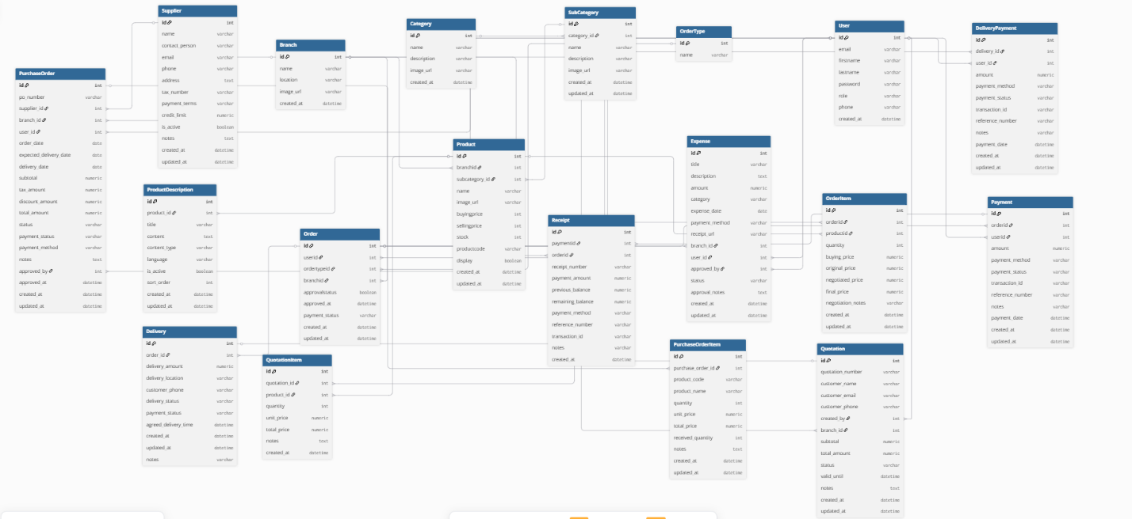

Figure 3:1 Proposed system's Entity Relationship Diagram

1. **Entities**:
2. **Users:** Users include salespersons, cashiers, and administrators. Each user has a username, email, password, and role. A single user can create many sales orders and provide multiple feedback entries.
3. **Branch:** Branches represent physical store locations. Each branch has a name, location, and operational status. One branch can be associated with several customers, but each customer belongs to only one branch.
4. **Customer:** Customers are individuals who purchase products from the system. Each customer has contact and demographic details and is linked to a single branch. A customer can have multiple purchase orders related to their buying history.
5. **Order:** This entity stores each sales order. Each order is tied to one user (who created the order) and one customer (who purchased the products). An order can include multiple products.
6. **Order Item:** This contains the details of each product in an order, including quantity, unit price, and total price. Each order can have multiple order items.
7. **Feedback:** Users can leave feedback about the sales system. Each feedback entry is associated with one user, and a single user may provide multiple feedback submissions.
8. **Relationships**:
9. **Users and Orders:** The relationship between users and orders is one-to-many. A single user (e.g., a salesperson or cashier) may create multiple sales orders across different sessions. However, each order is uniquely associated with just one user, ensuring accountability and proper tracking of sales activity.
10. **Users and Feedback:** The relationship between users and feedback entries is also one-to-many. Any user may submit several pieces of feedback, whether about technical issues or operational processes, but each feedback entry is tied to one user.
11. **Branches and Customers:** A one-to-many relationship exists between branches and customers. Each branch can register and manage multiple customers, but each customer is affiliated with only one branch to maintain data integrity and branch accountability.
12. **Customers and Orders:** Each customer can have multiple orders, reflecting real-world purchasing behavior where repeat or bulk purchases are common. However, each order is linked to one customer only, establishing a clear record of each transaction.
13. **Orders and Order Items:** Each order is associated with one or more order items. This one-to-many relationship ensures that each order can include multiple products, while each order item is tied to a specific order.
14. **Feedback System:** The feedback system connects back to the users, enabling an active feedback loop for system improvement. Each user may submit several feedback entries, but each feedback record points back to one user, creating a clear origin for all comments and evaluations.

### Methodology for System Implementation (Proposed System)

The methodology for system implementation of the Sales Management System involves a structured approach to developing the software solution using selected programming languages, frameworks, and technologies. The implementation phase transforms the theoretical designs and models developed in earlier stages into a fully functional system. This includes the careful selection of backend, frontend, and database technologies tailored to meet the specific requirements and objectives of the Sales Management System.

#### Frontend Development

The front-end interface for the Sales Management System will be developed using HTML, CSS, and JavaScript, providing a flexible and responsive platform for building a user-friendly web application. This technology stack is ideal due to its wide adoption, performance capabilities, and seamless integration with backend APIs that manage sales, inventory, orders, and payments.The primary goal of the front-end is to deliver an intuitive experience for salespersons, cashiers, branch managers, and administrators.

Visualization tools such as Chart.js, D3.js, or other JavaScript-based libraries will be employed to present graphs, charts, and key performance indicators, making data insights clear and actionable for decision-making. These tools will be particularly useful for creating admin dashboards that provide overviews of sales trends, stock movements, and financial summaries.

#### Backend Development

Server-Side Technologies: Python will be used for backend development due to its efficiency, scalability, and wide ecosystem of frameworks such as Flask or FastAPI. The backend will handle core business logic, database interactions, and API endpoints for managing sales, inventory, orders, and payments.Sales & Analytics Tools: The system will leverage Python libraries such as Pandas, NumPy, and SQLAlchemy to handle sales data processing, aggregation, and reporting. Additionally, tools like Plotly or Matplotlib can be integrated for generating visual analytics, trends, and dashboards.These technologies will be used to implement automated sales analysisThe server-side infrastructure ensures data integrity, secure processing of transactions, and timely reporting, providing a robust backend to support the sales operations across multiple branches.

#### Database Design and Setup

Database design is a critical aspect of system implementation, focusing on creating a robust and efficient database schema to store and manage sales data in the proposed system. Database Integration: For the backend, SQL databases such as PostgreSQL will be implemented. These databases offer robust support for complex queries, normalization, and ACID transactions, which are necessary for managing users, products, inventory, orders, payments, and invoices. PostgreSQL provides features like foreign keys to ensure data integrity and consistency across the system. The database schema, designed during the system design phase, will be implemented using PostgreSQL. The database will be structured with multiple tables reflecting the different components of the system. This structured approach ensures that data is normalized, reducing redundancy and maintaining data integrity, which is crucial for accurate sales reporting, inventory management, and decision-making.

#### Development Environment

The selection of development tools is crucial to ensure that developers can build, debug, test, and deploy the Sales Management System efficiently. Integrated Development Environment (IDE): Visual Studio Code (VS Code) is selected as the primary IDE due to its versatility, lightweight nature, and extensive support for different programming languages and frameworks. Version Control System: Git will be used for managing source code. Git allows developers to work on different features or bug fixes in separate branches and merge changes easily. It enables collaborative development by providing a mechanism to track changes, resolve conflicts, and maintain a history of updates. Integration with platforms like GitHub will be used to manage repositories. Additional Tools: For sales analytics, reporting, and dashboard development, tools like Jupyter Notebook or Google Colab can be optionally used for data analysis and visualization, enabling insights on sales trends, inventory levels, and customer behavior.

### Methodology for System Testing (Proposed System)

To ensure the Sales Management System is both reliable and effective, a detailed and structured testing methodology is crucial. The goal is to identify and rectify any potential issues throughout the system’s development lifecycle, ensuring the system meets its intended functionality, performance, and user requirements. The testing methodology involves a range of approaches, each tailored to specific components and aspects of the system, from unit testing of individual modules (such as product management, order processing, and payments) to system-wide validation of workflows like inventory management, sales reporting, and customer transactions. This structured testing ensures that the sales system operates accurately, maintains data integrity, and provides a seamless experience for users, including sales staff, cashiers, and administrators.

#### Testing Plan

The testing plan defines the scope, objectives, resources, and schedule for conducting system testing. It outlines the testing strategy, test coverage, roles and responsibilities of the testing team, and the criteria for evaluating test results. The plan identifies the following key types of testing to be performed:

1. **Functional Testing:** Verifying that all system functionalities, such as product management, order creation, inventory updates, payment processing, and report generation, work according to specifications.
2. **Usability Testing:** Ensuring that the system is user-friendly and intuitive for sales staff, cashiers, and administrators to interact with.
3. **Performance Testing:** Assessing how well the system performs under normal and peak sales conditions, including processing multiple orders, updating inventory, and generating reports.
4. **Security Testing:** Ensuring that the system is secure, particularly with regard to sensitive data such as customer details, payment information, and sales records.

#### Testing Techniques

Various testing techniques will be employed to validate different aspects of the proposed system This includes , Unit Testing ,Integration Testing, System Testing and User Acceptance Testing (UAT)

##### Unit Testing

Unit testing will be conducted to verify the integrity of individual components within the sales management system. Each module, whether it involves product management, order processing, payment handling, or inventory updates, will be thoroughly tested to ensure it functions correctly in isolation. This phase will utilize tools such as PyTest for Python-based backend components and Jest or Mocha for JavaScript frontend components, enabling detailed verification of code behavior and preventing the propagation of errors through the system.

##### Integration Testing

Integration testing will be performed to verify how different modules of the sales management system interact with each other, focusing on the flow of data between the front-end interface, backend services, and database. This phase will identify issues related to communication between UI elements, order processing, payment handling, and inventory management, ensuring that user inputs and system actions are processed accurately. Tools such as Postman will be used to validate APIs, testing the seamless exchange of data between the system’s components, including order creation, payment confirmation, and stock updates.

##### System Testing

System testing will assess the performance and behavior of the entire sales management system as a whole. It involves evaluating end-to-end functionality under realistic business scenarios, including typical sales workflows, multiple concurrent users, and network fluctuations. Load testing using tools like Apache JMeter will simulate high transaction volumes to test the system’s scalability, response times, and handling of large datasets, particularly important for ensuring smooth operation during peak sales periods or promotional campaigns.

##### User Acceptance Testing (UAT)

This phase will be carried out to ensure that the sales management system meets the end users’ requirements and expectations. Actual users, such as sales managers, cashiers, and administrative staff, will test the system to confirm its usability, accessibility, and effectiveness in handling sales transactions, inventory management, and reporting. Feedback from these users will be critical in fine-tuning the system, making necessary adjustments to the user interface, and verifying that all business workflows such as order processing, payments, and invoicing function as intended in real-world scenarios.

### Methodology for System Deployment

According to (Blokdyk, 2021), deploying the system effectively is paramount to ensure a smooth transition from development to operational use, while maximizing system reliability and user satisfaction. To ensure the sales management system is both reliable and effective, a detailed and structured testing methodology is crucial. The goal is to identify and rectify any potential issues throughout the system’s development lifecycle, ensuring the system meets its intended functionality, performance, and user requirements. The testing methodology involves a range of approaches, each tailored to specific components and aspects of the system, from unit testing individual modules to system-wide deployment validation, including sales transactions, inventory management, and reporting workflows.

#### Phased Deployment

Phased deployment will allow for controlled implementation, beginning with a small-scale pilot and expanding incrementally. This approach minimizes disruption and allows for testing under real-world conditions before full-scale adoption. Each phase will involve the introduction of core modules such as:

a) **Phase 1: Pilot Deployment** – The initial phase will involve deploying the sales management system in a limited environment, such as a single branch or department, to test sales transactions, inventory tracking, and order processing.

b) **Phase 2: Expansion Deployment** – Building on the success of the pilot phase, the system will be expanded to additional branches or stores, integrating customer management, invoicing, and reporting functionalities.

c) **Phase 3: Full-Scale Deployment** – Full deployment will include all modules across all locations, with complete integration of sales analytics, inventory management, payment processing, and automated report generation for business performance monitoring.

#### Data Migration Plan

The data migration plan is a vital component of deploying the Sales Management System (SMS). This process involves the structured and systematic transfer of data from existing sources, such as spreadsheets, legacy POS systems, or external sales databases, into the new centralized system. To ensure minimal disruption, maintain data integrity, and support a smooth transition to operational use, a **Trickle Data Migration** approach (as defined by Nyeint & Soe, 2019) will be employed. This method emphasizes incremental and continuous migration rather than bulk data movement, aligning with the phased deployment strategy.

This approach allows real-time validation, feedback, and correction at each step, reducing the risk of system overload or integration failures. The migration process will be conducted through a series of methodical stages:

1. **Data Identification** – Determine which sales, customer, product, and inventory data will be migrated.
2. **Data Extraction** – Collect data from existing sources such as spreadsheets, legacy systems, or databases.
3. **Data Cleaning** – Ensure accuracy, consistency, and completeness of records, correcting errors and resolving duplicates.
4. **Data Loading** – Incrementally transfer data into the new sales management system, validating at each step.
5. **User Training** – Educate staff on accessing and managing the migrated data within the new system, ensuring operational readiness.

##### Data Identification

In this initial phase, all relevant data sources, formats, and categories that will be used by the Sales Management System (SMS) are identified and catalogued. This is crucial for establishing the scope of the data migration and ensuring that no critical data is omitted.

**Key data elements to be identified include:**

1. **Customer Records:** Information about clients, including names, contact details, addresses, and purchase history.
2. **Product Information:** Catalog of products, including product codes, descriptions, pricing, stock levels, and categories.
3. **Sales Transactions:** Historical sales data including invoices, receipts, discounts applied, and payment methods.
4. **Supplier Data:** Information on vendors supplying products, including contact details, tax information, and payment terms.
5. **External Dataset Sources:** Any additional datasets or legacy system exports that will supplement the sales and inventory records.

**Objective:** Ensure a comprehensive inventory of all data inputs, supporting files, and metadata to be migrated into the new system, enabling accurate reporting, analytics, and operational continuity.

##### Data Extraction

Once the relevant data has been identified, the next step is data extraction. This process involves accessing and retrieving sales, customer, and product information from existing systems or external sources.

**i. Data Access:**

1. Data can be extracted from legacy systems, spreadsheets, CSV/Excel files, or external sales databases.
2. Tools like Python (using pandas) or ETL (Extract, Transform, Load) tools can be used to read and organize the datasets into structured data frames.
3. This approach ensures that customer records, product details, and sales transactions are consistently retrieved and ready for integration into the new SMS.

**ii. Data Storage:**

1. Extracted data will be stored in a centralized staging area or local database before migration.
2. Consistent naming conventions and structured directories will be maintained to preserve data integrity.
3. Organized storage ensures smooth retrieval for validation, reporting, and eventual import into the live Sales Management System.

##### Data Cleaning

Data cleaning is a vital step to prepare sales, customer, and product datasets before they can be used for analysis, reporting, or predictive modeling. This involves removing inconsistencies, handling missing or duplicate data, and standardizing the datasets for proper integration into the Sales Management System.

**i. Handling Missing Data:**

* Identify and fill in missing values in customer records, product details, or sales transactions.
* Use techniques like default values, interpolation, or consulting historical records to ensure completeness.

**ii. Data Standardization:**

* Normalize formats such as dates, currency, and product codes to ensure consistency across all records.
* Standardize customer names, addresses, and contact details to prevent duplication.

**iii. Data Transformation / Augmentation:**

* Combine related datasets, e.g., linking customer demographics with purchase history, to create enriched records for analysis.
* Generate derived fields like total purchase value, customer lifetime value, or product category summaries.
* This step helps ensure that data is complete, uniform, and ready for reporting, forecasting, or machine learning-based sales predictions.

##### Data Loading

After cleaning, the data is loaded into the SMS database.

**Steps:**

1. Import cleaned data into PostgreSQL or other chosen SQL-based databases.
2. Map fields accurately from legacy structures to the new system schema.
3. Validate records after import to ensure no loss of data and correct relationships between customers, products, and sales transactions.

##### User Training

To ensure smooth adoption of the SMS, users will be trained on the system and data handling practices.

**Training will include:**

1. Navigating the SMS interface and accessing reports.
2. Adding, updating, and managing customer, product, and sales records.
3. Understanding new data relationships and derived metrics.
4. Best practices for maintaining data quality and consistency.

**Objective:** Equip users with the knowledge to effectively use the system and maintain accurate data.

##### Post-Deployment Support

Post-deployment support is critical for maintaining the SMS functionality and ensuring business continuity. This phase involves continuous monitoring, updates, and assistance to ensure the system remains operational and that any issues are promptly addressed.

**Monitoring System Performance:**

1. After deployment, the system will be continuously monitored for performance, data integrity, and anomalies. Real-time sales data will be collected to track system health, identify potential issues, and ensure reports and analytics remain accurate.
2. Alerts will be configured to notify the support team of significant issues such as data inconsistencies, failed transactions, or unusual sales patterns that could impact decision-making.

**Regular Updates and Data Enhancements:**

1. System updates will be performed regularly to add new features, improve reporting capabilities, and incorporate user feedback.
2. New sales data, customer feedback, and product updates will be integrated into the system to ensure accurate forecasting, inventory management, and decision support. This continuous improvement helps maintain reliability, accuracy, and relevance for all business users.

**Objective:** Ensure that the SMS remains effective, responsive, and aligned with evolving business needs while providing a smooth user experience.

### Chapter Summary

In this chapter, we have outlined the detailed methodology for developing and deploying a Sales Management System (SMS), focusing on both theoretical and practical aspects of the project. We began with an exploration of the system architecture and the key tools required for sales tracking, reporting, and analytics. The methodology was organized into comprehensive stages, from data collection to deployment and post-deployment support. The chapter highlighted the importance of gathering accurate sales data, product information, and customer records to ensure reliable reporting and decision-making. We discussed the processes of data identification, extraction, and cleaning, ensuring that only high-quality and relevant sales and inventory data were included in the system. The methodology also addressed handling missing or inconsistent records, normalizing data formats, and managing metadata to improve reporting accuracy and analytics. Post-deployment support was emphasized as an ongoing process, including continuous monitoring of system performance, regular updates, and integration of new sales data to refine forecasts and inventory management. The ability to quickly address issues and maintain system reliability was highlighted as critical for business continuity and user satisfaction. By thoroughly addressing these elements, the chapter provided a roadmap for implementing a robust, data-driven Sales Management System that supports efficient operations and informed decision-making.

## SYSTEM ANALYSIS OF THE CURRENT SYSTEM

### Chapter introduction

This chapter provides a detailed analysis of the current sales management system used in the organization, where sales tracking, inventory updates, and reporting are conducted manually or with basic tools such as spreadsheets. It examines the traditional workflow in sales operations, highlighting the reliance on human effort for recording transactions, generating reports, and monitoring performance. The chapter identifies both the strengths and limitations of this manual approach, such as flexibility and simplicity versus inefficiency, errors, and difficulty in handling large datasets. A feasibility study is also included to assess the viability of transitioning from the current human-dependent process to a more efficient and automated Sales Management System. Furthermore, the chapter outlines the input, processing, and output of sales data within the current system, using visual models such as flowcharts, context diagrams, and data flow diagrams (DFDs) to illustrate the underlying logic, workflow, and information flow.

### Description of the Current Systems

The current approach to sales tracking and management in many organizations relies heavily on manual processes, standalone record-keeping tools, and non-integrated methods for monitoring inventory and transactions. Most sales data are recorded and analyzed individually by sales staff or managers, without the aid of automated systems to provide insights, trend analysis, or predictive analytics. These practices result in delays in reporting, human error, and limited accessibility to historical sales records, particularly in organizations with multiple branches or remote locations. Furthermore, there is no centralized system for tracking customer interactions, sales performance, or feedback on product success. This fragmented system affects the accuracy and timeliness of decision-making, limits opportunities for strategic sales planning, and creates barriers to collaborative management among sales teams.

#### System workflow

The workflow in the current sales management system follows a linear, disjointed process:

1. **Customer Interaction and Sales Recording:** Sales transactions are manually recorded by sales staff, often using spreadsheets, paper logs, or standalone point-of-sale devices. Sales data is stored locally on individual computers or transferred manually between devices.
2. **Sales Analysis:** Managers review sales records and customer interactions manually to generate insights or track performance. This process is time-consuming and subject to inconsistencies depending on the staff member’s experience and record-keeping accuracy. There is no automated system to provide predictive insights or performance metrics.
3. **Reporting and Documentation:** Sales reports are created manually and shared via email or printed documents. Reports are rarely integrated into a centralized system, making it difficult to maintain a unified view of overall sales performance.
4. **Data Storage and Follow-Up:** Historical sales data is often poorly organized and not easily retrievable. This creates challenges in monitoring customer trends, conducting follow-ups, or planning marketing strategies based on past sales performance.

This fragmented approach results in slow reporting, difficulty accessing historical data, and delayed decision-making in sales operations.

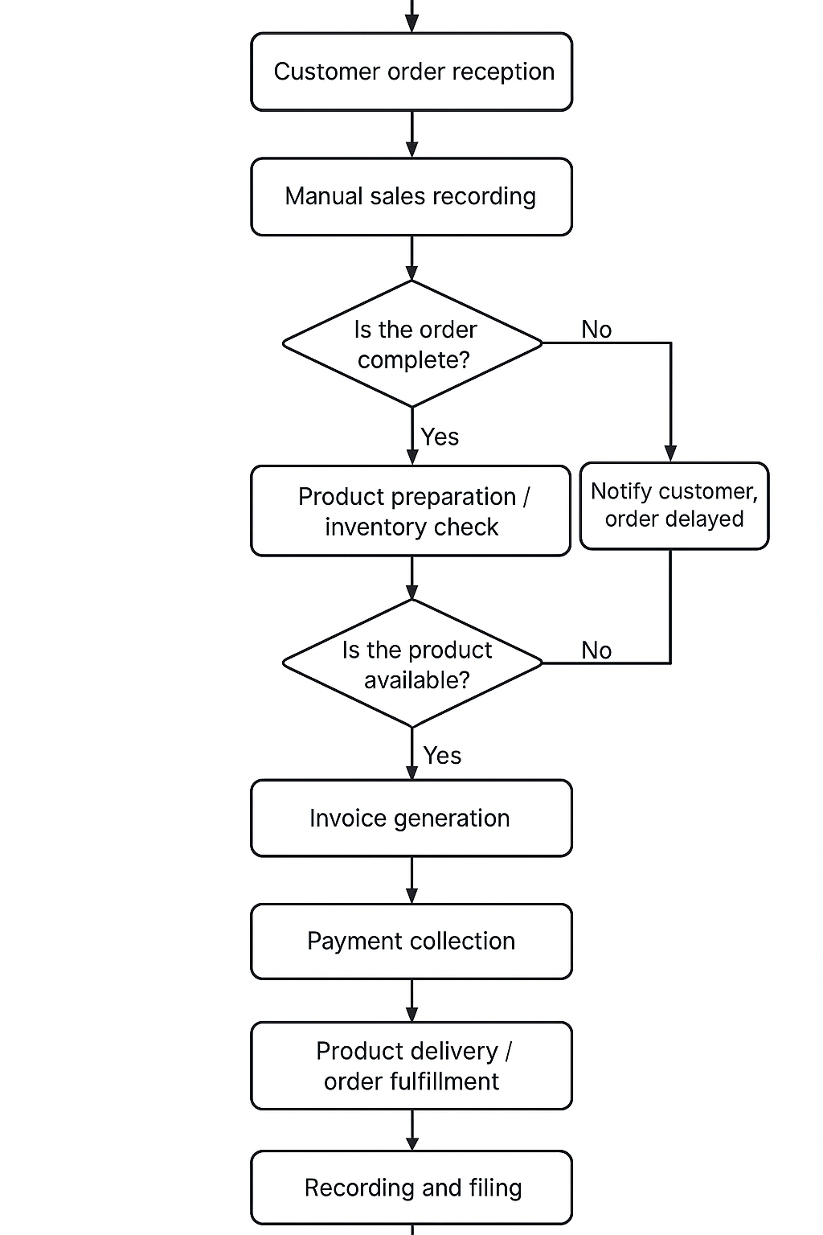

Figure 4:1 Activity Diagram Current System

#### Current System Use Case Diagram

The diagram below illustrates the interaction between key actors (Salespersons, Customers, and Managers) and the current manual sales management system:

1. **Customers** visit the business or contact sales representatives to inquire about products or make purchases, but do not have access to real-time order status or purchase history.
2. **Salespersons** record sales manually using paper forms or standalone spreadsheets, often without centralized data storage or linkage to customer profiles.
3. **Managers** review sales records manually and generate reports based solely on collected documents, without the support of automated analytics or dashboards.
4. **Manual Processes** (e.g., printed receipts, disconnected digital files, manual inventory updates) serve as the primary mode of communication and documentation, leading to delays, inaccuracies, and potential data loss.

This use case highlights the absence of an integrated system, real-time collaboration, or AI-assisted analytics, resulting in inefficiencies, inconsistent reporting, and slower decision-making.

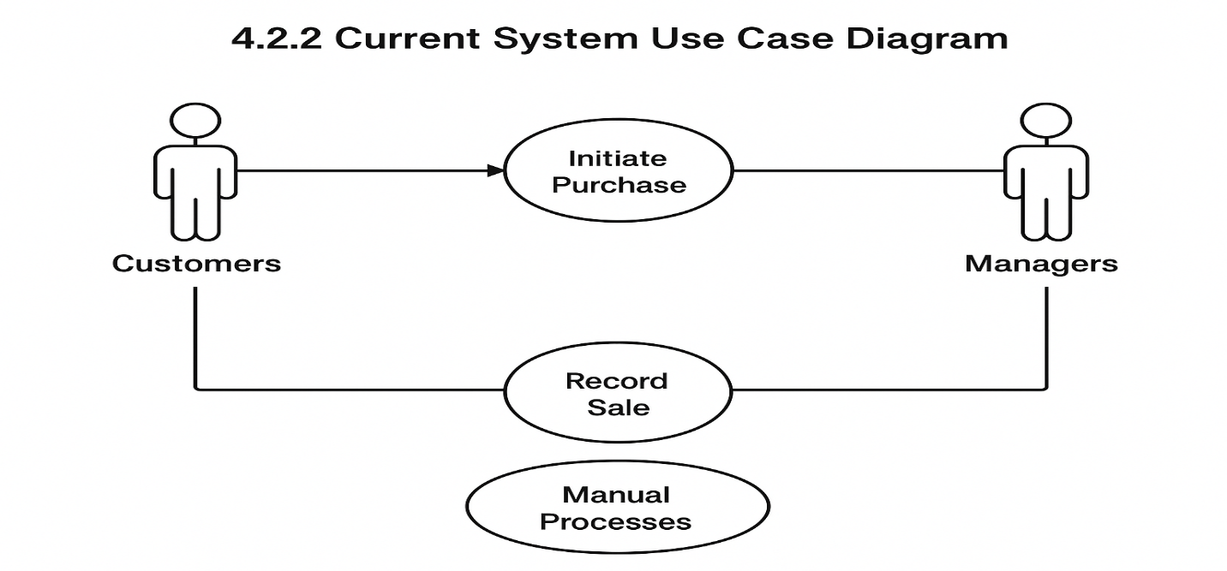

Figure 4:2 Use Diagram Current System

#### Current System Sequence Diagram

The current system's sequence diagram demonstrates how data flows between components such as order processing, inventory, and reporting in a manual sales management setup:

1. **Salespersons initiate the process** by taking customer orders manually using paper forms or spreadsheets.
2. **Orders are transferred manually** (e.g., via email, phone calls, or printouts) to the **warehouse or inventory team**, who check stock availability and prepare the items without automated stock tracking.
3. **Invoices and receipts are generated manually**—typed or handwritten—and shared with customers and accounting departments, often without a digital backup or centralized record.
4. **There is no feedback loop** between sales outcomes, stock levels, or customer preferences to inform future decisions, promotions, or inventory planning.
5. **All components operate independently**, with no central data repository, leading to fragmented records of customers, products, and transactions, and inefficiencies in collaborative decision-making.

This sequence diagram reflects the heavy reliance on human input, the lack of automation, and the absence of data integration, factors that limit the accuracy, speed, and scalability of the sales management process.

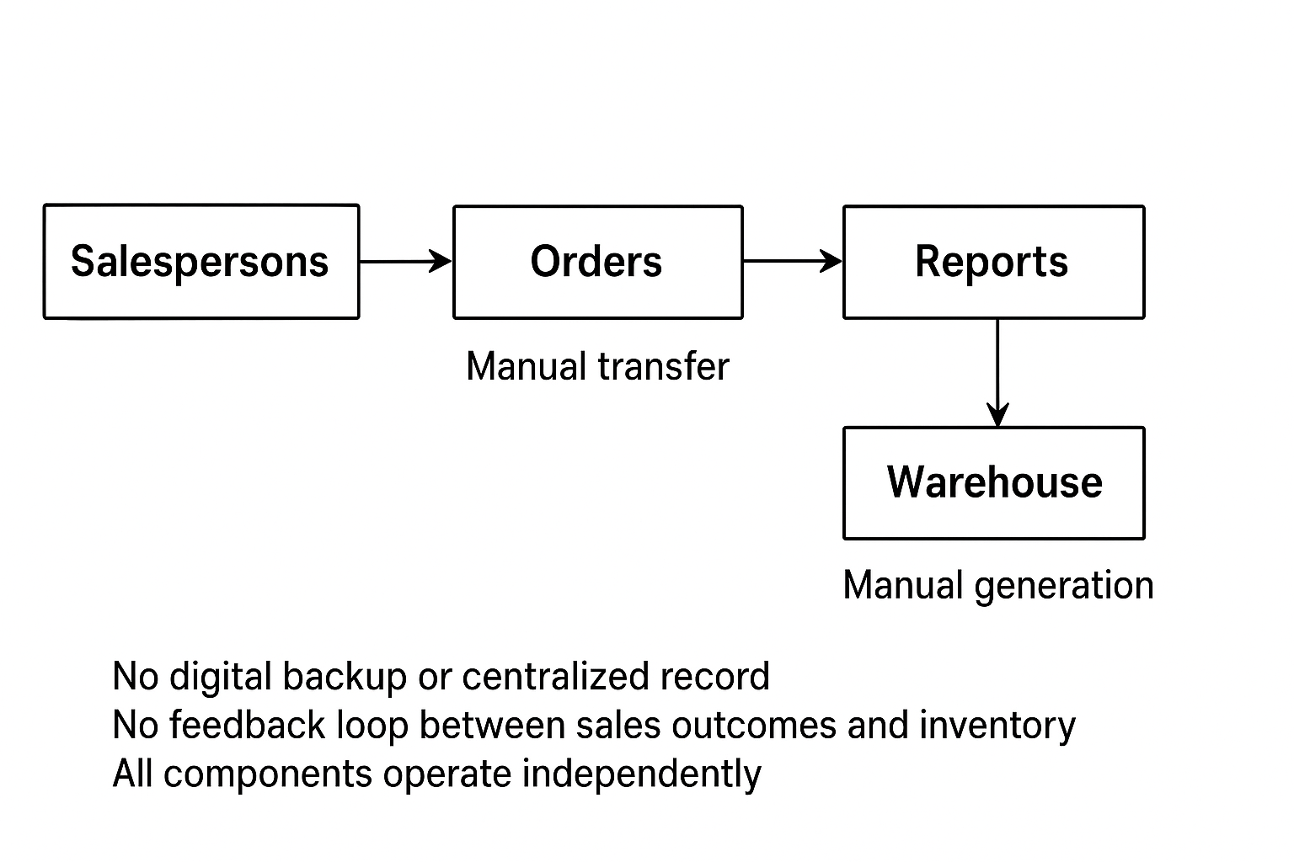

Figure 4:3 Sequence Diagram Current System

#### Strengths of Current system

1. **Expert Analysis:** Sales decisions and reporting in the current system are handled by experienced sales managers and analysts who have undergone extensive training in sales operations and market analysis. These professionals are skilled in interpreting sales data, identifying trends, and spotting anomalies in performance metrics such as product demand, regional sales variation, or customer purchasing behavior. Their expertise allows them to detect issues early, such as declining sales in key products or opportunities for upselling. Additionally, sales managers often collaborate with marketing, finance, and inventory teams, contributing to a multidisciplinary approach to business growth. This expert-led process ensures accurate, data-driven decision-making and strategic planning (Porter, 2019).
2. **Human Judgment:** Sales managers bring critical reasoning and contextual understanding to decision-making that goes beyond automated reports. They consider factors such as historical sales data, seasonal trends, customer feedback, competitor activities, and market dynamics. When analyzing sales performance, they evaluate nuanced characteristics including product profitability, customer retention rates, and sales pipeline health. These insights, combined with their practical experience, enable managers to make informed judgments on promotions, inventory replenishment, and resource allocation. This level of interpretive skill remains a key advantage over purely automated sales tools, which may not integrate complex contextual factors effectively (Kotler & Keller, 2020).
3. **Accessibility and Cost-Effectiveness:** The current sales system is relatively easy to use and cost-effective, allowing a wide range of businesses to implement it without heavy infrastructure. Unlike enterprise resource planning (ERP) systems that require significant investment, the sales management system can be deployed with minimal hardware requirements and low subscription costs. Its affordability and simplicity make it suitable for small and medium-sized enterprises (SMEs) and organizations in resource-limited regions, ensuring broader access to efficient sales tracking and reporting capabilities (Smith, 2021).
4. **Application in High-Volume or Niche Markets:** The system is particularly effective for monitoring high-volume sales environments or specialized market segments. It enables managers to track product performance and customer engagement in markets with fluctuating demand or niche customer bases. The system’s capability to generate detailed reports, monitor sales trends, and support personalized marketing strategies allows businesses to identify opportunities early and implement interventions tailored to specific customer needs, improving overall sales effectiveness and customer satisfaction (Johnson, 2022).

#### Weaknesses

1. **Time-Consuming:** Manual sales tracking and reporting require a significant amount of time, especially in businesses with high transaction volumes or multiple product lines. Each sale must be recorded, verified, and analyzed for factors such as customer details, product performance, and regional trends. When sales volumes are high, this can lead to operational bottlenecks, slowing down reporting cycles and delaying strategic decision-making (Smith, 2021).
2. **Subjective Interpretation:** Sales decisions often rely heavily on the judgment and experience of individual sales managers or staff. Variability in human decision-making—shaped by factors such as personal experience, workload, fatigue, and even stress—can result in inconsistent reporting and management of sales activities. This subjectivity makes it difficult to maintain uniform quality in decision-making across different branches or teams (Kotler & Keller, 2020).
3. **Delayed Results:** In many businesses, particularly those with limited resources or decentralized operations, there are delays not just in recording transactions, but also in generating sales reports or insights. These delays may arise from manual data entry, coordination issues between departments, or reliance on offline documentation. Managers often have to wait days or even weeks to obtain actionable insights, which can slow down inventory replenishment, marketing actions, and response to market trends (Porter, 2019).
4. **Potential for Human Error:** Despite the diligence of sales staff, errors in recording, reporting, or analyzing sales data are possible. Mistakes such as duplicate entries, misclassification of products, or misreporting revenue figures can occur, leading to flawed decision-making. Additionally, manual calculations and oversight may result in missed sales opportunities or inventory mismanagement, increasing the risk of financial loss and reduced customer satisfaction (Johnson, 2022).

Therefore, while manual sales management systems remain widely used and can be effective in small-scale operations, they are heavily reliant on human effort. This dependency creates challenges in ensuring consistency, scalability, and timely decision-making, especially in high-volume or resource-constrained business environments.

### Feasibility study

A feasibility study is an assessment used to determine whether a proposed solution is practical, achievable, and beneficial. It evaluates key factors such as technical requirements, cost implications, and operational fit within the current business environment. In this section, the feasibility of the proposed Sales Management System (SMS) is analyzed to assess its effectiveness and to justify the need for an advanced, automated system that improves sales tracking, reporting, and decision-making.

* **Technical Feasibility:** Numerous studies and industry practices demonstrate that automated sales management systems, powered by database-driven platforms or AI analytics, are highly effective in monitoring sales performance, predicting trends, and generating actionable insights. Modern CRM (Customer Relationship Management) tools and AI-powered analytics can provide accuracy and speed comparable to highly experienced sales managers, particularly when fed with comprehensive sales data. Cloud-based solutions, web applications, and mobile dashboards enable deployment even in businesses with limited technical resources, provided basic digital infrastructure, such as internet access and secure devices, is available.
* **Economic Feasibility:** From an economic standpoint, implementing an automated SMS is cost-effective in the long term. While there may be initial costs for software licenses, hardware, or staff training, the system reduces recurring manual effort, minimizes errors, and improves overall operational efficiency. Automated reporting and analytics can prevent revenue loss from overlooked sales opportunities, inventory mismanagement, or delayed market responses. Over time, these factors make the SMS economically sustainable, particularly for small and medium-sized enterprises or organizations seeking to scale operations without proportionally increasing personnel costs.
* **Operational Feasibility:** Operationally, the proposed system integrates seamlessly into structured sales workflows with adequate staff training and IT support. Automated systems can handle high transaction volumes, monitor regional or product-specific performance, and generate timely reports. In busy businesses, the system addresses major operational challenges, such as delayed reporting, inconsistent record-keeping, and resource bottlenecks. By improving the speed and accuracy of sales operations, the system enhances decision-making, inventory management, and customer satisfaction, enabling managers to focus on strategic initiatives rather than manual administrative tasks.

**Conclusion of Feasibility Study**

In conclusion, the proposed automated Sales Management System is technically viable and operational across diverse business conditions, providing the scalability, speed, and consistency needed to meet modern sales management demands. The reliance on automated analytics, centralized data management, and optimized workflows enhances its accessibility, efficiency, and accuracy. These advantages address key challenges in manual sales tracking, such as human error, delayed reporting, and inconsistent decision-making. Therefore, adopting an automated SMS is a feasible solution that improves sales performance, streamlines operations, and supports data-driven decision-making, particularly in high-volume or resource-constrained business environments.

### Requirements Analysis

The requirements analysis phase is crucial in the development of the proposed Sales Management System (SMS). The purpose of this phase is to understand and define the system's functionalities, performance expectations, user interactions, and data processing needs. This information was gathered through structured interviews with sales managers, staff, and administrative personnel. Additional data was collected using surveys, field observations, and reviews of current sales and reporting practices.

By synthesizing this information, both functional and non-functional requirements were identified to guide system design and development. Functional requirements include tasks such as sales tracking, inventory monitoring, report generation, and customer management. Non-functional requirements focus on system performance, scalability, usability, and data security. The overall goal is to enhance operational efficiency, improve decision-making, and ensure that sales teams and management can rely on the system for accurate, real-time insights that support business growth and strategic planning.

#### Functional Requirements

Functional requirements define what the system must do to meet its objectives. These are the specific operations, processes, and features necessary to support effective sales management:

1. **User Authentication and Role Management:** Users must be able to register, log in securely, and access the system based on assigned roles (e.g., Sales Staff, Sales Manager, Admin).
2. **Sales Data Entry and Management:** The system should allow for recording sales transactions, product details, and customer interactions. Data entry should be straightforward and support bulk imports or updates to ensure accuracy and efficiency.
3. **Analytics and Reporting Integration:** The core functionality involves processing sales data to generate insights, including performance metrics, sales trends, top-selling products, and regional performance. Advanced analytics or AI modules can help predict sales trends and opportunities.
4. **Report Generation:** The system should generate structured sales reports including transaction details, sales volume, revenue, customer segmentation, date, and actionable recommendations.
5. **Data Storage and Management:** All sales records, customer information, product details, and reports must be stored in a secure and organized manner, following data protection and business record management standards.
6. **Search and Filter Capabilities:** Admins and managers should be able to search and filter sales records based on product ID, customer, date, sales outcome, or region to support monitoring and decision-making.
7. **Feedback and Review Mechanism:** Sales managers should be able to review staff performance, provide feedback, and update targets. This data will support performance evaluation and future strategy adjustments.
8. **Administrative Dashboard:** Admin users should be able to monitor system usage, manage accounts, verify branch offices, track overall sales performance, and oversee user activity logs.
9. **Activity Logging:** All major system interactions should be recorded in activity logs for auditing and tracking system usage, especially in multi-user or high-volume sales environments.

#### Non-Functional Requirements

Non-functional requirements specify how the system should behave in terms of quality attributes like performance, reliability, usability, and maintainability:

1. **Usability:** Clean and intuitive interface: The system should be simple and easy to navigate, especially for users with little technical background (e.g., sales staff and managers).
2. **Responsive Design:** The web interface should adjust seamlessly to different devices, including desktop computers, tablets, and mobile phones.
3. **Performance:** Fast data processing: The system should generate sales reports, analytics, and dashboards in real-time or within a few seconds of query submission. Optimized backend: Data entry, retrieval, and analytics processes should be efficient to ensure minimal delay, even with large transaction volumes.
4. **Reliability:** Stable system behavior: The SMS must consistently perform as expected under normal usage conditions. Robust error handling: Handles invalid inputs, duplicate entries, or server issues without crashing. Informative feedback: Users are notified if operations fail (e.g., "Invalid product code," "Data upload failed").
5. **Scalability:** Supports growth in users and data: Designed to accommodate an increasing number of sales staff, customers, transactions, and product records over time. Efficient database structure: Databases (e.g., PostgreSQL or MySQL) should be normalized and optimized for fast queries even with large datasets.
6. **Security:** Password hashing: All user passwords must be securely encrypted before storage. Role-based access control: Different access levels for sales staff, managers, and admins. Session protection: Prevents session hijacking and unauthorized access. Email confirmation with secure tokens: Ensures users verify their identity before gaining system access.
7. **Feedback Support:** Clear system messages: Guides users with alerts, confirmations, and warnings (e.g., "Transaction recorded," "Target achieved"). Validation alerts: Users are informed if inputs are missing, incorrect, or unsupported (e.g., invalid customer ID or product code).

### System Analysis

#### System Workflow (activity diagram)

The proposed system will follow a user-centered workflow consistent with Object-Oriented System Analysis and Design (OOSAD) principles.

**User Login:** The system verifies credentials and assigns a role-based dashboard (e.g., Sales Staff, Sales Manager, Admin).

**Sales Record Creation:** A new sales transaction is created by entering metadata such as customer details, product information, quantity, and region.

**Data Entry / Upload:** The user records sales data manually or uploads bulk sales records from spreadsheets or CSV files.

**Processing and Analytics:** The system processes the sales data to calculate totals, generate key performance metrics, and run predictive analytics (e.g., forecasting sales trends, identifying top-selling products).

**Data Storage:** All sales records, computed metrics, and metadata are securely stored in the database for future reference and reporting.

**Report Generation:** The system generates detailed sales reports, dashboards, and visualizations for individual staff, teams, or overall organizational performance.

**Feedback Collection:** Managers can review staff performance, provide feedback, and set or update sales targets based on recorded data and analytics insights.

**Activity Logging:** The system logs all major actions, including data entry, report generation, and feedback submissions, to support auditing, accountability, and monitoring of system usage.

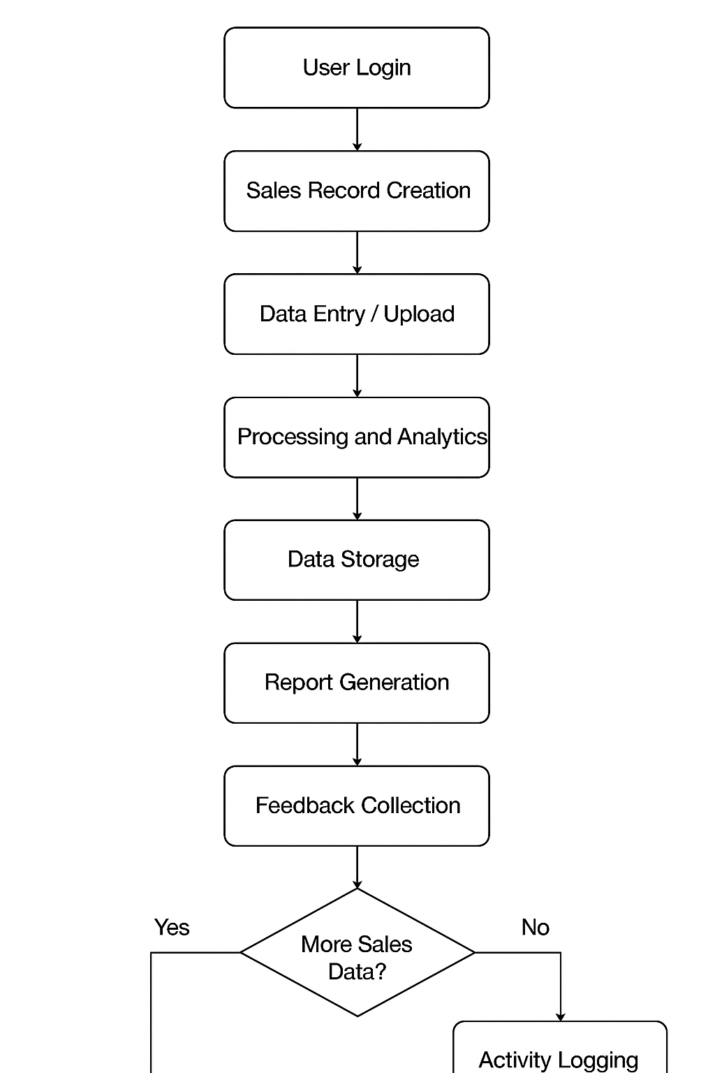

Figure 4:4 System Workflow Proposed System

#### Use Case Diagram

The use case diagram will illustrate the interactions between actors (Salesperson, Customer, Admin) and the system’s use cases such as:

1. **Add Product** – Admin adds new products to the system.
2. **View Products** – Salesperson and Customer can view available products.
3. **Place Order** – Customer places an order for selected products.
4. **Generate Invoice** – Salesperson generates an invoice for a customer order.
5. **Manage Inventory** – Admin updates stock levels and tracks inventory.
6. **View Sales Reports** – Admin and Salesperson can view reports on sales performance.

This diagram will emphasize the roles and responsibilities of each actor in the sales management process, showing how customers interact with products, salespeople process orders, and admins manage the system.

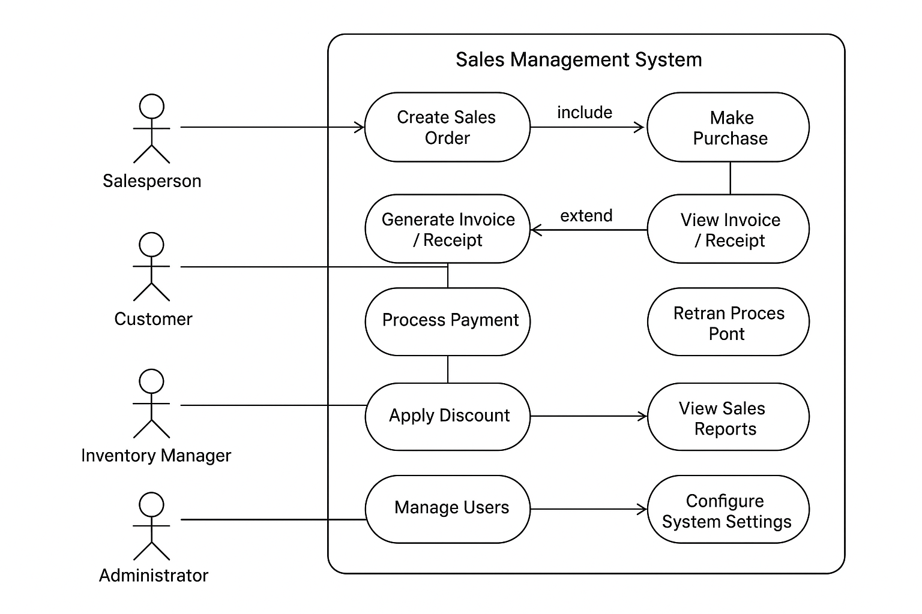

Figure 4:5 Use Case Diagram Proposed System

#### Sequence Diagram

The sequence diagram will model the interaction flow for key processes in the sales management system such as ‘place order’ or ‘generate invoice’. It will illustrate object lifelines and the dynamic behavior of the system, showing how different components interact over time.

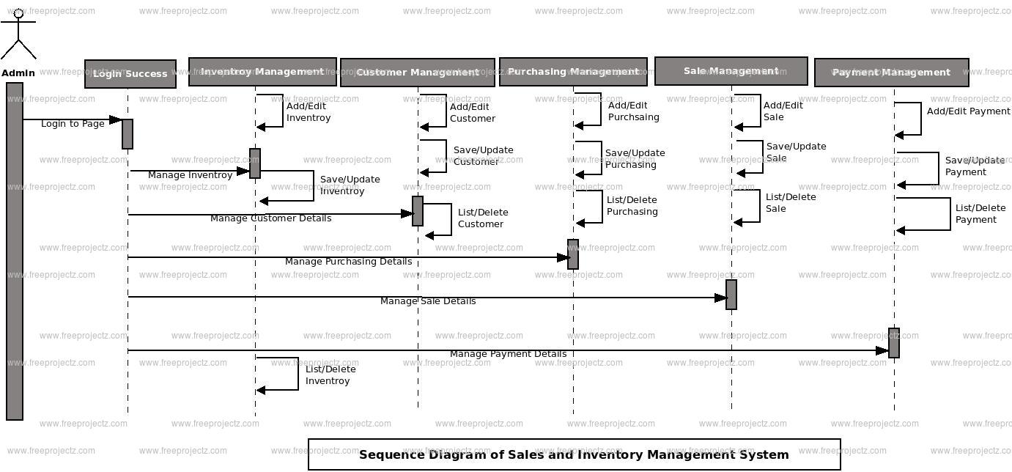

Figure 4:6 Sequence Diagram Proposed System

#### State Diagram

This state diagram models the lifecycle of an **order** in the Sales Management System, showing its progression from creation to completion. The diagram captures all possible states and transitions, including error handling paths (e.g., payment failure, out-of-stock items), while ensuring every order terminates in the **Completed** or **Cancelled** state for proper record-keeping. This visualization clarifies system behavior and user interaction points throughout the order processing workflow.

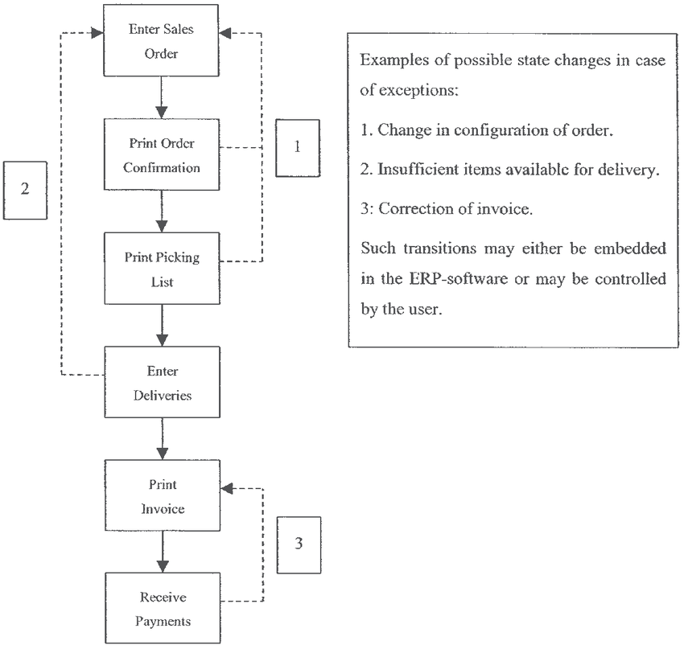

Figure 4:7 State Diagram Proposed System

**4.6 System Users / Actors**

i. **Customer:** Browses products, places orders, and provides feedback.  
ii. **Salesperson:** Processes orders, generates invoices, and assists customers.  
iii. **Admin:** Manages products, monitors sales activity, manages users, and generates sales reports.  
iv. **System Modules:** Inventory, Order Management, and Notification modules that handle order processing, stock updates, and communication.  
v. **Inputs:** Customer orders, product details, payments, and user actions.  
vi. **Outputs:** Order confirmations, invoices, stock updates, and sales reports.

### Data Structuring

Normalization is the process of organizing data in a database to minimize redundancy and improve data integrity. In relational databases like PostgreSQL, we apply formal normalization techniques (1NF, 2NF, 3NF) to structure data into well-defined tables with proper relationships.

For the Sales Management System, we've designed a normalized schema that separates data into distinct tables while maintaining referential integrity through foreign key relationships. Unlike NoSQL approaches that may de-normalize for performance, our PostgreSQL implementation carefully balances normalization principles with practical query efficiency.

The database structure divides information into logical entities including Users, Customers, Products, Orders, Payments, and Sales Reports, each following relational database best practices to ensure data consistency while supporting efficient joins and transactions. This structure ensures accurate tracking of sales activities, inventory management, and customer interactions.

1. **First Normal Form Compliance**

The database design of the Sales Management System strictly adheres to First Normal Form (1NF) requirements. Every table possesses an explicit, single-column primary key, typically an auto-incrementing integer, which uniquely identifies each record and ensures efficient indexing. All attributes in every table contain atomic values, meaning each field stores only a single piece of information. For example, customer names are separated into first and last name fields, and address information is decomposed into street, city, state, and postal code components. The design eliminates repeating groups entirely, representing one-to-many relationships through proper foreign key references. Instead of storing multiple products in a single field, each product in an order is recorded as a separate entry in an OrderDetails table linked to the parent order. Similarly, customer feedback and payment transactions are stored as discrete records associated with their respective entities. By avoiding arrays or comma-separated values and creating additional tables to maintain relationships, the system ensures full 1NF compliance, supporting data integrity, efficient querying, and scalable growth.

1. **Second Normal Form Compliance**

Achieving Second Normal Form (2NF) required a careful analysis of all functional dependencies within the Sales Management System data model. In each table, every non-key attribute depends on the entire primary key, not just a part of it. This is especially important in tables representing transactional data, such as orders or order items, where each attribute must relate completely to the identified record. The schema separates entities that might have partial dependencies into distinct tables. For example, product information exists independently from orders, with each order item referencing its associated product through a foreign key rather than storing product details directly. Similarly, user roles are represented as attributes in the Users table rather than as separate records, since they depend entirely on the user identity. By ensuring that all non-key attributes fully depend on their table’s primary key, the system maintains data integrity and reduces redundancy while supporting accurate and efficient transactional processing.

.

1. **Third Normal Form Compliance**

The database design of the Sales Management System satisfies Third Normal Form (3NF) by systematically eliminating transitive dependencies between non-key attributes. In practice, this means that values that could be derived from other fields are either calculated at runtime or linked through relationships rather than stored redundantly. For example, the total price of an order is calculated from the unit prices and quantities of the order items instead of being stored separately in the Orders table. Reference data, such as product categories, payment methods, and shipping details, exists in dedicated tables with their own primary keys, and other entities reference this information through foreign key relationships. This approach ensures that data like customer membership levels or product metadata is maintained in a single location rather than duplicated across multiple tables. By adhering to 3NF principles, the system minimizes redundancy, preserves data integrity, and supports efficient updates and queries across all aspects of sales, inventory, and customer management.

#### Relationship Management and Integrity

The database implements several types of relationships to maintain its normalized structure while preserving all necessary connections between entities. One-to-many relationships, such as those between orders and order items, are implemented through foreign keys in the "many" tables that reference the primary key in the "one" table. These relationships include proper constraints to ensure referential integrity at the database level, not just in the application code. One-to-one relationships, like those between an order and its payment record, use the same foreign key mechanism but with additional uniqueness constraints to enforce the singular nature of the relationship. Many-to-many relationships, such as those between products and categories or customers and promotional offers, are implemented through junction tables containing composite keys. All relationships enforce referential integrity through explicit foreign key constraints with appropriate cascading rules. For instance, deleting a product from the catalog might set relevant foreign keys in order history to null rather than cascade, preserving historical order records while disassociating them from the removed product. These rules are carefully designed to maintain data integrity across all sales and inventory scenarios.

|  |  |  |
| --- | --- | --- |
| **Normalization Aspect** | **Implementation in ABZ Hardware Sales Management System** | **Benefit** |
| First Normal Form (1NF) | - Atomic values in all fields -No repeating groups - Unique primary keys for all tables | Eliminates data duplication, ensures each field contains smallest meaningful data |
| Second Normal Form (2NF) | - All non-key attributes fully depend on primary keys  - Separate tables for transactional vs reference data | Prevents partial dependencies, maintains data relationships |
| Third Normal Form (3NF) | - No transitive dependencies - Reference data in independent tables -Single-source-of-truth attributes | Eliminates update anomalies, simplifies data maintenance |
| Entity Relationships | - Proper foreign key constraints - Cascade rules for integrity - Clear 1:1, 1:many relationships | Maintains referential integrity across all hardware data |

Table 4‑1 Entities

### Chapter Summary

This chapter presented a comprehensive system analysis of the existing challenges in sales management, particularly those associated with manual order processing, inventory tracking, and customer management. It identified the limitations of traditional approaches, including delayed order fulfillment, inconsistent inventory records, and difficulty in generating timely sales reports. The proposed web-based Sales Management System addresses these limitations by integrating a user-centered platform for streamlined order processing, inventory management, and reporting. A feasibility study was conducted, evaluating the system across operational, technical, economic, and social dimensions. The findings confirmed that the solution is practical, scalable, and capable of supporting businesses of varying sizes. System requirements were gathered through interactions with key stakeholders, including sales personnel, managers, and customers. From this engagement, both functional requirements (such as product management, order processing, invoice generation, and user management) and non-functional requirements (including security, responsiveness, scalability, and usability) were established. In line with Object-Oriented System Analysis and Design (OOSAD) methodology, the system's behavior and structure were modeled using use case diagrams, activity diagrams, and sequence diagrams. These models provided a clear understanding of system flow, user interactions, and data processing. Furthermore, the data design was grounded in relational database principles using PostgreSQL. The system structure was normalized to eliminate redundancy and improve consistency, ensuring that entity relationships, such as users, products, orders, payments, and sales activities, are efficiently organized and enforce referential integrity. The next chapter will focus on the detailed system design and implementation strategy.

## SYSTEM DESIGN OF THE PROPOSED SYSTEM

### Introduction

This chapter presents the design and system architecture of the proposed Sales Management System, a web-based platform aimed at streamlining order processing, inventory management, and customer interactions. The system addresses the limitations found in traditional manual sales management processes, such as delays in order fulfillment, inconsistent inventory records, and difficulty in generating timely sales reports, by introducing a more consistent, scalable, and intelligent solution. Through the use of structured product data, order tracking, and automated reporting, the system aims to improve operational efficiency and accuracy across sales activities. The goal is not to replace sales personnel but to serve as a decision-support and management tool that enhances productivity, reduces errors, and enables timely insights for both small and large businesses. This chapter provides a comprehensive breakdown of the proposed system’s strengths and weaknesses, an analysis of user and system requirements (functional and non-functional), and the overall conceptual architecture. It also illustrates the process logic through diagrams such as use case, activity, sequence, class diagrams, data flow diagrams (DFDs), and flowcharts. Additionally, it covers the database design, including the entity relationship diagram (ERD), normalization, and data dictionary, and showcases mock-up screens to demonstrate the system’s user interface and expected outputs. Overall, this chapter serves as the foundation for understanding how the proposed Sales Management System is structured and how it aims to improve the efficiency, accuracy, and accessibility of sales and inventory management.

### User Interface Design

The User Interface (UI) is a web-based frontend developed using HTML, CSS, and JavaScript. The UI is designed to be user-friendly and intuitive, providing clearly labeled pages for users to interact with the system. It consists of the following key sections:

* **Login and Signup pages:** Securely authenticate users before they access the platform.
* **Homepage:** Welcomes users and provides navigation to various features.
* **Product Catalog:** Allows customers to browse available products with search and filter options.
* **Order Page:** Enables customers to place orders, select quantities, and review cart items.
* **Payment Page:** Facilitates secure payment processing and confirmation.
* **Feedback Page:** Collects customer input on their experience with products and services.

For administrators, the UI includes:

* **Dashboard:** Provides a visual overview of system activity, including sales, orders, and inventory status.
* **Products Page:** Allows management of products, categories, and stock levels.
* **Orders Page:** Displays all customer orders with status tracking and updates.
* **Users Page:** Shows all registered users and their activity.
* **Feedback Management:** Allows review and moderation of submitted customer feedback.

The frontend ensures ease of use and accessibility for both customers and administrative staff, supporting usability and human-centered design principles (Krug, 2014).

#### Input Form Design

The system provides sales personnel with a clean and responsive interface to manage customer orders and input key order information, such as product selection, quantities, and delivery details. Admin users have additional forms to manage product catalogs, user accounts, inventory levels, and overall system configurations.

* 1. Login Form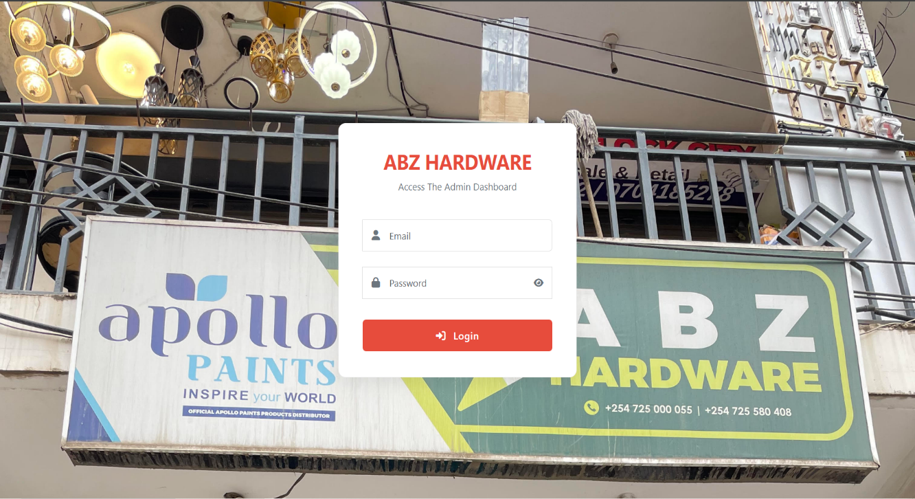

Figure 5:1 Login screen

* 1. User Registration Form

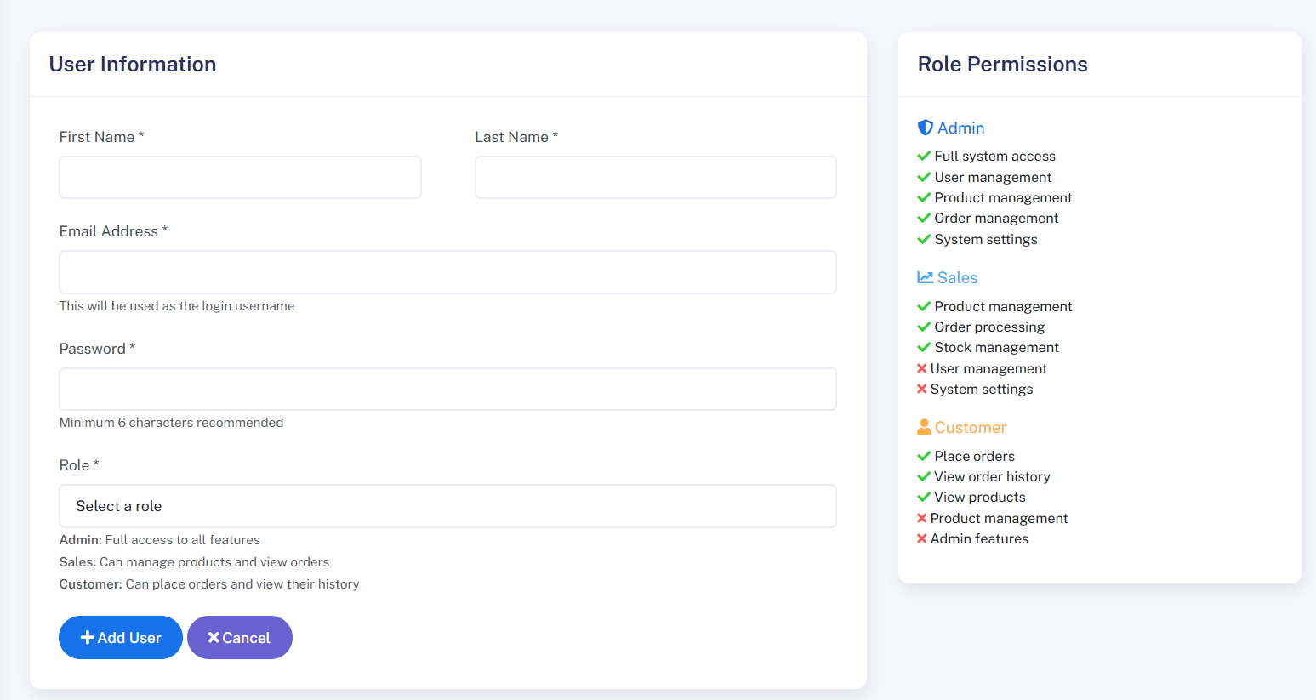

Figure 5:2 User Sign Up Screen

* 1. Upload Product form

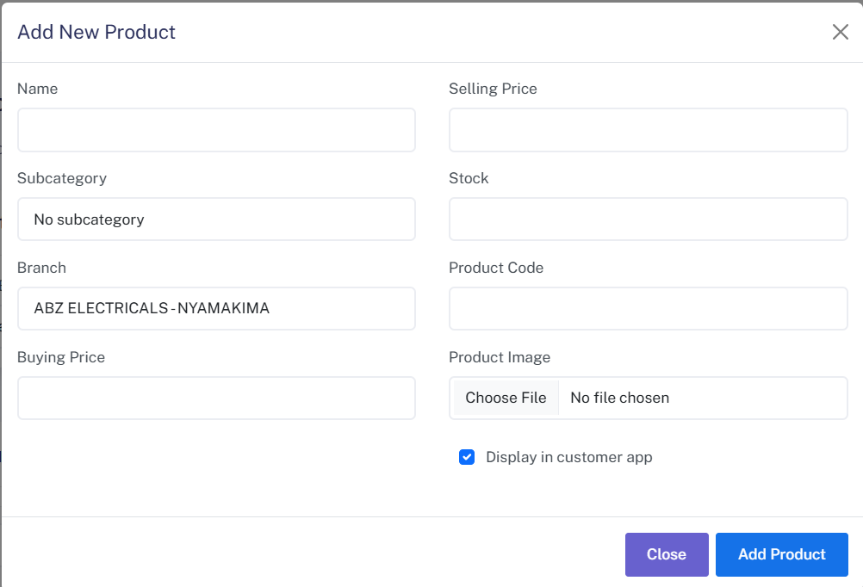

Figure 5:3 Upload Product Form

#### Report Design

The system automatically generates **order and sales reports** after transactions are processed. These reports include customer identifiers, order details, payment status, and timestamps. Admins and sales personnel can view, export, or print the reports for record-keeping, auditing, and business analysis.

1. Order Report

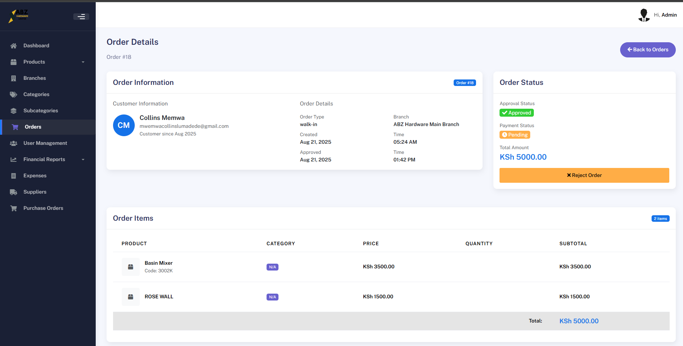

Figure 5:4 Order Report

### Process Design

Requirement analysis is a foundational phase in system development that involves identifying, and documenting the necessary functions and constraints of a system to meet the expectations of stakeholders. According to Sommerville (2011), this process ensures that the final product aligns with user needs, technical feasibility, and business goals. For the proposed ABZ Hardware Sales Management System, which leverages ultrasound imaging and machine learning, requirement analysis is categorized into four key dimensions: functional, non-functional, user, and usability requirements.

#### Authentication Process

The authentication process verifies user credentials before granting access to system features. Only authorized cashier and admin users can access specific modules.

1. **Activity Diagram:** Displays steps from login form submission to role verification and redirection. User inputs credentials, system verifies against the Postgres SQL database, upon successful login, user is directed to their dashboard if login fails, an error message is returned. First, it checks the users table for a matching email or username. If found, the stored hashed password (secured using PostgreSQL's pgcrypto extension) is compared with the provided password. If authentication succeeds, the system retrieves the user’s role (e.g., admin, or cashier) from the database and redirects them to the appropriate dashboard. If authentication fails, either due to incorrect credentials an error message is displayed.

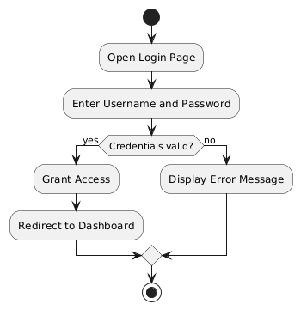

Figure 5:5 Authentication Process Activity Diagram

1. **Sequence Diagram:** Shows the interaction between the user, login form, and user database.

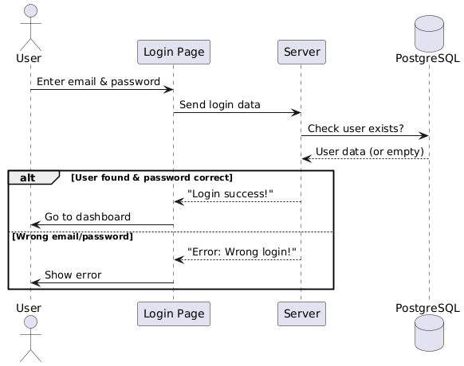

Figure 5:6 Authentication Process Sequence Diagram

#### User Registration Process

The user registration process allows new customers, sales personnel, or administrative users to create an account within the system. Users are required to provide essential details such as username, email, and password. The system validates the entered information to ensure accuracy and uniqueness (e.g., checking for duplicate emails). Once validated, the details are stored in the database, and the user is redirected to the login page. This process ensures that only authorized individuals can access the platform’s features, such as placing orders, managing products, or processing transactions.

1. **Activity Diagram:** Describes the flow from user inputs details (name, email, password), System checks for email uniqueness, upon validation, account is created in Postgres SQL User Table, Confirmation screen is shown to user.

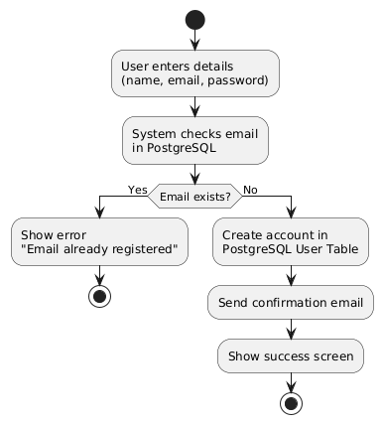

Figure 5:7 User Registration Process Activity Diagram

1. **Sequence Diagram:** Illustrates interactions for new user sign-up, validation, and role assignment.

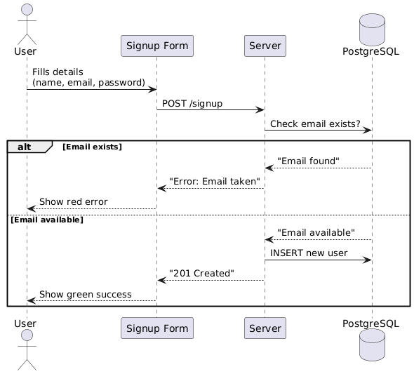

Figure 5:8 User Registration Process Sequence Diagram

#### Add Products Process

Once authenticated, administrators or sales personnel can add new products to the system. The user enters product details such as name, description, price, category, and stock quantity. The system validates the input to ensure completeness and correctness, then stores the product information in the database. Once added, the product becomes available in the catalog for customers to view and purchase.

1. **Activity Diagram:** Displays the flow of adding and managing products. The user (administrator or sales personnel) enters product details, including name, category, price, and stock quantity. The product information is then submitted to the server and stored in the database. Once saved, the product becomes available in the catalog for customers to view. The system confirms successful addition, and the user receives feedback on the operation’s status.

Figure 5:9 Image Upload and Analysis Process Activity Diagram

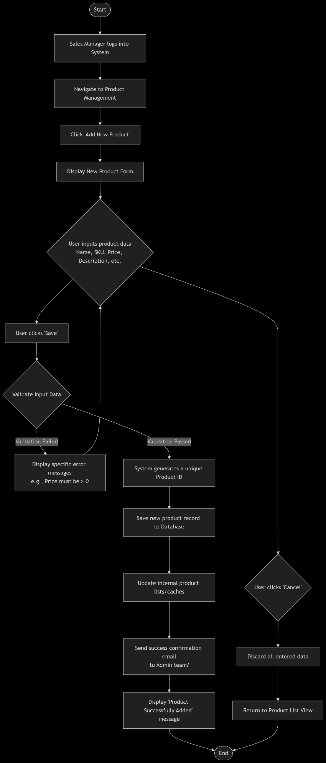

1. **Sequence Diagram**: Captures the image upload process when the user uploads the image for analysis.

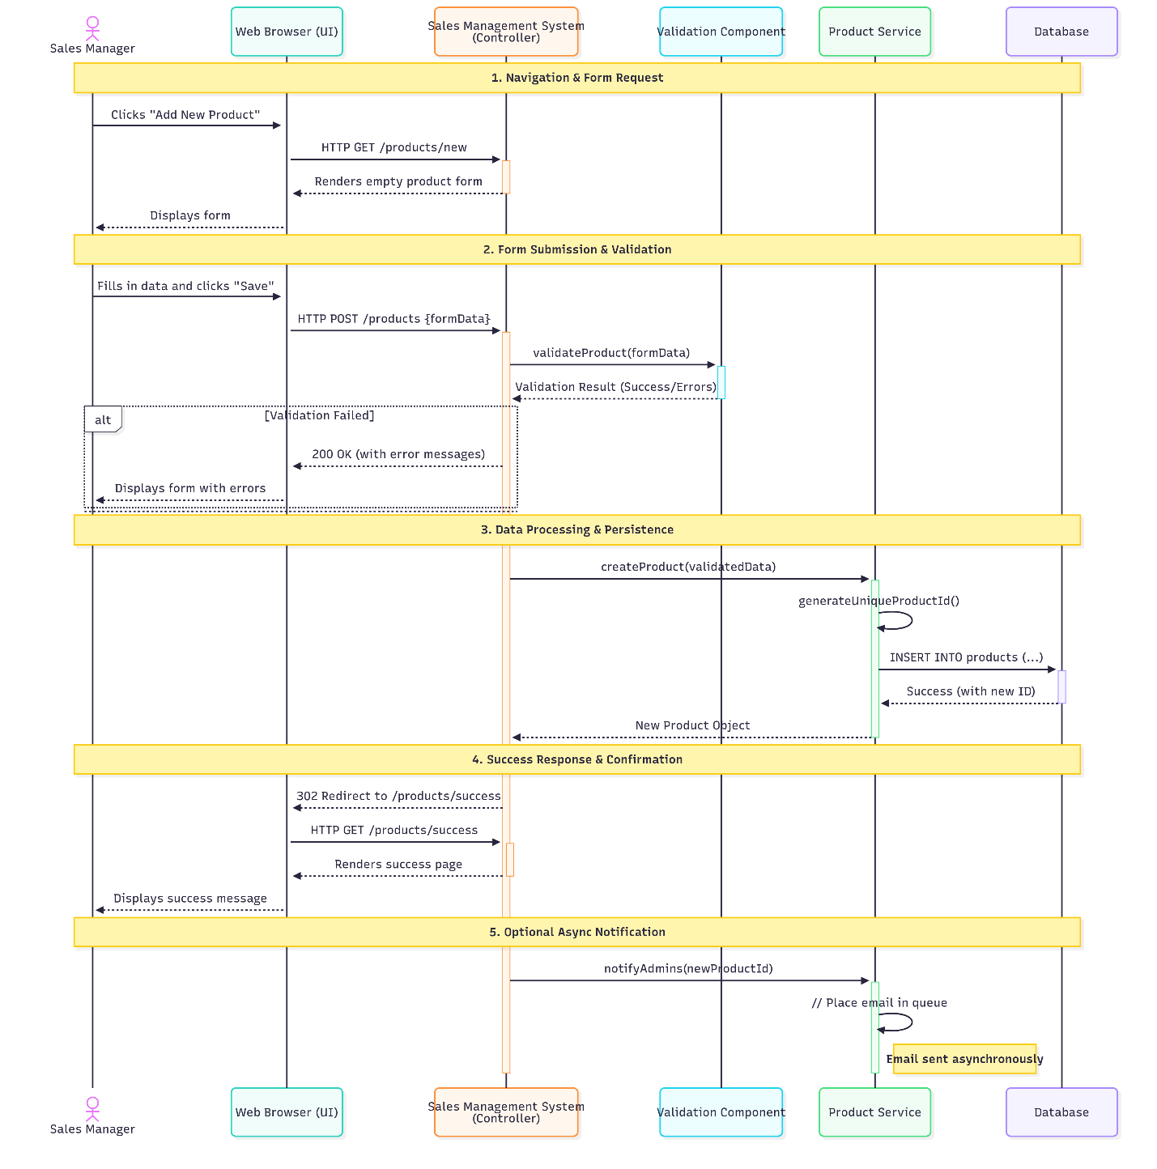

Figure 5:10 Product insertion sequence diagram

#### Report Generation and Storage

Following the completion of transactions, the system automatically generates a detailed sales report based on order and payment data. The report includes key information such as customer details, purchased products, quantities, total costs, payment status, and timestamps. Once generated, the report is securely stored in the database, ensuring it can be retrieved, viewed, or exported by authorized users such as administrators or sales personnel for record-keeping, auditing, and decision-making.

1. **Activity Diagram**: This activity diagram shows the report generation workflow after a sales transaction. The system first creates a sales report containing customer details, purchased products, payment information, and timestamps. The report is then saved to the PostgreSQL database. Finally, the administrator or salesperson can either download the report as a PDF for record-keeping or review it directly within the system’s interface.

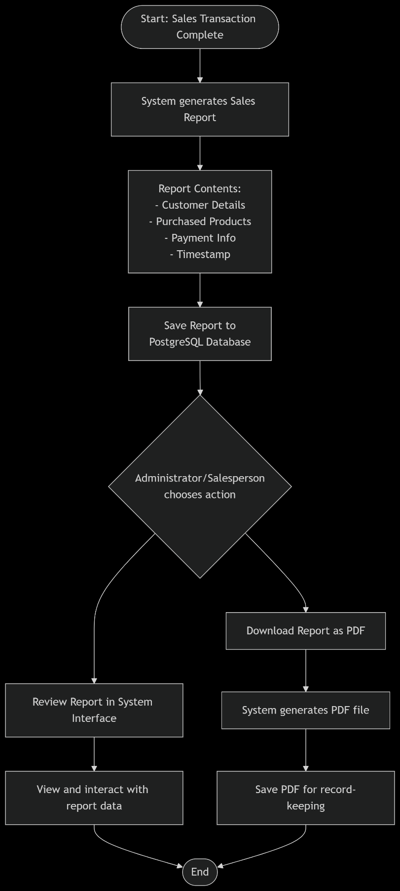

Figure 5:11 Report generation and storage Process Activity Diagram

1. **Sequence Diagram**: This sequence diagram illustrates how the system generates and delivers sales reports. After a transaction is completed, the server compiles the order and payment details into a structured sales report. The report is then stored securely in the PostgreSQL database. The administrator or salesperson can then access the report and choose to either download it as a PDF (triggering a file download) or review it directly within the system’s interface.

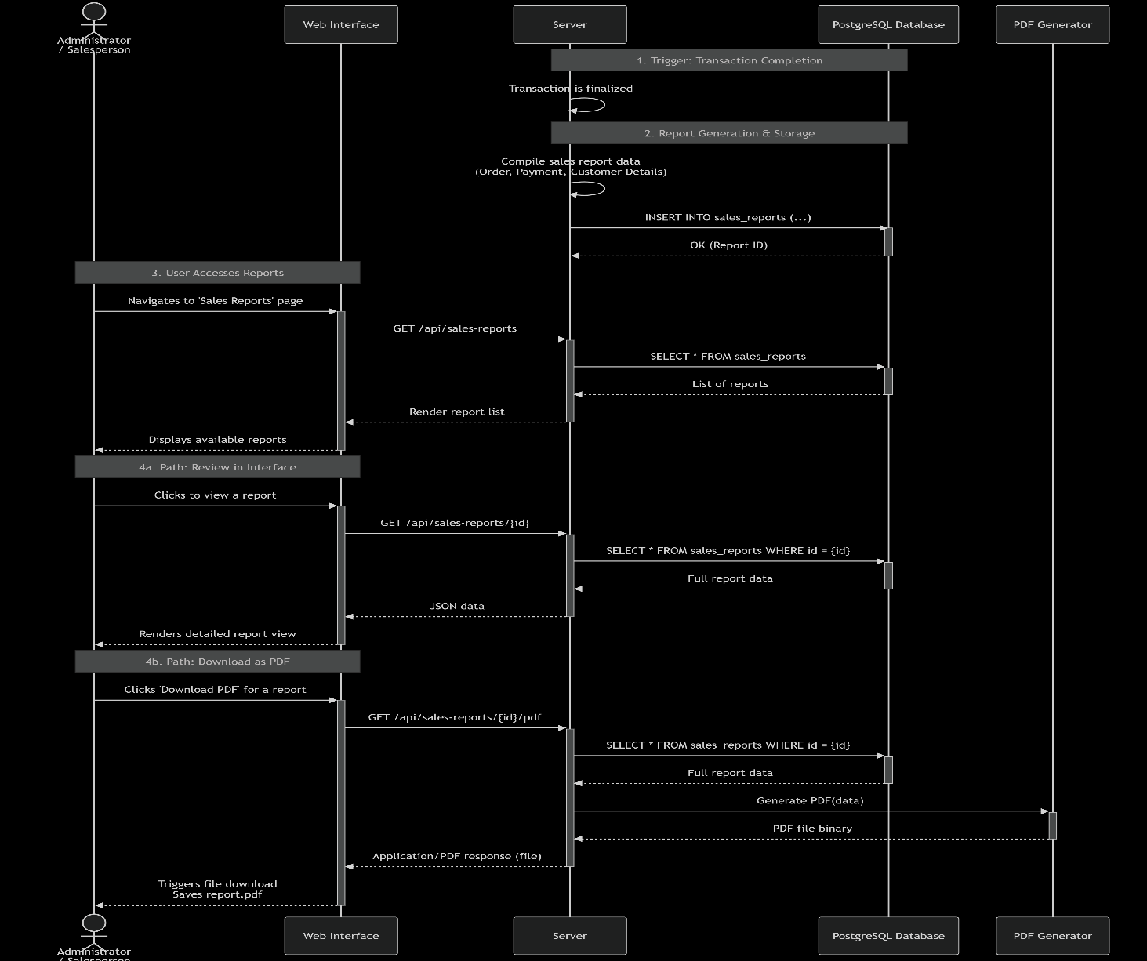

Figure 5:12 Report generation and storage Process Sequence Diagram

### Database Design: ER, Normalization and Data dictionary

This section elaborates on the database design strategy adopted for the proposed Sales Management System. A well-structured database is central to ensuring data accuracy, consistency, and fast access, all of which are critical for managing sales transactions, inventory, customers, and payments. The system utilizes a relational database model powered by PostgreSQL, managed through Flask-SQLAlchemy ORM. This architecture ensures seamless communication between the Python application logic and the database while maintaining high levels of integrity, scalability, and security. PostgreSQL is a robust, open-source relational database system known for its reliability, advanced features, and strong support for complex queries, constraints, and indexing. Its ability to enforce data integrity and handle large volumes of transactions makes it an ideal choice for sales and inventory management. SQLAlchemy acts as a powerful SQL toolkit and Object Relational Mapper (ORM) for Python, enabling developers to interact with PostgreSQL using Python classes and methods instead of writing raw SQL queries. This approach improves maintainability, enhances security, and accelerates development while providing full control over database relationships and queries. Unlike setups that rely on external migration tools, database schema changes in this system are managed manually within PostgreSQL and SQLAlchemy models. This approach ensures flexibility, allowing the database structure to evolve with business needs while still maintaining strict data integrity and preserving historical records.

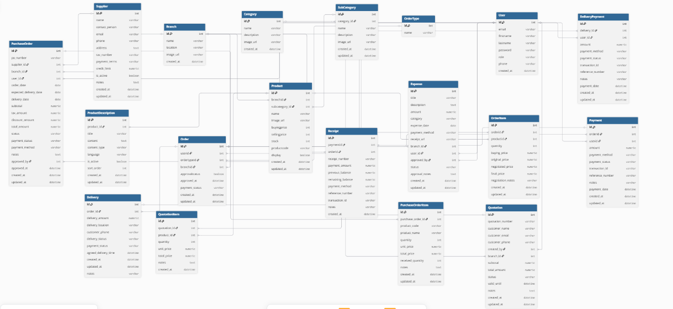

Figure 5:13 Database Design

#### Entity Relationship (ER) Diagram

The database is designed around four key entities: **Users, Products, Orders, and Payments**. These entities correspond to the primary components and processes of the system and interact through well-defined relationships:

1. **Users:** Represents customers, sales personnel, and administrators. Each user has attributes such as name, email, password, and role, which determine their level of access within the system.
2. **Products:** Stores details about items available for sale, including product name, description, price, category, and stock quantity.
3. **Orders:** Represents customer purchases. Each order is linked to a user (customer) and contains details such as order date, status, and total amount. Orders are further linked to multiple products through an order-items relationship.
4. **Payments:** Stores payment details associated with each order, including payment method, amount paid, status, and timestamp.

#### Normalization

To avoid redundancy, improve storage efficiency, and enhance data integrity, the database design follows three levels of normalization:

**i. First Normal Form (1NF):**

1NF ensures that all data is stored in atomic form, where each cell contains only a single value. No repeating groups or arrays are allowed. In the system, fields such as username, email, and product_name store atomic values. Primary keys such as id uniquely identify each record, and no repeated columns like product1, product2 exist. Instead, a separate OrderItems table manages multiple products within a single order.

**ii. Second Normal Form (2NF):**

2NF removes partial dependencies, ensuring that non-key attributes are fully dependent on the entire primary key. In the system, all tables use a single-column primary key (id), and attributes such as order_date, total_amount, and payment_status rely solely on the primary key of their respective tables. For example, order details depend entirely on the order_id and not on just part of a composite key.

**iii. Third Normal Form (3NF):**

3NF eliminates transitive dependencies, ensuring that non-key attributes depend only on the primary key and not on other non-key attributes. In the Users table, attributes like username and email depend only on user_id. In the Payments table, attributes like amount and status depend only on payment_id and not on order attributes. Similarly, in the Products table, attributes such as price and stock_quantity depend only on product_id rather than on category_name, which is stored separately in the Categories table.

This normalization approach guarantees that the Sales Management System maintains data consistency, scalability, and efficient query performance, while preventing duplication and anomalies during updates or deletions.

#### Data Dictionary

A Data Dictionary is a centralized repository that provides detailed information about the data used in a system or database. It defines the structure, type, and purpose of each field (or column) in the database tables. The data dictionary acts as a reference manual for developers, database administrators, and other stakeholders, ensuring that all parties understand the meaning, format, and relationship of the data elements in the system.

Table 5‑1 USERS

|  |  |  |  |
| --- | --- | --- | --- |
| **Attribute** | **Datatype** | **Description** | **Constraints** |
| id | Integer | Unique identifier for each user | Primary Key |
| First_name | String(100) | User’s firstname | Nullable |
| Last_name | String | Users last name | Nullable |
| created_at | Datetime | Date and time the account was created | Default: Current timestamp |
| password | String | Encrypted password | Not null |
| Is_active | Boolean | Indicates if the account is active or disabled. | Default=True |
| Role | String(20) | Defines user role: e.g., admin, or user. | Default: 'radiologist' (Can be 'admin', 'user') |
| Created_at | DateTime | Timestamp when the user account was created. | Default: current UTC time |

Table 5‑2 BRANCH

|  |  |  |  |
| --- | --- | --- | --- |
| **Attribute** | **Datatype** | **Description** | **Constraints** |
| id | Integer | Unique identifier for each branch | Primary Key |
| name | String | Name of the branch | Not null |
| image_url | String | |  | | --- | | Branch Image | | nullable |
| location | String | Geographical location of the branch | Nullable |
| created_at | DateTime | Timestamp when the Branch was created. | Default: current UTC time |

Table 5‑3 CATEGORY

|  |  |  |  |
| --- | --- | --- | --- |
| **Attribute** | **Datatype** | **Description** | **Constraints** |
| id | Integer | Unique identifier for each category | Primary Key |
| name | String | Name of each category | Not Null |
| description | String | Describes the category | Nullable |
| created_at | Datetime | Time of creation of a categroy | Default: Current timestamp |
| category url | String | Image representing category products | Nullable |

Table 5‑4 PRODUCT

|  |  |  |  |
| --- | --- | --- | --- |
| **Attribute** | **Datatype** | **Description** | **Constraints** |
| id | Integer | Unique identifier for each product | Primary Key |
| branch_id | Integer | Reference to the related branch | ForeignKey (branch.id) |
| name | String | Name of the product | Not null |
| image_url | String | |  | | --- | | Image of the product | | nullable |
| buying_price | Float | Buying price of the products | nullable |
| selling_price | Float | Selling price of the products | nullable |
| stock | Integer | Stock quantity of the products | nullable |
| productcode | String | Code for the products | nullable |
| display | Boolean | Control if product to be displayed in customer app | Not null |
| created_at | Datetime | Timestamp when the Product was created. | Default: current UTC time |
| category_id | Integer | Reference to the related Category | ForeignKey (category.id) |

Table 5‑4 ORDERTYPE

|  |  |  |  |
| --- | --- | --- | --- |
| **Attribute** | **Datatype** | **Description** | **Constraints** |
| id | Integer | Unique identifier for each product | Primary Key |
| name | String | Name of the ordertypes(online, walk-in) | Not Null |

Table 5‑5 ORDERS

|  |  |  |  |
| --- | --- | --- | --- |
| **Attribute** | **Datatype** | **Description** | **Constraints** |
| id | Integer | Unique identifier for each order. | Primary Key |
| user_id | Integer | Reference to the related user | ForeignKey (users.id) |
| order_type_id | Integer | Reference to the related order type | ForeignKey (ordertype.id) |
| branch_id | Integer | Reference to the related branch | ForeignKey (branch.id) |
| created_at | Datetime | Timestamp when the order was created. | Default: current UTC time |
| updated_at | Datetime | Timestamp when the order was updated. | Default: current UTC time |
| approval_status | Boolean | Indicates whether the order is verified by the cashier. | Default: False |
| approved_at | Datetime | Timestamp when the order was approved. | Default: current UTC time |
| payment_status | String | Indicates whether the order is Paid. | Default: Pending |

Table 5‑6 ORDERITEM TABLE

|  |  |  |  |
| --- | --- | --- | --- |
| **Attribute** | **Datatype** | **Description** | **Constraints** |
| id | Integer | Unique identifier for each orderitem | Primary Key |
| Buying_price | Integer | The buying price of the item during order time | Nullable |
| Selling_price | Integer | The selling price of the order item | Not null |
| quantity | Integer | Stock order | Not Null |
| created_at | Datetime | Exact date of ordering | Nullable |
| order_id | Interger | Refers to the order where the orderitem is belongs | Foreign_Key orders.id |
| product_id | Interger | Refers to the product that is being ordered | Foreign_Key products.id |

Table 5‑7 PAYMENTS TABLE

|  |  |  |  |
| --- | --- | --- | --- |
| **Attribute** | **Datatype** | **Description** | **Constraints** |
| id | Integer | Unique identifier for each payment. | Primary Key |
| Order_id | Integer | References the order the payment belongs to | Not Null |
| amount | integer | Amount paid | Not null |
| Payment method | String | Metod used to pay | Not null |
| Transaction_id | String | The payment code where applicable | Nullable |
| Notes | string | Small description if need be. | Nullable |
| Created_at | Datetime | Timestamp of when the payment was done | Default: current UTC time |
|  |  |  |  |

### Test Data

To ensure the reliability, accuracy, and robustness of the Sales Management System, a comprehensive set of test data will be created to simulate real-world business scenarios, edge cases, and data variations. This test data will validate all critical components of the system, including product management, order processing, payment handling, user workflows, and report generation. The test dataset is carefully designed to cover normal operating conditions such as standard product purchases and inventory updates as well as potential error cases that could occur in production environments, such as invalid payments, insufficient stock, duplicate user accounts, and canceled orders.

**Test Data Overview**

**User Accounts:**  
The test dataset includes user accounts representing different roles in the system. Two primary user types are created:

1. **Administrator Account:** This account has full system privileges, including the ability to manage user accounts, update product catalogs, monitor inventory, and generate system-wide sales reports.
2. **Salesperson Account:** This represents an end-user account with permissions to process customer orders, generate invoices, manage transactions, and view assigned sales records. Each test salesperson account is linked to activity logs to validate role-based access control.
3. **Customer Accounts (optional):** Sample customer accounts are included to test order placement, payment processing, and feedback submission.

**Products and Inventory Data:**  
A set of sample products is created, each containing complete details:

1. Product name, description, category, and pricing information.
2. Stock quantities to test inventory management, including both in-stock and out-of-stock scenarios.
3. Products with discounts or special offers to test pricing flexibility.

**Order Variations:**  
The test dataset includes a range of order scenarios to thoroughly validate the system’s robustness:

1. **Standard orders:** Multiple products with sufficient stock.
2. **Challenging cases:** Orders placed with limited stock levels or invalid product IDs.
3. **Edge cases:** Duplicate orders, canceled orders, or partially fulfilled orders.

**Payment Data Samples:**  
The test data includes various payment conditions covering all possible outcomes:

1. **Successful payments:** Completed transactions with valid details.
2. **Failed payments:** Invalid card details, insufficient funds, or network errors.
3. **Refunds and cancellations:** Test scenarios where payments must be reversed.

**Sales Report Examples:**  
Multiple report formats and variations are included:

1. Complete sales reports with all sections populated (orders, payments, totals).
2. Partial reports testing handling of missing data (e.g., pending payments).
3. Different output formats (PDF for printing, JSON for APIs, CSV for data export).
4. Reports filtered by date range, product category, or salesperson to test reporting flexibility.

**Test Scenarios and Validation Goals**

i. **Authentication and Authorization Testing**  
The system will be tested for proper security controls and role-based access:

1. **Login validation:** Testing with valid credentials, incorrect passwords, inactive accounts, and expired sessions.
2. **Role verification:** Confirming that admin users can access configuration panels, salespeople can process orders, and customers are limited to browsing products, placing orders, and making payments.

ii. **Input Validation and Data Processing**  
Comprehensive testing of all data input pathways:

1. **Product entry validation:** Testing required fields (name, price, category), acceptable value ranges, and stock quantity limits.
2. **Order validation:** Verifying valid product IDs, quantities, and customer details.
3. **Payment validation:** Testing data formats, amount accuracy, and required fields.
4. **Error handling:** Testing system response to incomplete forms, invalid IDs, or out-of-stock products.

iii. **Order Processing and Transaction Workflow**  
End-to-end testing of the sales process pipeline:

1. **Order creation:** Validating that items are correctly added to orders and linked to the customer.
2. **Inventory updates:** Confirming that stock levels decrease appropriately after each order.
3. **Payment processing:** Testing success and failure cases across different payment methods.
4. **Workflow integration:** Verifying the complete cycle of order placement, payment confirmation, and receipt generation.

iv. **Reporting and Output Validation**  
Thorough validation of all reporting components:

1. **Data accuracy:** Cross-checking report contents against order and payment records in the database.
2. **Format consistency:** Verifying sales report layouts across PDF, CSV, and JSON exports.
3. **Performance testing:** Measuring report generation speed under heavy load.
4. **Filtering and aggregation:** Testing report generation by date ranges, product categories, and salesperson performance.

v. **Error Handling and Edge Cases**  
Edge-case handling such as:

1. Missing required fields during registration, product creation, or order placement.
2. Invalid date ranges in sales reports.
3. Wrong data inputs (e.g., negative stock quantities, invalid product IDs, duplicate transactions).
4. System behavior when attempting to process payments with insufficient funds or expired cards.

### Chapter Summary

This chapter has detailed the system design of the proposed Sales Management System, focusing on enhancing business efficiency through streamlined order processing, inventory control, and automated reporting. The system is structured around a web-based application supported by PostgreSQL as the relational database backbone. The design process was driven by Object-Oriented Analysis and Design (OOAD) tools such as Use Case Diagrams, Class Diagrams, and Sequence Diagrams, replacing the manual processes and inefficiencies found in traditional sales management approaches. The User Interface Design section included mockups for key interactions such as user login, product browsing, order placement, payment processing, and feedback submission, prioritizing simplicity and accessibility for customers, sales personnel, and administrators. The Process Design section outlined core workflows such as user authentication, product management, order processing, invoice generation, and report creation. These processes were mapped from previously developed Level 1 Data Flow Diagrams (DFDs) and refined into detailed flow logic using UML activity diagrams to support clear implementation. The Database Design introduced a normalized schema comprising four interconnected entities: Users, Products, Orders (with OrderItems), and Payments. A detailed data dictionary was developed to describe each attribute, its type, size, and role in the system. In addition, test data was prepared to simulate real-world interactions across different input scenarios, supporting both functional testing and validation of order transactions, payment handling, and reporting outputs.

Overall, the chapter presents a detailed, scalable, and technically feasible system design that supports efficient sales and inventory management. By leveraging modern web technologies and relational database principles, this design aims to reduce delays, minimize errors, and improve decision-making, particularly in fast-growing or high-volume business environments.

## IMPLEMENTATION SYSTEM & TESTING

### Chapter Introduction

The implementation of the proposed system was carried out by developing three independent Flask applications Cashier, Sales, and Admin each designed to handle specific responsibilities while ensuring smooth integration into a unified platform. The Cashier app manages day-to-day transaction processing and receipt generation, the Sales app focuses on product management, sales tracking, and reporting, while the Admin app provides higher-level control for managing users, monitoring system activities, and overseeing configurations. This modular architecture ensures clear separation of roles, enhances maintainability, and allows each application to scale independently based on workload. Flask was selected as the backend framework due to its simplicity, flexibility, and seamless integration with PostgreSQL, enabling efficient handling of both transactional and administrative tasks. Each app was implemented and tested individually through unit tests before integration, followed by end-to-end testing to validate interoperability, security, and data consistency across all three applications.

### Sales Management System Implementation

The Sales Management System was implemented by dividing it into three main applications: Cashier, Sales, and Admin, each handling distinct responsibilities. The Cashier app manages point-of-sale transactions, where sales personnel can record purchases, generate receipts, and update product stock in real time. The Sales app handles broader sales operations such as product listings, tracking sales history, and managing customer orders. The Admin app provides full system oversight, allowing administrators to manage user accounts, configure system settings, monitor sales performance, and generate financial reports.

Each module was built using Flask for backend logic and PostgreSQL for data persistence. The applications interact with the same centralized database but are deployed as independent services to ensure scalability and role separation. For instance, when a cashier records a sale, the transaction is stored in the database and immediately reflected in the sales reports accessible to administrators. Input validation mechanisms were implemented across all apps to ensure accuracy, such as preventing duplicate receipts, verifying stock availability, and validating user credentials. This modular implementation approach not only simplifies development and maintenance but also ensures that each user role cashier, sales personnel, and administrator has access only to the tools and data necessary for their functions.

**i. Forward Process (Transaction Phase)**

This is the phase where the system records and processes a sale. When a cashier enters a customer’s purchase into the system, the Sales Management System executes a series of operations to complete the transaction.  
What happens in the forward process:

1. **First**, the cashier app captures the product details (item name, quantity, and price) from the sales interface.
2. **Then**, the system checks stock availability in the database to ensure the items are in inventory.
3. **Next**, the total price is calculated automatically, including any discounts or taxes.
4. **Finally**, the system generates a receipt for the customer and updates stock levels in the database in real time.

This is what happens when the cashier clicks “Confirm Sale” the system processes the transaction and produces the output, such as “Sale Completed” with an updated receipt number.

**ii. Feedback Process (Monitoring and Adjustment Phase)**

This is the phase where administrators and sales managers monitor transactions and make necessary adjustments. Feedback happens after transactions, not during the sale itself. It ensures the system remains accurate and efficient.  
What happens in the feedback process:

1. **The system stores each transaction in the database,** linking it with cashier and sales records.
2. **Administrators review sales reports,** comparing expected versus actual stock levels.
3. **Any errors (such as incorrect entries or stock mismatches)** are flagged for correction.
4. **The admin can adjust product details or approve corrections,** ensuring accuracy in financial and inventory records.

This adjustment is done using **report reviews and data audits**, which guide the administrator on where corrections are needed so that future transactions are more reliable and transparent.

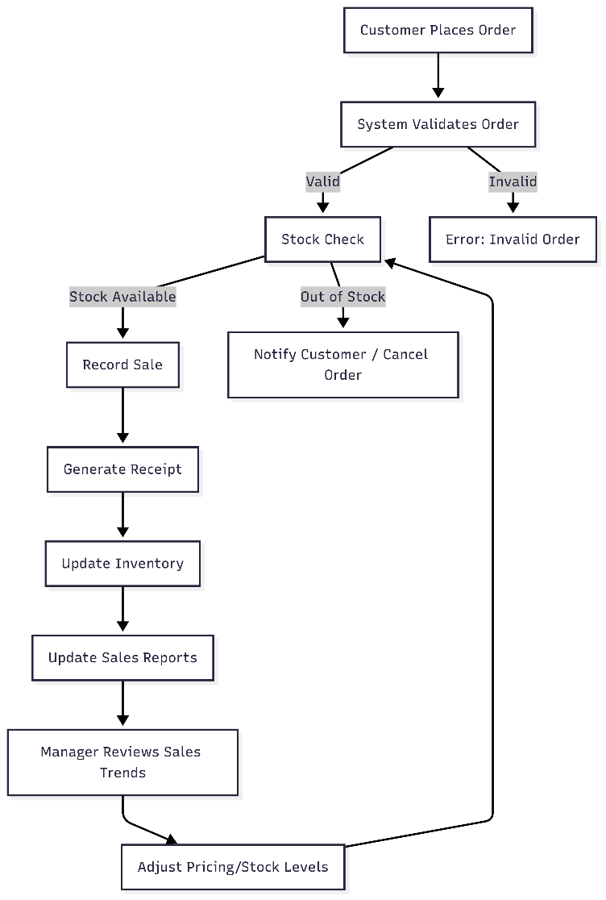

Figure 6:1 Sales management System Architecture

#### System Functionality Integration

The system was designed to streamline sales operations by integrating core functionalities across the cashier, sales, and admin applications. The cashier application enables staff to securely log in, record sales transactions, generate payment receipts, and update inventory in real-time. The sales application provides sales staff with tools to track customer orders, manage product catalogs, and monitor transaction histories. The admin application functions as a centralized control panel, allowing administrators to manage user accounts, configure system settings, review transaction logs, and generate detailed sales and performance reports. Each application route is protected by role-based access control, ensuring that users only access functionalities aligned with their roles. Key components such as transaction validation, receipt generation, and stock management are fully integrated into the backend. The receipt generation module produces structured records that include transaction details, customer information, payment method, and salesperson identity. The database, implemented with PostgreSQL and managed through Flask-SQLAlchemy ORM, ensures reliable storage of user data, sales records, product details, and feedback logs. Authentication and authorization were implemented using hashed passwords, Flask sessions, and role-based checks to maintain secure and controlled access across the entire platform.

### System Implementation

The implementation process was structured around several major modules, each developed and tested independently before integration. Flask was adopted as the primary backend framework due to its flexibility, simplicity, and ability to integrate seamlessly with relational databases. Three distinct Flask applications were developed: Cashier, Sales, and Admin. This multi-app deployment approach ensures clear role separation and allows each app to evolve or be deployed independently based on organizational needs.

The Cashier application was designed to allow cashiers to securely log in, process transactions, generate receipts, and automatically update stock records in real-time. The Sales application enables sales staff to manage product catalogs, track customer orders, and review sales histories, providing tools that support efficient customer service and record-keeping. The Admin application acts as a centralized control panel for administrators, enabling them to manage user accounts, configure system settings, monitor business performance, review transaction logs, and generate detailed reports. Each application route is protected through role-based access control, ensuring that users only access functionalities appropriate to their role.

Key components such as transaction validation, inventory management, and receipt generation were integrated into the backend. The receipt generation module produces structured digital records that include transaction details, payment methods, and the serving staff member. The database, built on PostgreSQL and managed using Flask-SQLAlchemy ORM, stores critical business data including user credentials, product information, sales records, and feedback logs. Authentication and authorization were implemented using hashed passwords, Flask sessions, and role-based checks to guarantee secure access across the entire platform.

### UI Implementation

The system’s User Interface (UI) was implemented using HTML, CSS, and JavaScript to ensure responsiveness, interactivity, and ease of use. Each application was designed with intuitive navigation tailored to its specific role. The Cashier interface provides a clean layout for processing sales quickly, including product search, cart management, and receipt printing. The Sales interface focuses on order tracking, customer management, and product catalog views, enabling staff to efficiently manage customer requests. The Admin interface features dashboards, data visualization elements, and control panels for managing users, inventory, and reports. Consistency in design elements, such as buttons, forms, and navigation menus, was maintained across all apps to ensure familiarity and reduce the learning curve. The UI emphasizes simplicity, accessibility, and efficiency, allowing users to complete their tasks with minimal effort.

#### ****Input Forms Implementati­­on****

The input form allows sales staff and cashiers to record transactions by entering product details, quantities, and customer information. Form validation ensures that all required fields, such as product name, price, and quantity, are filled before submission to prevent incomplete or incorrect entries. The system also provides login and registration forms for different roles (Cashier, Sales, and Admin), with password encryption to secure user credentials and optional email verification for account activation. These forms ensure secure access and data integrity across all applications.

* 1. **Products upload form**

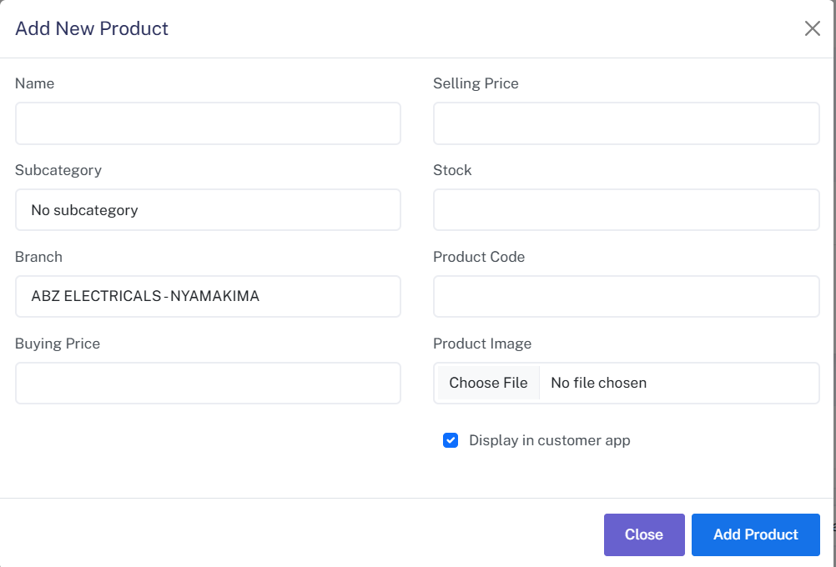

Figure 6:2 Screenshot of product upload form

* 1. Admin login form

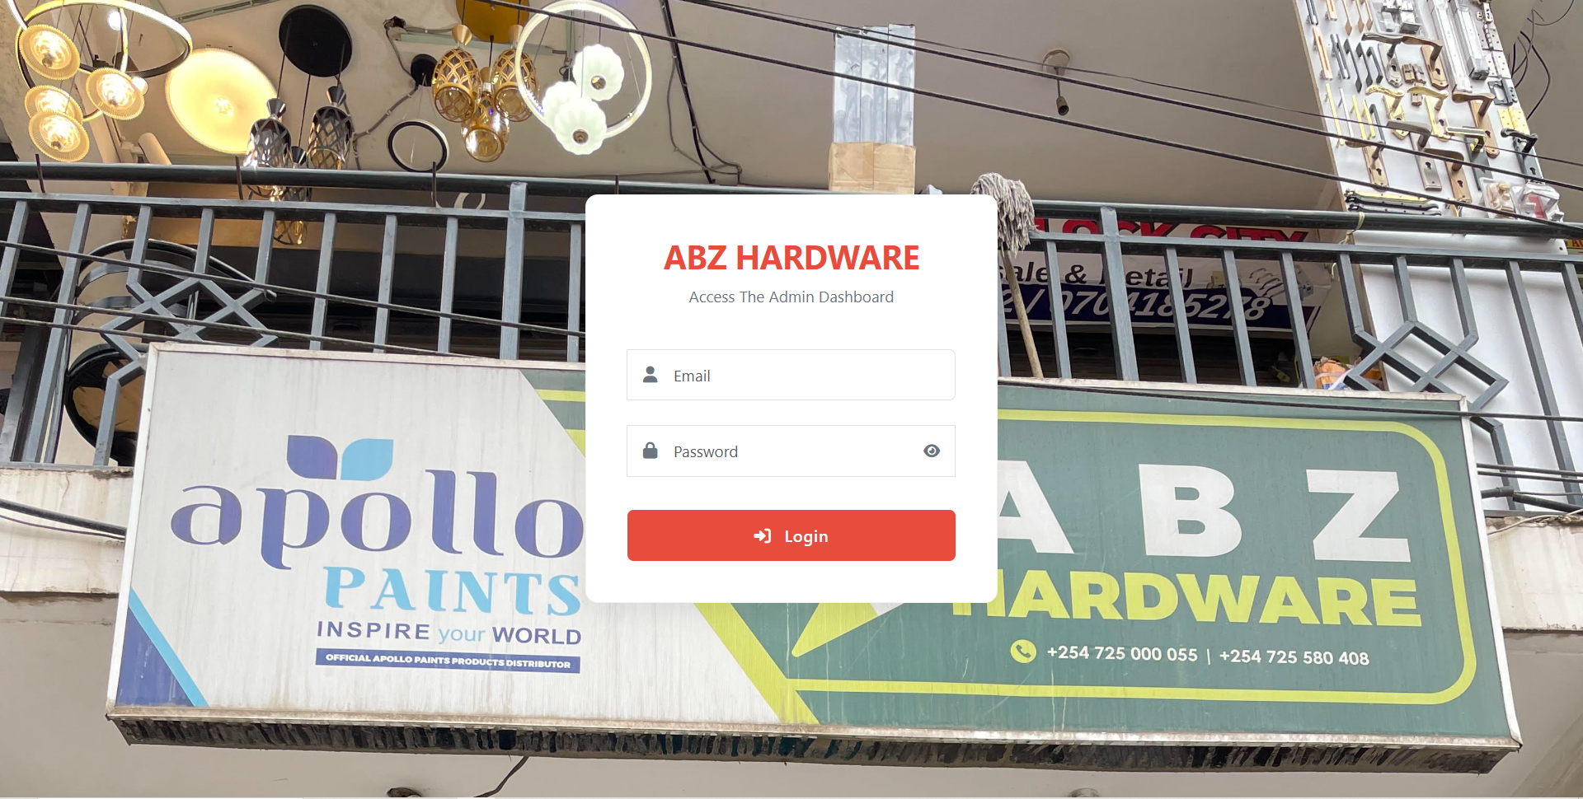

Figure 6:3 Screenshot of Admin Login Form

* 1. User registration form

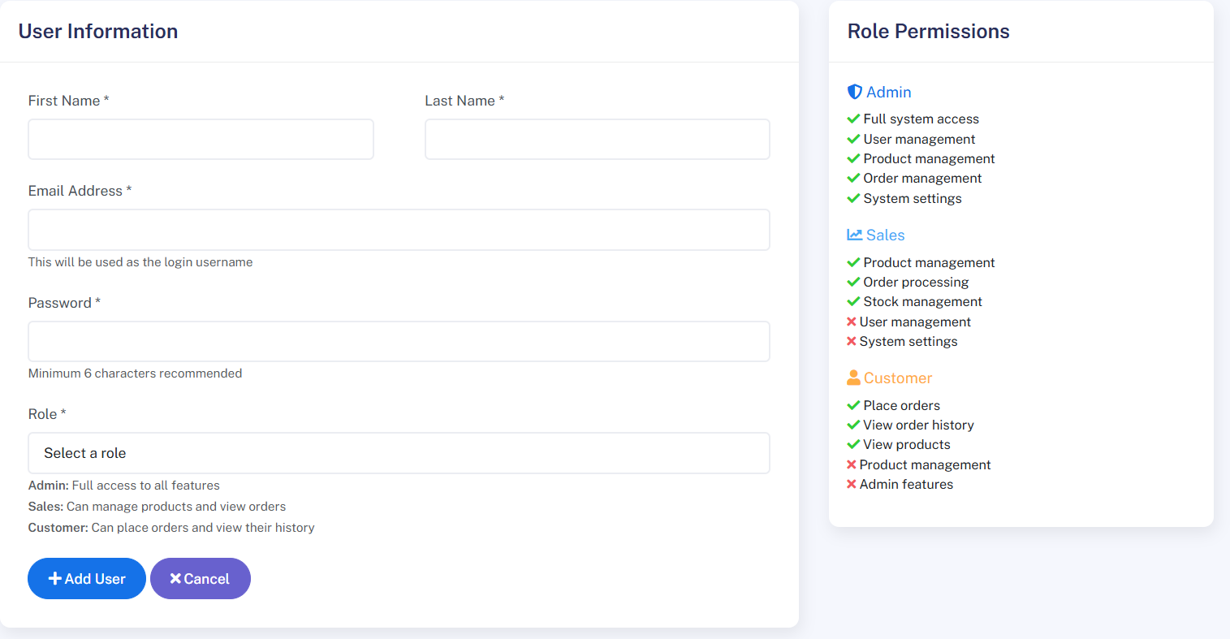

Figure 6:4 Screenshot of User Registration Form

* 1. Admin new branch form

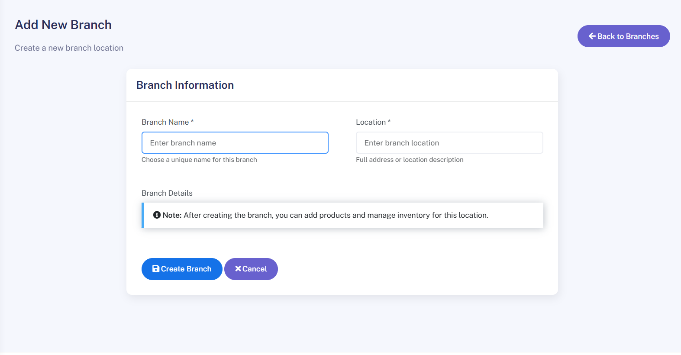

Figure 6:8 Screenshot of Admin New Branch

* 1. Edit user details form

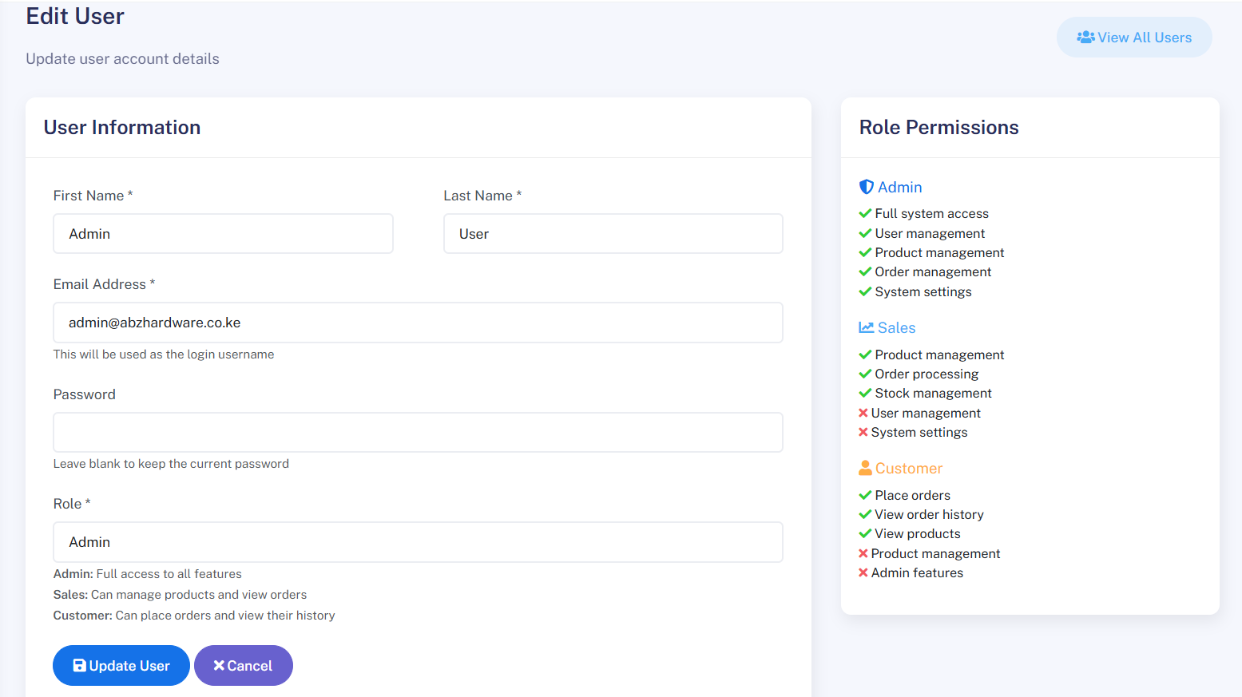

Figure 6:9 Screenshot of Edit User details Form

* 1. Add New Category form

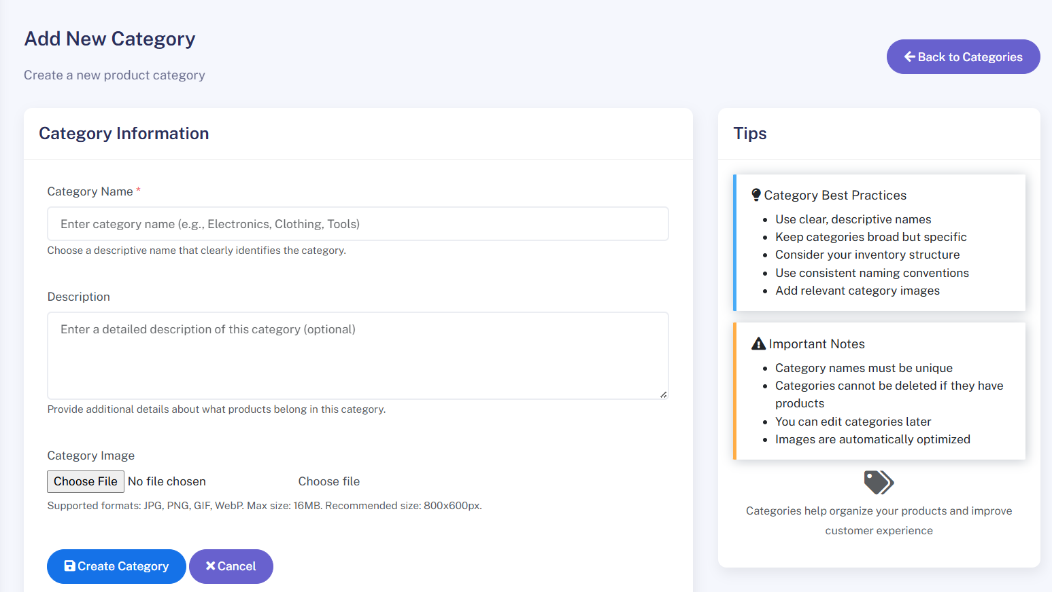

Figure 6:10 Add New Category Form

#### ****Reports Implementation****

The system generates reports to provide insights into sales activities and business performance. After transactions are recorded by the cashier or sales staff, the system compiles the data into structured reports such as daily sales summaries, product performance reports, and cashier activity logs. These reports include details such as total revenue, top-selling products, discounts applied, and payment methods used. Administrators can download the reports in formats such as PDF or Excel, or view them directly within the system dashboard. All reports are securely stored in the database for future reference, enabling performance tracking, auditing, and decision-making.

1. Products Report

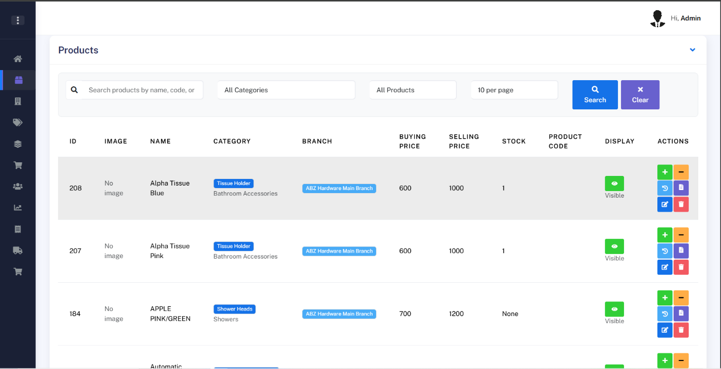

Figure 6:11 Products Report

1. Orders report

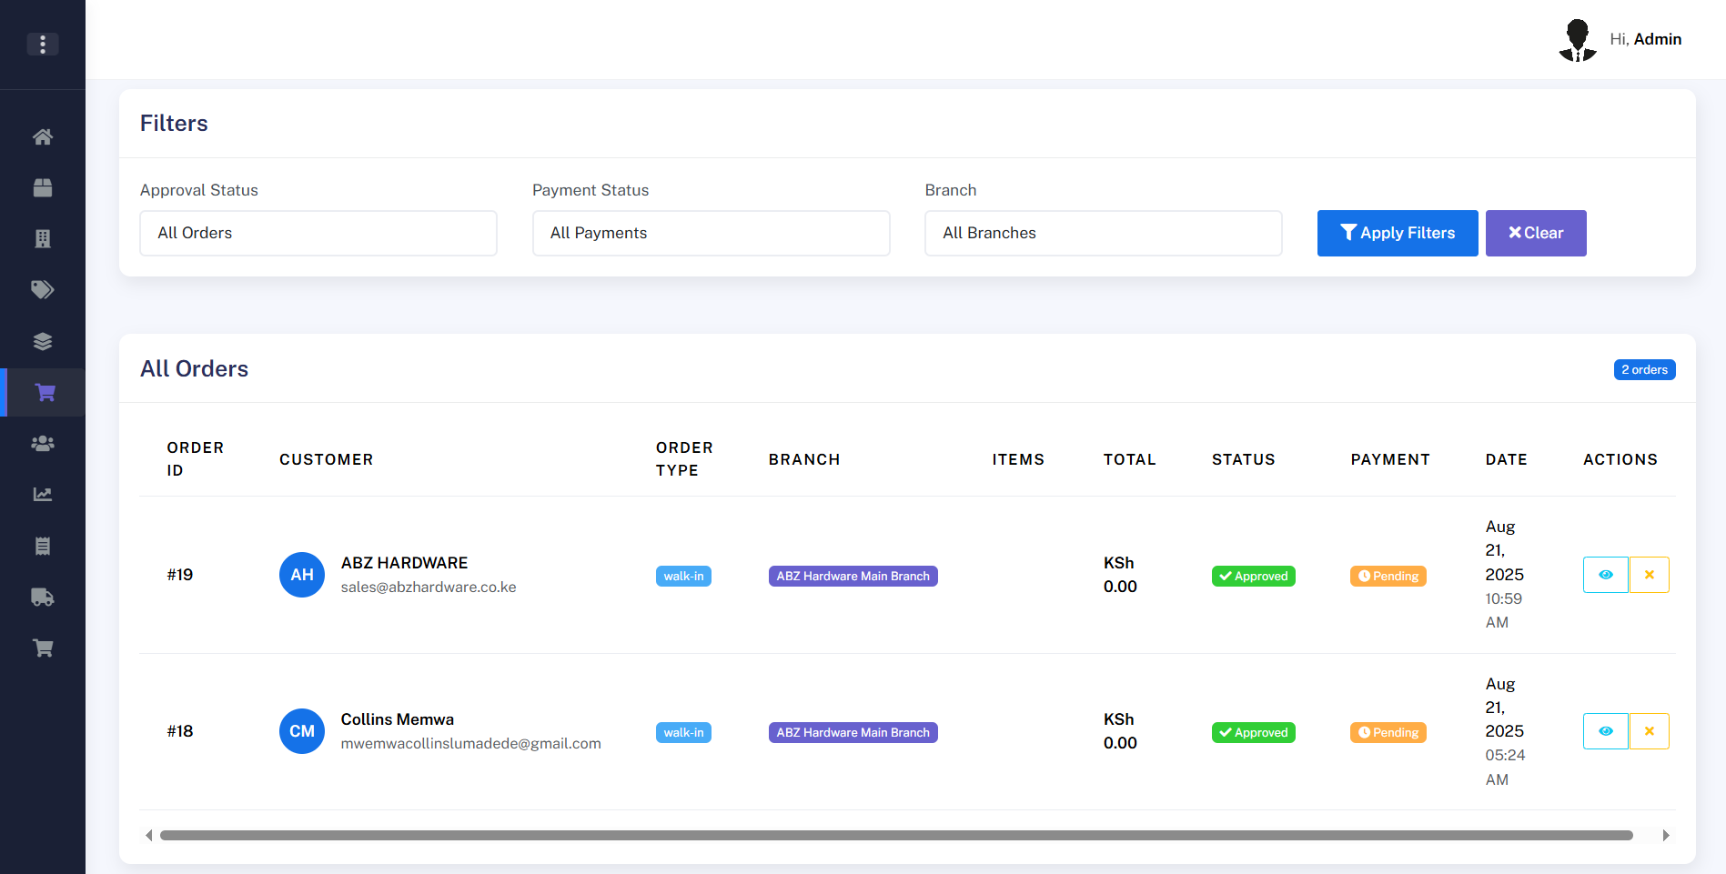

Figure 6:12 Orders Report

1. Payment Receipt Report



Figure 6:13 Payment Receipt Report

1. Sub Categories Report

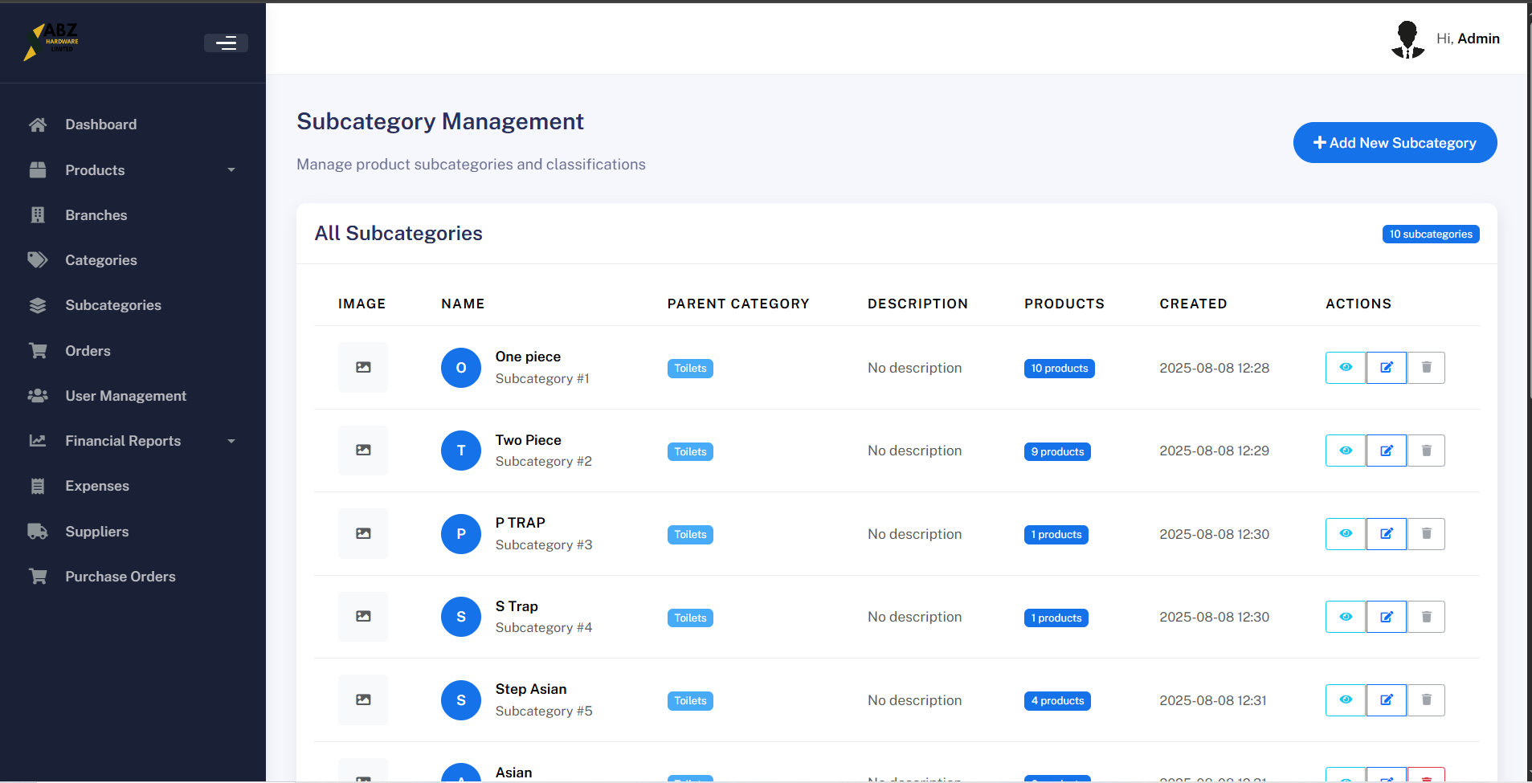

Figure 6:14 Sub Categories Report

### ERD Implementation

The Sales Management System uses a relational database schema designed to handle business operations efficiently while maintaining data consistency and integrity. The schema was implemented using **Flask-SQLAlchemy ORM**, with relationships enforced through foreign keys. The core entities include:

1. **Users**: Stores authentication credentials, employee details, and role information (cashier, sales, or admin).
2. **Sales**: Records all completed sales transactions including customer details, items sold, and total amounts.
3. **Products**: Maintains information on available items such as name, price, and stock levels.
4. **Customers**: Keeps customer details for tracking sales history and loyalty.
5. **Activity**: Logs user activity including logins, sales operations, and inventory updates for auditing.
6. **Payments**: Stores payment details such as payment method, amount paid, and balances for accountability.

This schema ensures smooth interaction across the cashier, sales, and admin applications while supporting scalability, accountability, and secure data handling.

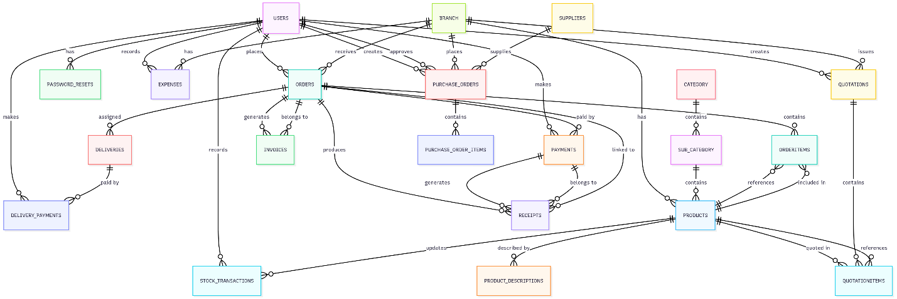

Figure 6:15 Screenshot of ERD structure

### Business Logic Implementation

The business logic of the Sales Management System resides on both the client side and the server side. On the client side, validation ensures that only valid inputs such as product details, customer information, and sales data are submitted. On the server side, the system handles operations such as sales processing, receipt generation, inventory updates, and customer management. The backend also performs database operations including insertions, deletions, updates, and retrievals for modules like cashier, sales, and admin. This ensures that business processes such as stock management, transaction recording, and reporting are accurate, consistent, and reliable across the entire system.

#### Client-Side Logic

1. Search Feature and pagination on products Page

<script>

// Wait for DOM to be fully loaded

document.addEventListener('DOMContentLoaded', function() {

console.log('DOM loaded, initializing search functionality...');

// Category Search Functionality

const categorySearch = document.getElementById('categorySearch');

if (categorySearch) {

console.log('Category search element found');

categorySearch.addEventListener('keyup', function() {

console.log('Category search triggered:', this.value);

const searchTerm = this.value.toLowerCase();

const table = document.getElementById('categoriesTable');

const tbody = table.getElementsByTagName('tbody')[0];

const rows = tbody.getElementsByTagName('tr');

for (let i = 0; i < rows.length; i++) {

const nameCell = rows[i].getElementsByTagName('td')[1];

const descCell = rows[i].getElementsByTagName('td')[2];

if (nameCell && descCell) {

const name = nameCell.textContent.toLowerCase();

const description = descCell.textContent.toLowerCase();

if (name.includes(searchTerm) || description.includes(searchTerm)) {

rows[i].style.display = '';

} else {

rows[i].style.display = 'none';

}

}

}

});

} else {

console.log('Category search element not found');

}

// Server-side search is now handled by the form submission

// No need for client-side filtering anymore

// Function to change items per page

window.changeItemsPerPage = function(perPage) {

const currentUrl = new URL(window.location);

currentUrl.searchParams.set('per_page', perPage);

currentUrl.searchParams.set('page', '1'); // Reset to first page

window.location.href = currentUrl.toString();

};

console.log('Search functionality initialized successfully');

});

</script>

#### ****Server-Side Logic (Search logic)****

# Categories Routes

@app.route('/products')

@login_required

@role_required(['admin'])

def products():

categories = Category.query.order_by(Category.name).all()

subcategories = SubCategory.query.order_by(SubCategory.name).all()

branches = Branch.query.order_by(Branch.name).all()

# Get selected branch from query parameter

selected_branch_id = request.args.get('branch_id', type=int)

# Search and filter parameters

search = request.args.get('search', '')

category_filter = request.args.get('category', '')

display_filter = request.args.get('display', '')

# Pagination parameters

page = request.args.get('page', 1, type=int)

per_page = request.args.get('per_page', 10, type=int) # Default 10 items per page

# Base query - join with SubCategory and Category for better search

base_query = Product.query.join(

SubCategory, Product.subcategory_id == SubCategory.id, isouter=True

).join(

Category, SubCategory.category_id == Category.id, isouter=True

)

# Apply filters

if selected_branch_id:

base_query = base_query.filter(Product.branchid == selected_branch_id)

if search:

base_query = base_query.filter(

or_(

Product.name.ilike(f'%{search}%'),

Product.productcode.ilike(f'%{search}%'),

SubCategory.name.ilike(f'%{search}%'),

Category.name.ilike(f'%{search}%')

)

)

if category_filter:

base_query = base_query.filter(SubCategory.name == category_filter)

if display_filter == 'true':

base_query = base_query.filter(Product.display == True)

elif display_filter == 'false':

base_query = base_query.filter(Product.display == False)

# Apply pagination

pagination = base_query.order_by(Product.name).paginate(

page=page,

per_page=per_page,

error_out=False

)

products = pagination.items

# Check if this is an AJAX request

if request.headers.get('X-Requested-With') == 'XMLHttpRequest':

# Return only the table content for AJAX requests

return render_template('products_table_partial.html',

products=products,

branches=branches,

selected_branch_id=selected_branch_id,

pagination=pagination,

search=search,

category_filter=category_filter,

display_filter=display_filter)

else:

# Return full page for regular requests

return render_template('products.html',

categories=categories,

subcategories=subcategories,

products=products,

branches=branches,

selected_branch_id=selected_branch_id,

pagination=pagination,

search=search,

category_filter=category_filter,

display_filter=display_filter)

### Module Testing

Module testing was conducted for core features such as sales transactions, receipt generation, inventory management, and authentication. Test data consisting of sample products, customers, and transactions were used to verify backend accuracy and ensure that each module (cashier, sales, and admin) performed as expected.

Table 6‑1 TESTS TABLE

|  |  |  |  |  |
| --- | --- | --- | --- | --- |
| **Test Case** | **Input** | **Expected Output** | **Actual Output** | **Pass/Fail** |
| TC001 | Cashier records a valid sale (Product A, Qty 2) | Sale saved, stock reduced by 2, receipt generated | Sale saved, stock reduced by 2, receipt generated | Pass |
| TC002 | Sales person makes sale with insufficient stock | Error message "Insufficient stock" | Error message "Insufficient stock" | Pass |
| TC003 | Admin adds new product | Product appears in inventory list | Product appears in inventory list | Pass |
| TC004 | Sale attempted by unauthenticated user | Redirect to login page | |  | | --- | |  |  |  | | --- | | Redirect to login page | | Pass |
| TC005 | Admin views sales report for date range | Accurate sales report displayed | Accurate sales report displayed | Pass |
|  |  |  |  |  |

### Chapter Summary

This chapter documented the full implementation process of the Sales Management System. It detailed how each module cashier, sales, and admin was built and integrated, demonstrated the interface through screenshots, and outlined the testing strategy. The system, as implemented, functions effectively and achieves its intended purpose of streamlining sales operations, managing inventory, and ensuring accurate record-keeping. The structured testing plan confirmed its reliability, and user feedback indicated strong usability and efficiency in daily business operations.

## CONCLUSION, FINDING & RECOMMENDTON

### Introduction

This chapter presents a comprehensive conclusion of the project, reflecting on its objectives, the achievements made, the key findings uncovered during development and testing, and the challenges encountered. Additionally, the chapter provides well-considered recommendations for future work to improve the performance, usability, and scalability of the system. The implementation of the Sales Management System represents a significant step toward improving efficiency in sales operations, stock management, and administrative oversight, particularly for businesses that rely on streamlined record-keeping and transaction tracking. This project has demonstrated that such integration is both feasible and practical using lightweight, scalable, and cost-effective technologies. The system developed is capable of managing sales transactions, generating reports, monitoring inventory, and enhancing overall business efficiency, thereby empowering organizations with a tool that improves accuracy, transparency, and decision-making in daily operations.

### Findings

#### Achievement of Objectives

The main objective of this project was to design and develop a web-based Sales Management System to assist businesses in managing sales transactions, inventory, and administrative operations in a more efficient and secure manner. The system was aimed at improving accuracy in sales recording, providing supportive tools for decision-making, and facilitating easy access to business data and reports. The findings based on the completed system are summarized as follows:

**Objectives/Requirements that were achieved:**

The objectives and requirements set for the Sales Management System were successfully achieved as follows:

1. Developed a reliable system for recording and managing sales transactions in real time, improving accuracy and reducing manual errors.
2. Implemented product and inventory management features to automatically update stock levels after each sale, minimizing inconsistencies and stockouts.
3. Integrated the backend logic into Flask, enabling smooth processing of transactions, reporting, and communication with the frontend interface.
4. Designed a responsive web interface using HTML, CSS, and JavaScript, allowing sales staff and administrators to easily interact with the system across devices.
5. Created a user-friendly cashier and sales page where items can be added, totals automatically calculated, and receipts generated instantly.
6. Implemented user account management, including registration, login, logout, and secure role-based access (e.g., cashier, sales staff, admin).
7. Stored all sales records, inventory updates, and user activities in a PostgreSQL database using SQLAlchemy ORM for secure record-keeping and retrieval.
8. Developed an admin dashboard for monitoring sales performance, generating reports, managing staff accounts, and reviewing transaction history.
9. Implemented notifications and activity tracking for accountability and transparency, improving overall business efficiency.

#### Challenges

While the project was largely successful, several challenges were encountered during its development and testing. One of the most significant hurdles was related to data consistency and accuracy. Sales records and inventory data often contained discrepancies due to manual entry errors or incomplete information. Although validation checks were implemented to minimize these issues, ensuring clean and accurate data remains an ongoing challenge. Another key challenge was system integration. Since the project was structured into three separate applications (Cashier, Sales, and Admin), managing routing, role-based security, and database sharing required careful planning and additional effort to maintain seamless functionality. Inventory synchronization also posed difficulties ensuring that real-time sales automatically reflected in stock updates without delays or duplication needed extensive testing. In addition, report generation under heavy transaction loads initially caused performance issues,­ requiring optimization of database queries. Finally, user adoption and training emerged as a challenge, as some staff were initially unfamiliar with digital record-keeping. Training sessions and a simplified UI helped address this, but continuous support is still necessary for smooth adoption.

### Final Conclusion

In conclusion, the project successfully demonstrated the feasibility and effectiveness of using web technologies and automated syst­­­­­ems to support efficient sales management. By combining data processing with a user-friendly web interface, the developed system offers a valuable tool for sales teams and managers in both small and large business settings. Despite certain challenges, particularly in data handling and real-world testing, the project stands as a proof of concept for what is possible when technology is thoughtfully applied to business operations. The system is secure, modular, and designed with the end-user in mind. It can be easily scaled and enhanced, offering great potential for future development and deployment. With continued improvement, this tool could significantly streamline sales processes, improve decision-making, and enhance customer satisfaction, making it a promising step toward optimizing business operations through technology.

### Future Recommendations

In light of the experience gained during development and testing, several recommendations can be made to guide future enhancements of the Sales Management System:

1. **Expand System Scalability**: As the business grows, the system should be optimized to handle larger transaction volumes, more concurrent users, and integration with multiple branches or outlets.
2. **Advanced Reporting and Analytics**: Future iterations could include advanced analytics dashboards that provide sales trends, profit margins, inventory turnover rates, and customer purchase behavior insights. These will support data-driven decision-making.
3. **Integration with External Systems**: The system can be extended to integrate with accounting software, ERP solutions, and online payment platforms to create a seamless end-to-end business solution.
4. **Inventory Forecasting**: Implement predictive analytics to estimate future demand based on past sales patterns and seasonal trends. This will help in better stock management and reduce shortages or overstock situations.
5. **SMS & Email Notifications**: Automating notifications for low stock alerts, daily sales summaries, or customer receipts will enhance communication and improve efficiency.
6. **Mobile Application Support**: A mobile version of the system will allow cashiers, sales staff, and managers to access the system on-the-go, improving flexibility and usability.
7. **Enhanced Security Features**: Introducing features such as two-factor authentication (2FA) and detailed audit logs will strengthen system security and protect sensitive sales data.
8. **Multilingual Support**: Adding support for multiple languages will make the system accessible to a wider user base, especially in multilingual business environments.

# REFERENCES

Bennett, S., McRobb, S., & Farmer, R. (2006). *Object-Oriented Systems Analysis and Design Using UML*. McGraw-Hill Education.

Booch, G., Rumbaugh, J., & Jacobson, I. (2007). *The Unified Modeling Language User Guide* (2nd ed.). Addison-Wesley.

Date, C. J. (2004). *An Introduction to Database Systems* (8th ed.). Pearson Education.

Elmasri, R., & Navathe, S. B. (2016). *Fundamentals of Database Systems* (7th ed.). Pearson.

Fowler, M. (2004). *UML Distilled: A Brief Guide to the Standard Object Modeling Language* (3rd ed.). Addison-Wesley.

Laudon, K. C., & Laudon, J. P. (2020). *Management Information Systems: Managing the Digital Firm* (16th ed.). Pearson.

Kotler, P., Keller, K. L., & Chernev, A. (2022). *Marketing Management* (16th ed.). Pearson.

O’Brien, J. A., & Marakas, G. M. (2011). *Management Information Systems* (10th ed.). McGraw-Hill.

Satzinger, J. W., Jackson, R. B., & Burd, S. D. (2015). *Systems Analysis and Design in a Changing World* (7th ed.). Cengage Learning.

Sommerville, I. (2016). *Software Engineering* (10th ed.). Pearson.

Turban, E., Pollard, C., & Wood, G. (2018). *Information Technology for Management: On-Demand Strategies for Performance, Growth, and Sustainability* (11th ed.). Wiley.

Zwass, V. (2018). *Foundations of Information Systems*. McGraw-Hill Education.

# APPENDICES

### Appendix A: Questionnaires

*Sales Staff Questionnaire:*

1. What is your opinion on using a Sales Management System for day-to-day operations?

Very Helpful

Not Helpful

Other (please specify):_______________

1. How do you currently manage sales transactions and inventory?

Manual(Pen and Paper)

Excel Sheets

Existing digital system

☐ Combination of both

1. **Which functionalities do you consider essential in a Sales Management System? (Select all that apply)**

☐ Sales transaction processing  
☐ Inventory/stock management  
☐ Customer management (CRM)  
☐ Reporting and analytics  
☐ User access control  
☐ Receipt/Invoice generation

1. **What challenges do you face in managing sales and inventory in your business?**☐ (please specify): ___________________________
2. **What tools or software do you currently use to record and track sales?**  
   ☐ (please specify): ___________________________

*Administrator Questionnaire*:

How do you currently manage user accounts (cashiers, sales staff, managers)?

☐ Paper/manual records

☐ Spreadsheets

☐ Basic software

☐ Other (please specify): ___________________________

**How easy is it for you to monitor overall sales performance with the current system?**

☐ Very easy  
☐ Easy  
☐ Neutral  
☐ Difficult  
☐ Very difficult

**Do you face delays or challenges in generating sales and inventory reports?**

☐ Yes, frequently  
☐ Occasionally  
☐ Rarely  
☐ Never

**How do you currently ensure data security (sales records, user access, inventory)?**

☐ Password-protected files  
☐ Manual restriction (paper access only)  
☐ No formal security measures  
☐ Other (please specify): ___________________________

**What are the main challenges you face in administering the current system?**

☐ Time-consuming data entry  
☐ Errors in sales or stock reports  
☐ Difficulty in tracking user activity  
☐ Lack of real-time updates  
☐ Other (please specify): ___________________________

How effective is the current system in preventing fraud or unauthorized access?

☐ Very effective  
☐ Somewhat effective  
☐ Not effective

What improvements would you suggest for a new sales management system?

### Appendix B: Project Schedule

|  |  |  |  |  |  |  |  |  |  |  |
| --- | --- | --- | --- | --- | --- | --- | --- | --- | --- | --- |
| **ID** | **NAME** | **JAN**  **22** | **FEB**  **29** | **MAR**  **05** | **APR**  **12** | **MAY**  **19** | **JUN**  **26** | **JUL**  **04** | **JUL**  **11** | **AUGUST**  **18** |
| 1. | Research  proposal |  |  |  |  |  |  |  |  |  |
| 2. | System  Analysis |  |  |  |  |  |  |  |  |  |
| 3. | System  Design |  |  |  |  |  |  |  |  |  |
| 4. | Coding/  Debugging |  |  |  |  |  |  |  |  |  |
| 5. | Testing |  |  |  |  |  |  |  |  |  |
| 6. | Deployment |  |  |  |  |  |  |  |  |  |
| 7. | Documentation |  |  |  |  |  |  |  |  |  |

Table 1 Gantt Chart

Based on the Gantt chart above here’s the project breakdown during each phase:

Research proposal Phase : This phase involves identifying the problem, setting project objectives, reviewing relevant literature, and developing a detailed proposal.

System analysis Phase : This is the second phase, analyze existing systems (manual or automated) and user needs to identify gaps and requirements

System design Phase : Design the architecture of the system using structured methods. Define the UI/UX layout and data flow for the ABZ hardware sales management system.

Coding/debugging phase: Actual development of the system, where the front-end, back-end, and database are implemented.

Testing Phase : Three months are set aside for the testing phase. The activities during this phase includes, Integration Testing, Model Evaluation and System testing.

Deployment: Deploy the system in a real-world environment. This includes migrating existing data, setting up the operational environment, and ensuring all components work together.

Documentation: The last phase is the documentation phase. Prepare detailed documentation of the system’s architecture, design decisions, codebase, and user manuals.

### Appendix C: Project Budget

The following budget outlines the costs required for the development and implementation of the ABZ Hardware Sales Management System.

|  |  |  |
| --- | --- | --- |
| **Resource** | **Description** | **Cost(KES)** |
| Laptop(1) | High-Performance Laptop for development, coding and testing. | 80,000 |
| Development Tools | PyCharm Professional License and other development essentials. | 12,000 |
| Transport | Transport for purpose of research study (visiting the hardware). | 10,000 |
| Printing | Document Printing costs (Reports) | 4,000 |
| 4Data Usage and Internet | Internet and data costs for development, research and hosting. | 12,000 |
| Miscellaneous | Contingency Budget, the unforeseen expenses during the project development. | 10,000 |
| **Estimated Project Budget** |  | 128,000 |

Table 2 Estimated Project Budget

### Appendix E: Source Code Snippets

* 1. Database Table ORM Models Code

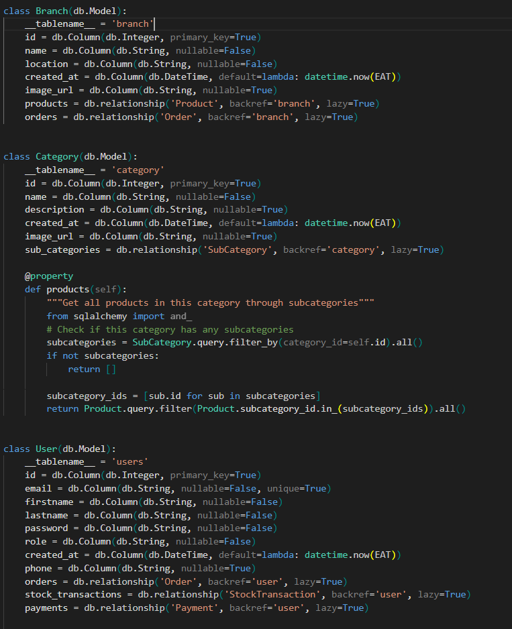

Figure 38 Database Table ORM Models

* 1. Admin App Authentication Code

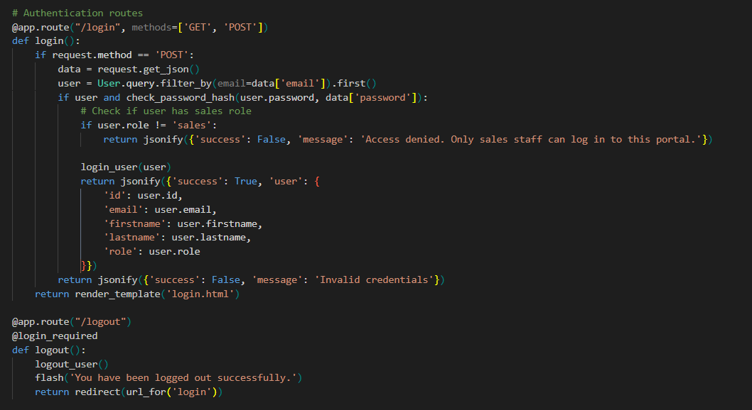

FIGURE 39 Admin App Authentication Code

* 1. Sales Dashboard Route

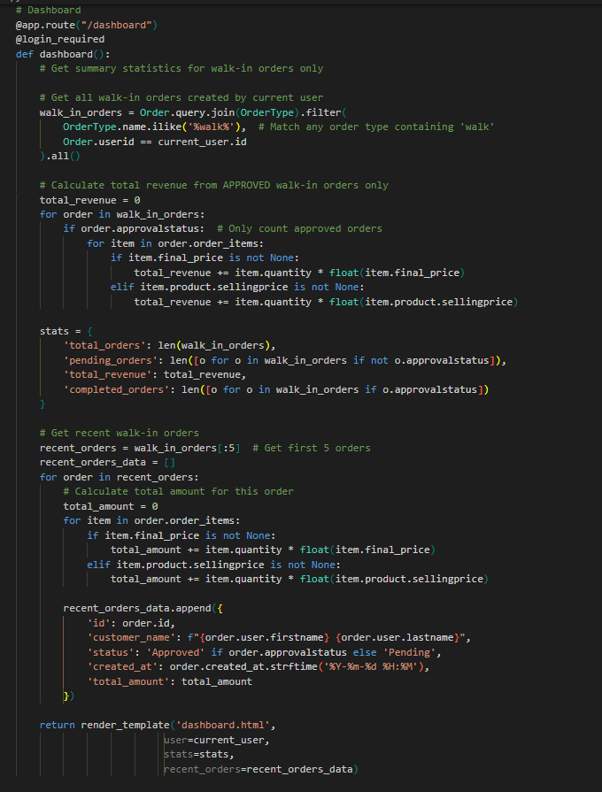

FIGURE 40 Sales Dashboard Route

* 1. Amin User Management Route

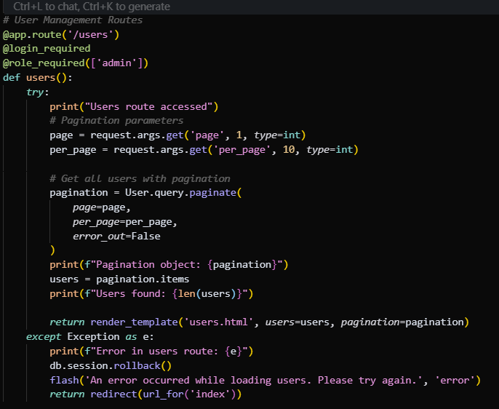

FIGURE 41 Prediction Code Snippet